**Latkes with Brown Butter Glazed Apples, Sour Cream and Chives**

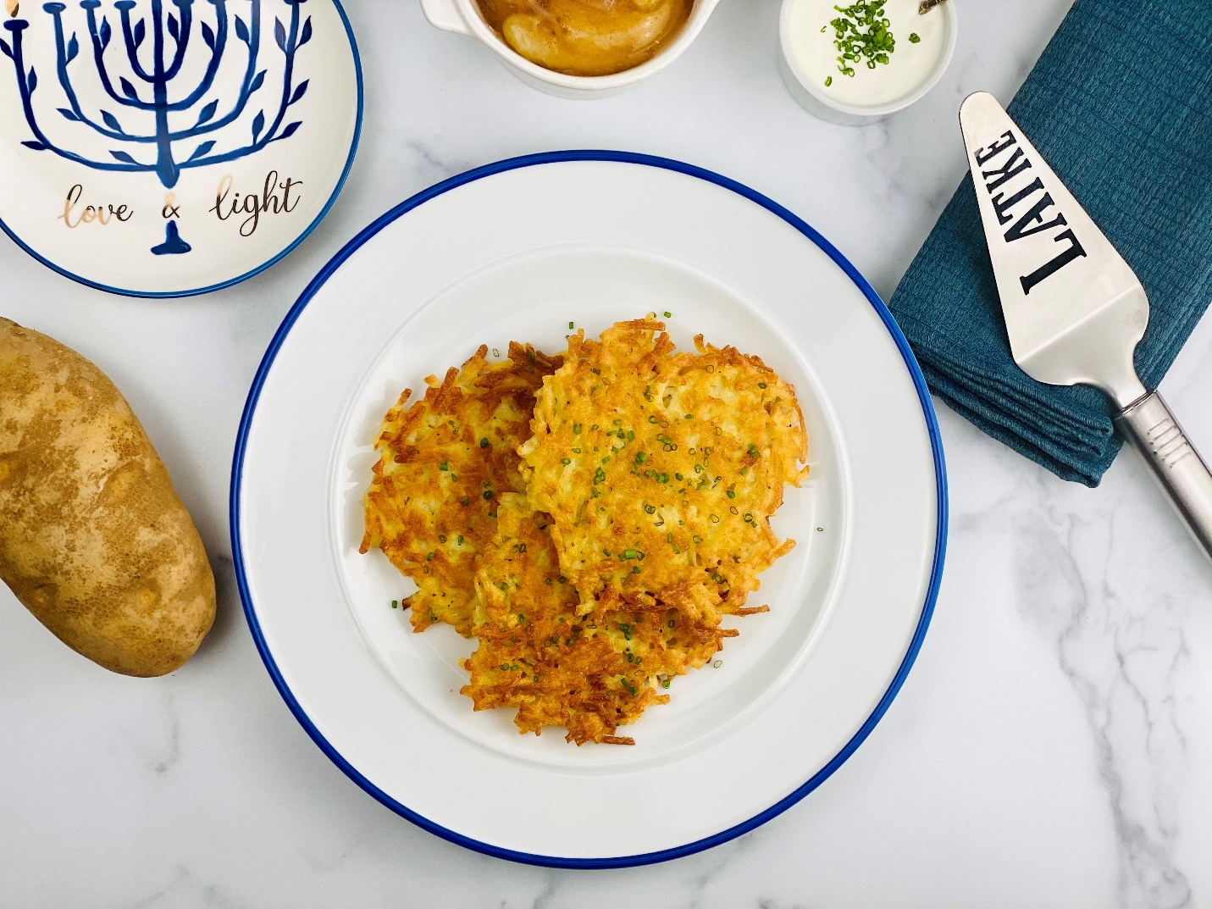

**Description:** Crispy and simple. Latkes are a classic potato pancake that sing of potato flavor. These latkes are served with sour cream and a not so traditional side of brown butter glazed apples.

**Servings:** 8

**Preparation Time:** 20 minutes

**Cooking Time:** 25 minutes

**Total Time:** 45 minutes

**Potato Type:** Russets or Dehydrated Potato Shreds

**Course:** Entrée, Side Dish, Lunch, Dinner

**Ingredients**

*For the Latkes:*

* 2 each (3 cups) Large Russet Potatoes, grated (about 8-10 ounces each or 454g total of potatoes), dehydrated potato shreds can work as well. Just rehydrate the potatoes and then measure the amount you need.
* 1 each (3/4 cup) 80g Yellow onions, grated
* 2 each (100g) Large Eggs
* 1/3 cup (45g) All Purpose Flour
* 2 teaspoons (2g) Kosher Salt
* 1 teaspoon (1g) Baking Powder
* ½ teaspoon (1g) Freshly Ground White Pepper
* As Needed Canola Oil, Sunflower Oil, or Vegetable Oil for frying

*For the Brown Butter Apples:*

* 2.2 pounds (1 kg) Granny Smith Apples, peeled and cut into wedges
* 4 tablespoons (30g) Unsalted Butter
* 3 teaspoons (12g) Cornstarch or Potato Starch
* ½ cup (120ml) Cold Water
* 4 tablespoons (30g) Brown Sugar
* ½ teaspoon Cinnamon
* ¼ teaspoon Salt

*To Plate:*

* ½ cup (120ml) Crème Fraiche or Sour Cream
* 2 tablespoons (1g) Fresh Chives, chopped

**Preparation**

1. To prepare the potatoes, grate the potatoes on the large side of a box grater. This can also be done in a food processor with a large grating attachment fixed to the inside of the processor bowl. Another way to do this is to simply use dehydrated potato shreds which have been rehydrated in warm water for 15-20 minutes then drained. Frozen shredded potatoes that have been thawed are also an option. If using fresh potatoes, grate the potatoes then transfer them into a clean dish towel. Wrap the potatoes up in a towel and squeeze the excess moisture out of the potatoes and place them into a large bowl.
2. To the potatoes, add the onions, eggs, flour, salt, baking powder, and pepper. Stir the mixture until it is just combined. Allow it to rest for 3-5 minutes.
3. To cook the latkes, heat the oil over medium high heat in a non-stick skillet or frying pan. Place golf ball sized mounds of the potato mixture in the hot oil, gently press the mixture down into a pancake.
4. Allow the latkes to get golden brown on both sides about 3-5 minutes. Flip the latkes over and continue to cook for another 3-5 minutes. Remove the latkes from the pan and allow them to drain slightly on a wire rack or a plate lined with paper towel.
5. Keep the cooked latkes warm in a 200 F oven until ready to plate.
6. To make the brown butter apples, begin by peeling and cutting the apples into wedges. In a large skillet or sauté pan, heat the butter over medium high heat until it is just golden, add the apples and sauté for 6-7 minutes or until they are almost tender.
7. Dissolve the cornstarch in the corn water and add this mixture to the apples. Stir in the brown sugar and the cinnamon, then boil the apples for 1-2 minutes or until they are thick. Remove the apples from the heat and keep warm.
8. To plate, arrange some of the latkes on a serving plate, sprinkle them with chives and serve with the sour cream and brown butter apples.
9. Serve these immediately and enjoy!

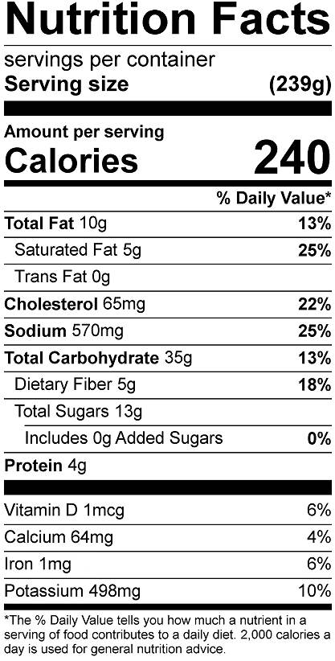

Vitamin C: 4.92mg