Lasagna Curly Fries
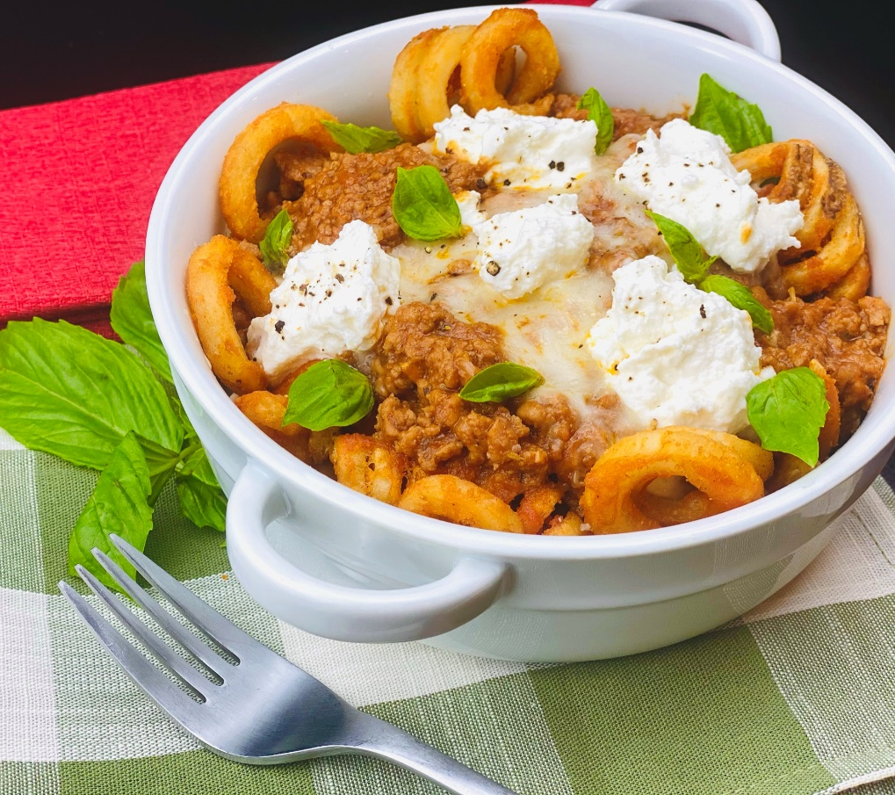
Description: Crispy curly fries topped with a rich Bolognese sauce, melted mozzarella, creamy ricotta cheese, and fresh basil.
Servings: 12
Preparation Time: 30 minutes
Cooking Time: 240 minutes
Total Time: 270 minutes
Potato Type: Frozen Curly Fries
Course: Entrée, Shareable Appetizer

Ingredients
For the Bolognese Sauce:
- ½ lb. (226.8g) Ground Pork
- ½ lb. (226.8g) Ground Beef
- ½ lb. (226.8g) Ground Veal
- 2 tablespoons (30ml) Extra Virgin Olive Oil
- 4 ounces (113.4g) Pancetta, diced very small
- 2 cups (220g) Onions, diced fine
- 1 cup (110g) Carrots, diced fine
- 1 cup (110g) Celery, diced fine
- 6 each (30g) Garlic Cloves, chopped fine
- 1 teaspoon (1g) Crushed Red Chili Flakes
- ¼ cup (56g) Tomato Paste
- ¾ cup (180ml) Dry Red Wine
- 2 tablespoons (30ml) Fish Sauce (optional)
- 1 quart (960ml) Beef Stock
- 2 cups (480ml) Whole Milk
- 1 piece (80g) Parmesan Cheese Rind
- 1 each Bay Leaf
- 1 tablespoon Italian Seasoning
- ½ tablespoon Kosher Salt
- ½ tablespoon Freshly Ground Black Pepper
- 2 teaspoons Freshly Grated Nutmeg
For the Curly Fries:
- 2.2 pounds (1kg) Frozen Curly Fries
- As Needed Vegetable Oil for Frying
- 1 teaspoon Salt
To Plate:
- 1 cup (120g) Shredded Mozzarella
- 1 cup (250g) Ricotta Cheese
- ½ teaspoon (1g) Freshly Cracked Black Pepper
- 1/2 cup (4g) Fresh Basil, picked

Preparation
Bolognese Sauce
- To make the Bolognese, begin by browning the pork, beef, and veal in a large heavy bottom pot.
- Remove the meat and drain the fat, return the pot to the heat.
- Add the olive oil and cook the pancetta until it is crisp.
- Remove the pancetta and add it to the browned ground meat from earlier, leave the fat in the pot, this will be used to sauté the vegetables.
- Add the onions, carrots, celery, garlic, and crushed red chili flakes to the pot. Cook the vegetables over medium high heat, and sauté until the onions are translucent about 3-5 minutes.
- Add the tomato paste and stir for about 2 minutes. Deglaze the pan with the wine, being sure to scrape any caramelized bits on the bottom of the pan.
- Reduce the wine by ½ and add the fish sauce. This is an optional step but will yield a very delicious Bolognese, the sauce won’t taste of fish, it will simply add umami notes to the final sauce.
- Add the browned ground meats and pancetta, beef stock, and the milk to the pot.
- Bring the sauce to a boil and reduce to a simmer over a low flame.
- Add the parmesan cheese rind, the bay leaf, and the Italian seasoning.
- Cook this sauce for about 3-4 hours until the liquid has reduced, and the meat and vegetables become indistinguishable from each other. Adjust the seasoning with salt and pepper. Add in the grated nutmeg and keep warm until ready to use.
Curly Fries
  - To fry the curly fries, fry them at 375 °F (190 °C) until they are crisp and golden brown.
  - Drain the fries and place them into a bowl, season them with the salt and toss to combine. Arrange the fries in an oven safe dish.
To Plate
- Spoon some of the Bolognese sauce over the fries.
- Sprinkle the top with the mozzarella, and dot with dollops of the ricotta cheese.
- Place the dish into an oven with the broil set on high. Cook the fries until the cheese is melted and bubbling (about 90 seconds).
- Remove the fries from the oven and season with fresh cracked black pepper then garnish with basil leaves. Serve immediately. Enjoy!
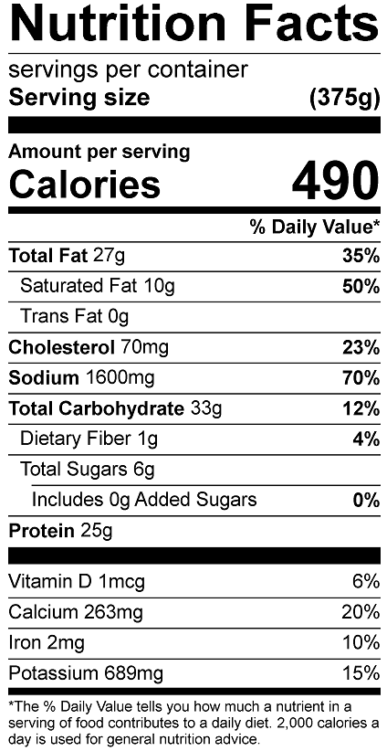
Vitamin C: 7.2mg

