**Korean Beef Bulgogi Loaded Fries**

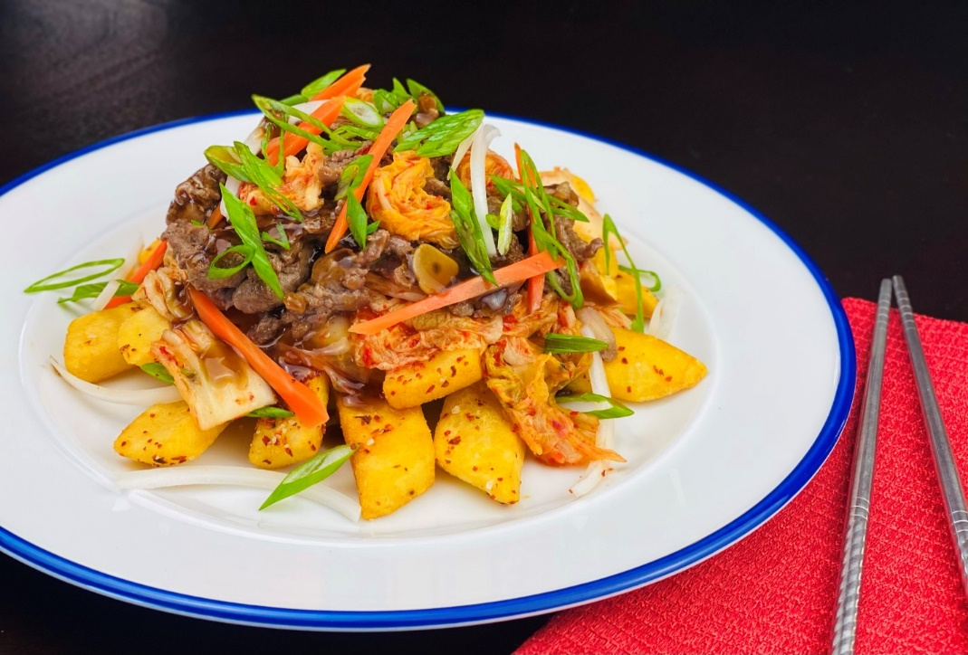

**Description:** Spicy steak cut fries topped with kimchi and tender beef bulgogi.

**Servings:** 12

**Preparation Time:** 120 minutes

**Cooking Time:** 20 minutes

**Total Time:** 140 minutes

**Potato Type:** Frozen Steak Cut Fries

**Course:** Entrée, Appetizer

**Ingredients**

**Korean Beef Bulgogi:**

**Yields 2 pounds (or buy pre-marinated & cook to instructions)**

Ingredients:

* 2 lbs. (908g) Beef tenderloin, sliced thinly

**Advertisement**

**Marinade** (for 2 pounds of beef):

* 1 cups (240ml) Pureed [pear](https://www.maangchi.com/ingredient/korean-pear)
* 1/2 cups (120ml) Onion purée
* 8 cloves (40g) Minced garlic
* ¾ tablespoon (8g) Minced ginger
* 2 each (30g) Chopped green onion
* ¼ cup (60ml) [Soy](https://www.maangchi.com/ingredient/soy-sauce) sauce
* ¼ cup (80g) Brown sugar
* ¼ teaspoon (1g) Ground black pepper
* 2 tablespoons (30ml) Toasted [sesame oil](https://www.maangchi.com/ingredient/sesame-oil)
* 1/3 cup (50g) Thin slices of carrot

**Cabbage Kimchi:**

**Makes 1 quart (or use store bought)**

Ingredients:

* 1 each (908g) Medium Head Napa cabbage (about 2 lbs.)
* 1/4 cup (16g) Sea salt or kosher salt
* 6 each (30g) Garlic Cloves, chopped
* 1 teaspoon (4g) Fresh Ginger, grated
* 1 teaspoon (10g) Granulated sugar
* 2 tablespoons (30ml) Fish sauce or salted shrimp paste
* 3 tablespoons (25g) Korean red pepper flakes ([gochugaru](https://www.thekitchn.com/from-the-spice-cupboard-gochug-142194))
* 8 ounces (240g) Korean radish or daikon radish, peeled and cut into julienne strips (1/8”x1/8”x2-3”)
* 4 each (50g) Medium scallions, trimmed and cut into 1-inch pieces

**Fries:**

* 2.2 lbs. (1 kg) Steak Cut Frozen Fries
* As Needed Vegetable Oil for frying
* 2 tablespoons (6g) Gochugaru (Korean Chili Flakes)
* 1 tablespoon (4g) Sea Salt

**Preparation**

1. To make the bulgogi, mix all the marinade ingredients in a bowl. Add the sliced beef and mix well. You can grill, pan-fry, or BBQ right after marinating, but it’s best to keep it in the fridge and let it marinate for at least 30 minutes, or overnight for a tougher cut of beef.
2. To make the Kimchi: Cut the cabbage lengthwise through the stem into quarters. Cut the cores from each piece. Cut each quarter crosswise into 2-inch-wide strips.
3. Place the cabbage in a large bowl and sprinkle with the salt. Using your hands, massage the salt into the cabbage until it starts to soften a bit. Add enough water to cover the cabbage. Put a plate on top of the cabbage and weigh it down with something heavy, like a jar or can of beans. Let stand for 1 to 2 hours.
4. Rinse the cabbage under cold water 3 times. Set aside to drain in a colander for 15 to 20 minutes. Meanwhile, make the spice paste.
5. Rinse and dry the bowl you used for salting. Add the garlic, ginger, sugar, and fish sauce, shrimp paste, or water and stir into a smooth paste. Stir in the gochugaru, using 1 tablespoon for mild and up to 5 tablespoons for spicy (3–1/2 tablespoons is a good medium heat); set aside until the cabbage is ready.
6. Gently squeeze any remaining water from the cabbage and add it to the spice paste. Add the radish and scallions.
7. Using your hands, gently work the paste into the vegetables until they are thoroughly coated. The gloves are optional here but highly recommended to protect your hands.
8. Pack the kimchi into a 1-quart jar. Press down on the kimchi until the brine rises to cover the vegetables, leaving at least 1 inch of space at the top. Seal the jar.
9. Place a bowl or plate under the jar to help catch any overflow. Let the jar stand at cool room temperature, out of direct sunlight, for 1 to 5 days. You may see bubbles inside the jar and brine may seep out of the lid. Check the kimchi once a day, pressing down on the vegetables with a clean finger or spoon to keep them submerged under the brine. Taste a little at this point. When the kimchi tastes ripe, transfer the jar to the refrigerator. You may eat it right away, but it's best after a week or two.
10. For the fries, cook the fries in preheated 375 °F (190 °C) oil for 4-6 minutes or until they are crispy and golden. Remove from the oil and transfer to a bowl, season the fries with the gochugaru (Korean red chili flakes and salt).
11. To plate, arrange a bed of the seasoned fries on a plate or platter. Top the fries with some kimchi, and lastly follow the kimchi with the cooked bulgogi beef. Garnish with green onions and sesame seeds if desired. Enjoy!

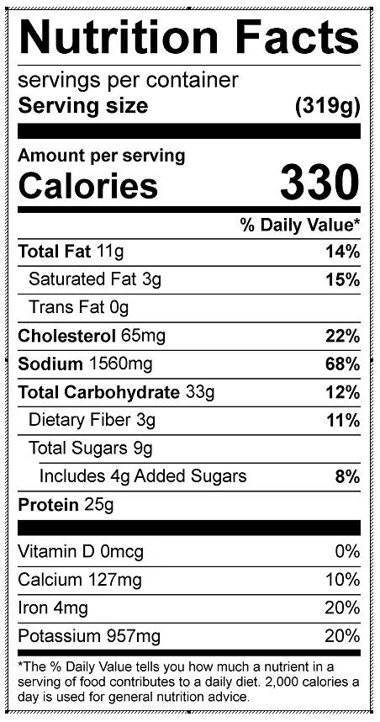

Vitamin C: 49 mg