Jersey Disco Fries
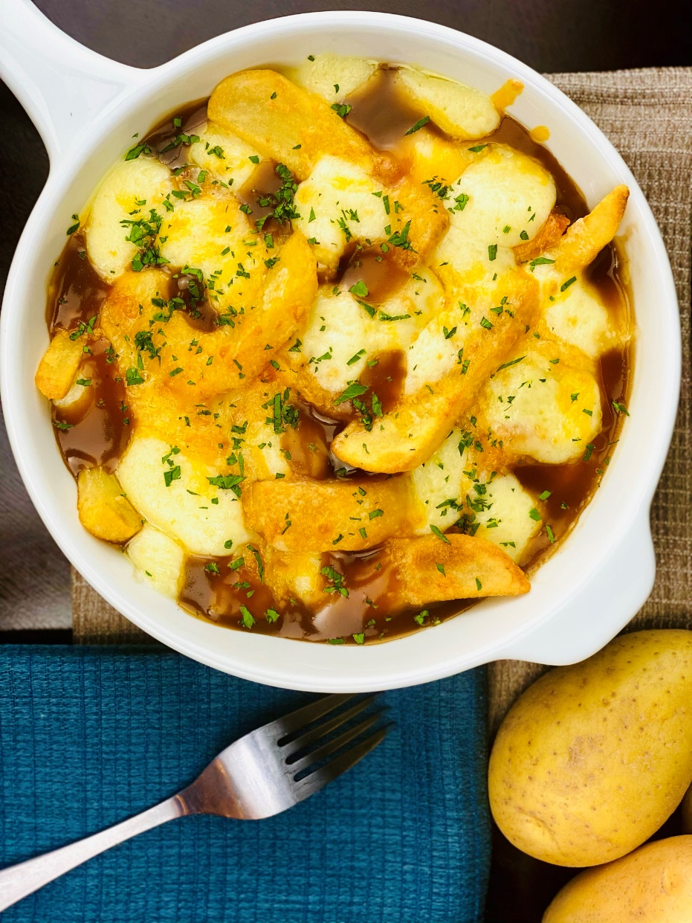
Description: Crispy fries covered in brown gravy and topped with melted mozzarella cheese and fresh herbs.
Servings: 8
Preparation Time: 10 minutes
Cooking Time: 30 minutes
Total Time: 40 minutes
Potato Type: Frozen Steak Cut Fries
Course: Entrée, Shareable Appetizer

Ingredients
For the Brown Gravy:
- 6 cups (1.44L) Beef Stock
- ¼ cup (37.5g) Shallots, chopped
- 2 each (10g) Garlic, chopped
- ½ cup (120ml) Unsalted Butter, melted
- ½ cup (120g) All Purpose Flour
- 1 tablespoon Worcestershire Sauce
- 2 teaspoons (7g) Sea Salt
- ½ tablespoon (8g) Freshly Ground Black Pepper
For the Steak Cut Fries:
- 2.2 lbs. (1kg) Frozen Steak Cut Fries
- As Needed Vegetable Oil for Frying
- 2 teaspoons (8g) Sea Salt
To Plate Up:
- 8 ounces (240g) Shredded Part Skim Mozzarella
- 2 tablespoons (3g) Italian Parsley, chopped
- ½ teaspoon (1g) Fresh Thyme, chopped

Preparation
- To prepare the gravy, melt the butter in a large saucepan. Add the shallot and garlic and sauté for 2-3 minutes. Season with salt and pepper. Add the flour and stir to combine. Slowly whisk in the beef stock and add in the Worcestershire sauce. Bring the sauce to a boil and allow it to simmer for 8-10 minutes. Remove from the heat and keep warm until ready to use.
- To prepare the fries, heat the oil to 375 °F (190 °C) drop the fries into the oil and cook for 4-6 minutes or until golden brown and crispy. Drain the fries and transfer them to a bowl. Season them with salt. Arrange the fries on an oven proof serving platter or plate.
- Cover the fries in the gravy and top with the shredded cheese. Place the fries under a broiler until the cheese is melted and just beginning to get brown in spots. Remove from the oven and garnish with the chopped herbs. Serve immediately. Enjoy!
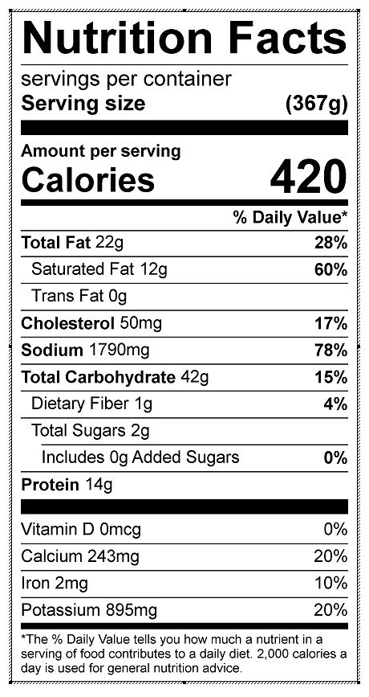
Vitamin C: 10.86 mg

