Jamaican Jerk Chicken Fries
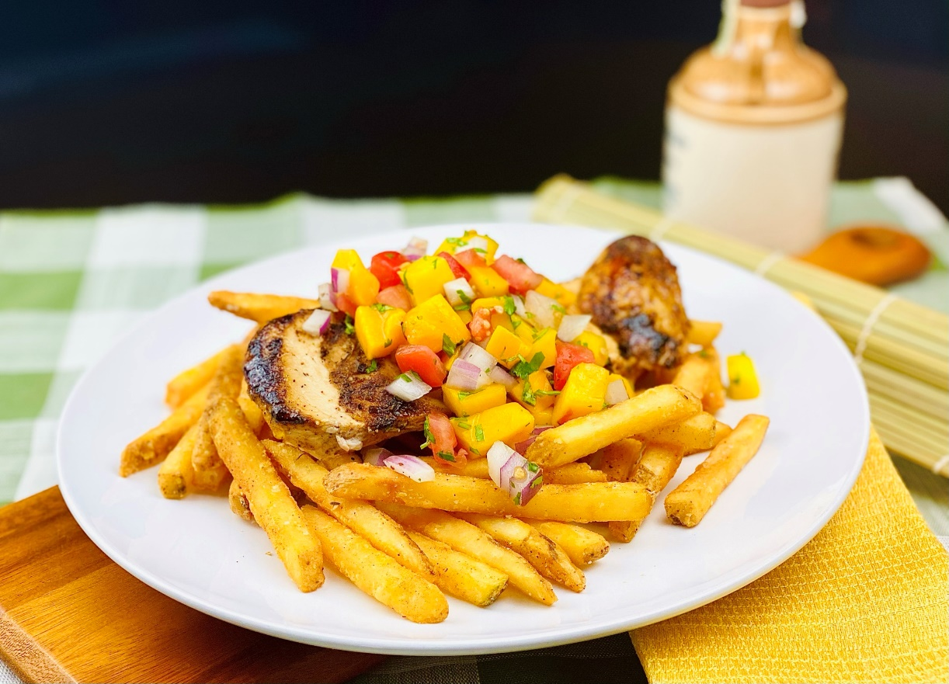
Description: Fragrant and spicy grilled Jamaican jerk chicken with mango salsa served on top crispy straight cut fries seasoned with jerk seasoning.
Servings: 8
Preparation Time: 140 minutes
Cooking Time: 45 minutes
Total Time: 185 minutes
Potato Type: Frozen Straight Cut Fries
Course: Entrée, Shareable Appetizer

Ingredients
For the Jerk Chicken:
- ¾ cup (105g) Yellow Onions, chopped 1/4 -inch
- ¾ cup (105g) Green Onions, chopped
- 2 each (6g) Habanero Peppers, sliced
- 2 each (10g) Garlic Cloves, chopped
- 1 tablespoon (8g) Five Spice Powder
- 1 tablespoon (8g) Jamaican Allspice Berries, ground
- 1 tablespoon (8g) Freshly Ground Black Pepper
- 1 teaspoon (2g) Dried Thyme
- 1 teaspoon (1g) Freshly Grated Nutmeg
- 1 teaspoon (4g) Sea Salt
- ½ cup (120ml) Soy Sauce
- 1 tablespoon (15ml) Vegetable Oil
- 3-1/2 lbs. (1.6kg) Whole Chickens, quartered
For the Mango Salsa:
- 2 cups (300g) Mango, diced ½-inch cubes
- ½ cup (75g) Roma Tomatoes, diced ½-inch cubes
- 1/2 cup (75g) Red Onion, diced ¼-inch pieces
- ¼ cup (4g) Cilantro, chopped
- 1 teaspoon (4g) Sea Salt
- 1 tablespoon (15ml) Honey
- 1 tablespoon (15ml) Lime Juice
For the Straight Cut Fries:
- 2.2 lbs. (1kg) Frozen Straight Cut Fries
- As Needed Vegetable Oil for Frying
- 2 teaspoons (8g) Sea Salt
- 1 tablespoon (8g) Jamaican Jerk Seasoning Powder

Preparation
- To prepare the chicken, combine the onions, scallions, peppers, garlic, five spice powder, allspice, pepper, thyme, nutmeg, and salt in a blender. Pulse until a thick paste is formed. Remove from the blender and transfer to a medium bowl. Whisk in the soy, and while whisking constantly drizzle in the oil. Place the chicken into a large resealable plastic bag. Pour the marinade over the chicken and allow it to marinate in the refrigerator for at least 2 hours but preferably overnight.
- Preheat a grill or a grill pan to medium high. Grill until the chicken is brown on all sides and the internal temperature reaches 165 °F (74 °C). Allow the chicken to rest while the fries and salsa are being prepared.
- For the salsa, combine the mangos, tomatoes, red onions, cilantro, salt, honey, and lime juice together in a medium sized bowl. Stir until everything is well incorporated and set aside until ready to use (can be done the day before).
- To prepare the fries, heat the oil to 375 °F (190 °C) drop the fries into the oil and cook for 4-6 minutes or until golden brown and crispy. Drain the fries and transfer them to a bowl. Season them with the salt and the jerk seasoning powder. Arrange the fries on a serving platter or plate.
- Slice the chicken, taking it off the bone if desired. Top the chicken with the mango salsa. Serve immediately. Enjoy!
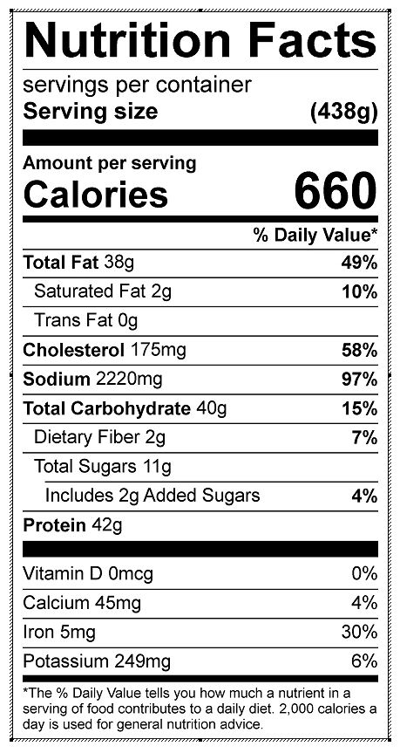
Vitamin C: 26.70 mg

