**Garlicky Greek Fries**

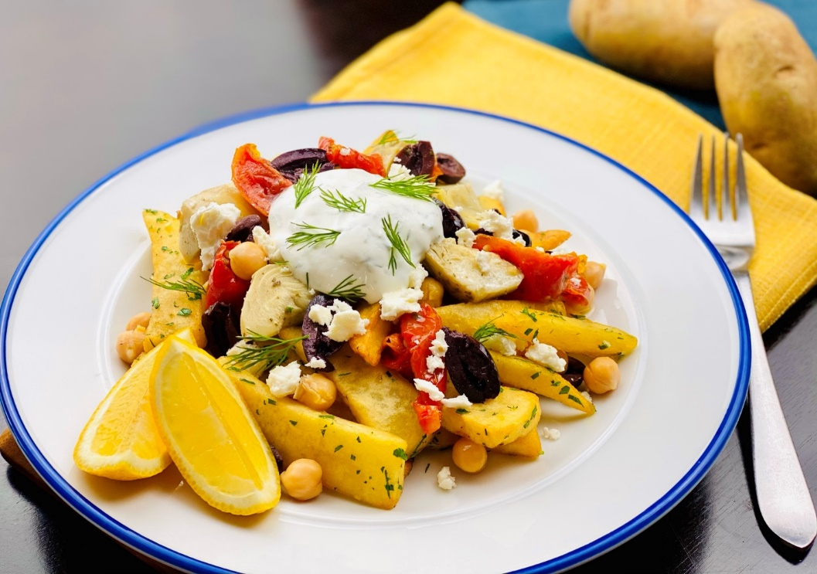

**Description:** Steak cut fries seasoned with garlic and parsley before being topped with kalamata olives, roasted tomatoes, artichoke hearts, feta cheese, chickpeas, and a lemon yogurt sauce.

**Servings:** 12

**Preparation Time:** 15 minutes

**Cooking Time:** 10 minutes

**Total Time:** 25 minutes

**Potato Type:** Frozen Steak Cut Fries

**Course:** Entrée, Shareable Appetizer

**Ingredients**

*Lemon Yogurt Sauce:*

* 1 cup (240ml) Plain Greek Yogurt
* 2 tablespoons (30ml) Lemon Juice
* 2 tablespoons (2g) Fresh Dill, chopped
* 2 tablespoons (2g) Fresh Mint, chopped
* 1 teaspoon (1g) Cumin
* 2 each (10g) Garlic Cloves, chopped
* ½ teaspoon (2g) Sea Salt
* 1 teaspoon (4g) Freshly Ground Black Pepper

*Steak Cut Fries:*

* 2.2 lbs. (1kg) Frozen Steak Cut Fries
* As Needed Vegetable Oil for Frying
* 2 teaspoons (8g) Sea Salt
* 1 tablespoon (15g) Chopped Garlic
* 1 tablespoon (2g) Italian Parsley, chopped

*To Plate:*

16 ounces (453g) Marinated Artichoke Hearts

16 ounces (453g) Roasted Marinated Tomatoes

1 cup (240g) Canned Chickpeas, drained

8 ounces (227g) Kalamata Olives

8 ounces (227g) Feta Cheese, crumbled

As Needed Lemon Wedges (optional)

**Preparation**

1. To make the yogurt sauce, combine the yogurt, lemon juice, cumin, dill, mint, garlic, salt and pepper. Hold the sauce in the refrigerator until ready to use.
2. To fry the fries, drop the fries into preheated 375 °F (190 °C) oil. Cook the fries for 4-6 minutes or until they are golden brown and crispy. Drain the fries and transfer them into a bowl, season the fries with the salt, garlic, and parsley then toss to combine.
3. Arrange the fries on a plate, and garnish with the artichoke hearts, tomatoes, chickpeas, olives, and feta cheese.
4. Spoon some of the lemon yogurt dressing over the fries and garnish with a lemon wedge if desired. Serve immediately. Enjoy!

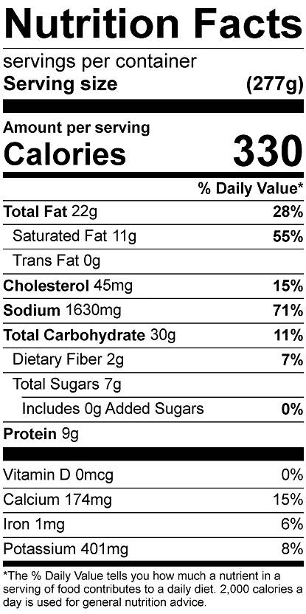

Vitamin C: 11 mg

**Notes**

* The nutritionals are based on this recipe being an entree. If sharing as an appetizer, the nutritionals can be divided by the number of people you're sharing it with.