**Forager Fries**

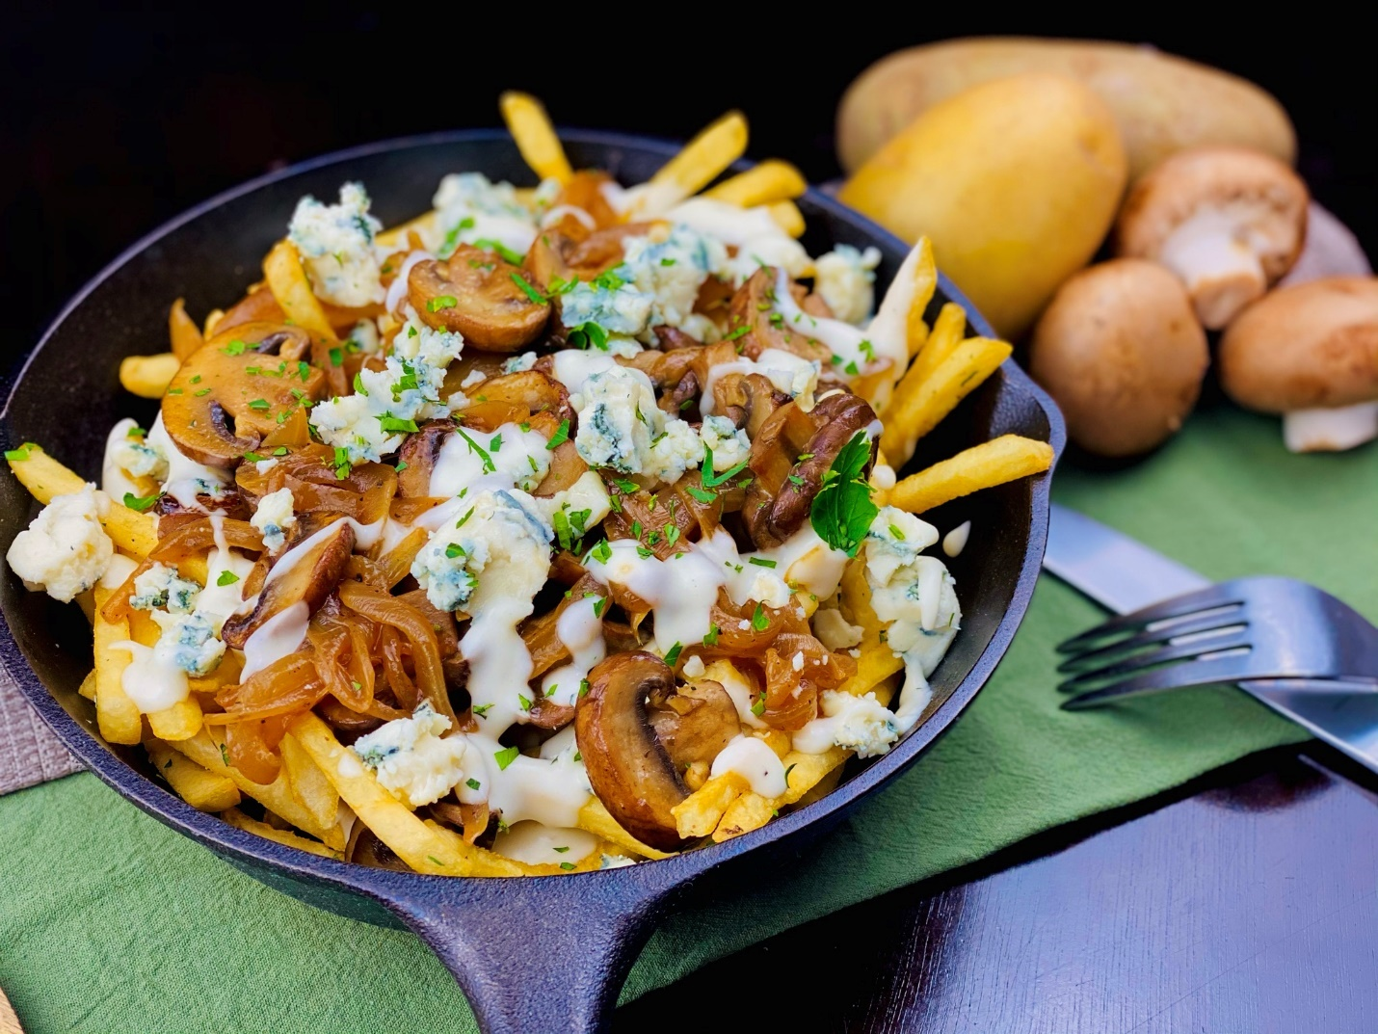

**Description:** Crisp shoestring fries, topped with caramelized onions, sauteed mushrooms, and blue cheese fondue.

**Servings:** 8

**Preparation Time:** 20 minutes

**Cooking Time:** 55 minutes

**Total Time:** 75 minutes

**Potato Type:** Frozen Shoestring Fries

**Course:** Entrée, Shareable Appetizer

**Ingredients**

*For the Caramelized Onions:*

* 2.2 pounds (1 kg) Yellow Onions, sliced thin
* 2 tablespoons (30g) Unsalted Butter
* 2 teaspoon (4g) Sea Salt

*For the Sauteed Mushrooms:*

* 1 pound (453g) Cremini (crimini) Mushrooms, sliced
* 2 tablespoons (30g) Unsalted Butter
* 1 teaspoon (4g) Sea Salt
* ½ teaspoon (1g) Fresh Thyme, chopped
* ½ teaspoon (5ml) Truffle Oil or Truffle Butter

*For the Blue Cheese Fondue:*

* 3 tablespoons (45g) Unsalted Butter
* 3 tablespoons (45g) All Purpose Flour
* 2 cups (480ml) Half and Half
* 2 teaspoons (8g) Sea Salt
* 4 ounces (113g) Blue Cheese, crumbled

*For the Shoestring Fries:*

* 2.2 pounds (1kg) Frozen Shoestring Fries
* As Needed Vegetable Oil for Frying
* 2 teaspoons (8g) Sea Salt
* 2 teaspoons (8g) Freshly Ground Black Pepper

*To Plate Up:*

4 ounces (113g) Blue Cheese, crumbled

**Preparation**

1. To prepare the caramelized onions, melt the butter in a heavy bottomed shallow pan over medium heat. Add the onions and season with salt. Continue to cook the onions, stirring regularly until the onions are deep brown and caramelized. Remove from the heat and set aside until ready to use.
2. To sauté the mushrooms, slice the mushrooms and heat the butter in a large sauté pan over medium high heat. Add the sliced mushrooms and cook until they are golden brown, season with the sea salt and thyme. Drizzle with the truffle oil or truffle butter and keep the mushrooms warm until ready to use.
3. To make the blue cheese fondue, heat the butter in a medium saucepan, when the butter is melted, add the flour and cook it over medium high heat for 2-3 minutes. Whisk in the half and half, as well as the salt and stir constantly over the heat until the sauce is thick and smooth. Remove from the heat, and stir in the blue cheese. Keep the sauce warm until ready to use.
4. To fry the fries, drop the fries into preheated 375 F (190 C) oil. Cook the fries for 4-6 minutes or until they are golden brown and crispy. Drain the fries and transfer them into a bowl, season the fries with the salt then toss to combine.
5. To plate up, arrange the fries in the bottom of a platter or cast iron skillet. Top the fries with the caramelized onions and sauteed mushrooms. Drizzle the fries with the blue cheese fondue and top with the crumbled blue cheese. Serve immediately.
6. Enjoy!

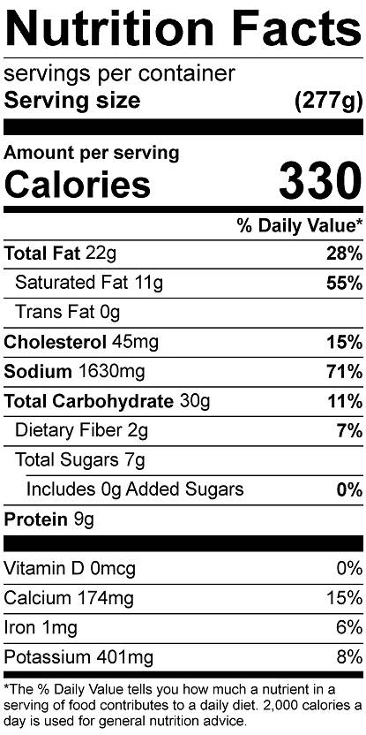

Vitamin C: 6.57 mg