Cuban Mojo Pork Fries
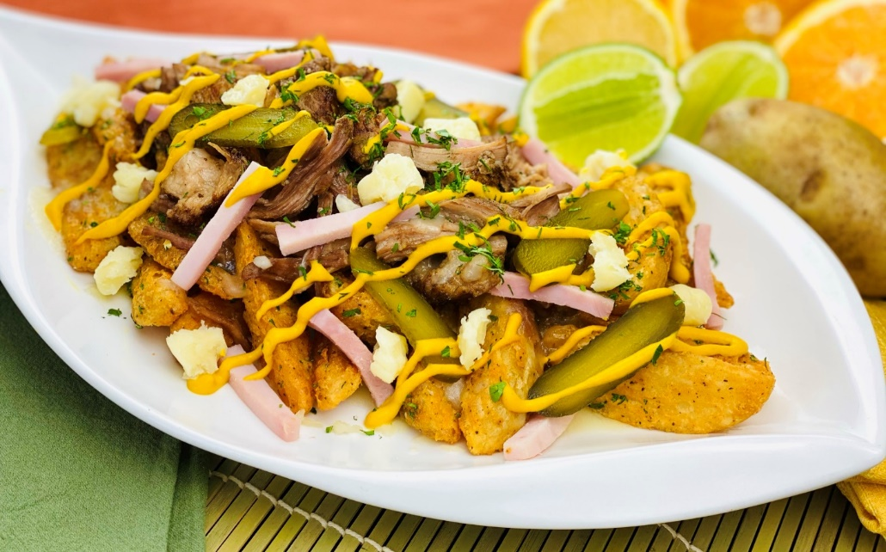
Description: Batter wedge cut fries, topped with pulled pork in a citrus garlic marinade, cured ham, pickles, swiss and yellow mustard.
Servings: 12
Preparation Time: 30 minutes
Cooking Time: 240 minutes
Total Time: 270 minutes
Potato Type: Frozen Wedge Cut Fries
Course: Entrée, Appetizer

Ingredients
Mojo Pork:
- 4.4 lbs. (2 kg) Pork Shoulder, bone in
- ¼ cup (60ml) Orange Juice
- ¼ cup (60ml) Lime Juice
- 2 teaspoons (2g) Cumin
- 2 teaspoons (2g) Dried Oregano
- ¼ teaspoon (1g) Crushed Red Pepper Flakes
- 4 each (20g) Garlic Cloves, chopped
Wedge Cut Fries:
- 2.2 lbs. (1kg) Frozen Waffle Fries
- As Needed Vegetable Oil for Frying
- 2 teaspoons (8g) Sea Salt

To Plate:
8 ounces (227g) Cured Ham, cut into small batons
8 ounces (227g) Swiss Cheese, torn into small pieces
4 ounces (113g) Sliced Dill Pickles
¼ cup (60ml) Yellow Mustard
2 tablespoons (1g) Fresh Cilantro, chopped

Preparation
- Score the pork shoulder in a hatch pattern with a sharp knife.
- Combine the orange juice, lime juice, cumin, oregano, red pepper flakes, and chopped garlic cloves. Pour the marinade over the pork and allow it to marinate over night, turning once to redistribute the marinade.
- Adjust oven rack to lower-middle position and preheat oven to 275°F (135 °C). Line a rimmed baking sheet with a double layer of heavy-duty aluminum foil. Place pork and juices on top and fold up foil, crimping to seal loosely but making sure that there is room for air to circulate inside. Place in oven and roast for 3 hours. Fold back foil, increase oven temperature to 325°F (163 °C), and continue roasting, basting pork with pan juices occasionally, until pork shows almost no resistance when a metal skewer or knife is inserted into it and the surface is crackly and brown, 2 to 3 hours longer. Remove pork from oven and let rest for 10 to 15 minutes.
- Shred the pork and toss in the residual marinade that is in the roasting pan.
- To fry the fries, drop the fries into a preheated fryer set to 375 °F (190 °C). Cook the fries for 4-6 minutes or until they are golden and crispy.
- Drain the fries and transfer them to a bowl. Season the fries with salt and arrange them on a platter.
- Top the fries with the shredded pork. Top the pork with the ham, cheese, pickles, and a drizzle of yellow mustard. Garnish the fries with the chopped cilantro. Enjoy!
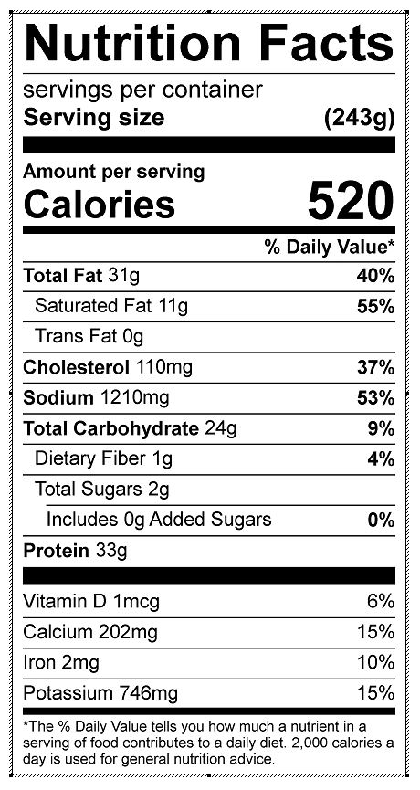
Vitamin C: 6.26 mg

