**Clam Chowder Fries**

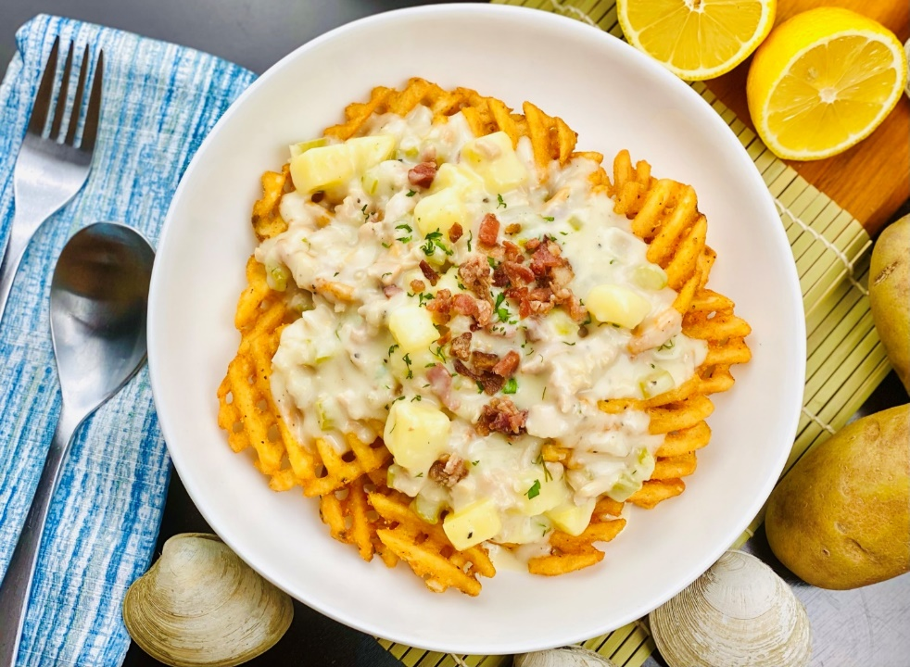

**Description:** Crispy waffle fries, smothered in piping hot, creamy clam chowder.

**Servings:** 12

**Preparation Time:** 30 minutes

**Cooking Time:** 75 minutes

**Total Time:** 105 minutes

**Potato Type:** Frozen Waffle Fries

**Course:** Entrée, Appetizer

**Ingredients**

*Clam Chowder:*

* ¼ lb. (113g) Bacon (Hickory, Applewood, or Cherrywood Smoked), diced
* 2 tablespoons (30g) Unsalted Butter
* ¾ cup (112g) Onions, diced ¼ inch
* ½ cup (75g) Celery, diced ¼ inch
* 2 each (10g) Garlic Cloves, chopped fine
* ¼ cup (60g) All Purpose Flour
* 1 quart (960ml) Clam Juice
* 3x 6.5ounce cans (552g) Canned Clams
* ¾ cup Heavy Cream
* ½ lb. (227g) Yellow Potatoes, peeled and diced ½ inch cubes
* 1 teaspoon (10ml) Tabasco Sauce
* 2 tablespoons (4g) Fresh Dill, chopped
* ¼ cup (15g) Fresh Chives, chopped
* 1 tablespoon (2g) Lemon Zest
* 2 tablespoons (30ml) Freshly Squeezed Lemon Juice
* 1 tablespoon (8g) Sea Salt
* ½ tablespoon (4g) Freshly Cracked Black Pepper

*Waffle Fries:*

* 2.2 lbs. (1kg) Frozen Waffle Fries
* As Needed Vegetable Oil for Frying
* 2 teaspoons (8g) Sea Salt

**Preparation**

1. To prepare the chowder, begin by heating a large pot over medium heat.
2. Add the bacon and render the fat until the bacon is crispy. Remove the bacon pieces and reserve. Add the butter to the bacon fat and sauté the onions, celery, and garlic until the onions are translucent. Add the flour and stir until well combined, continue to cook for 2-3 minutes this will remove the raw flour taste.
3. Add the clam juice, and stir until the soup is smooth.
4. Add the clams and any reserved liquid that comes with them, then stir in the heavy cream. Bring this to a simmer, then add the potatoes. Continue to cook this for 15-20 minutes or until the potatoes are tender.
5. Season the chowder with the tabasco sauce, dill, chives, lemon zest, lemon juice, salt and pepper. Keep the soup hot until ready to serve.
6. To fry the fries, drop the waffle fries in the oil preheated to 375 °F (190 °C), cook the fires for 4-6 minutes or until the fries are golden and crispy.
7. Drain the fries well and transfer them to a large bowl, season the fries with the sea salt and toss to combine. Arrange the fries on the bowl of a serving bowl and ladle some of the chowder on top of the fries. Sprinkle the top of the dish with some of the reserved bacon from earlier. Serve immediately. Enjoy!

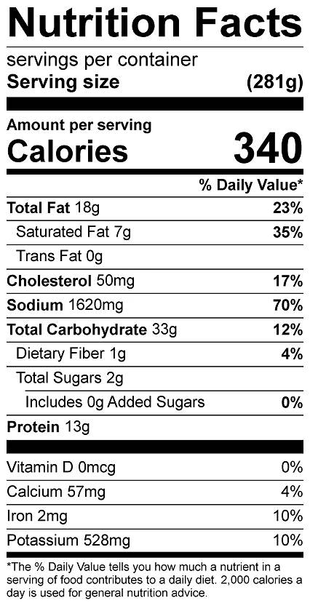

Vitamin C: 9.5mg