**Chili Lime Enchilada Potato Bites**

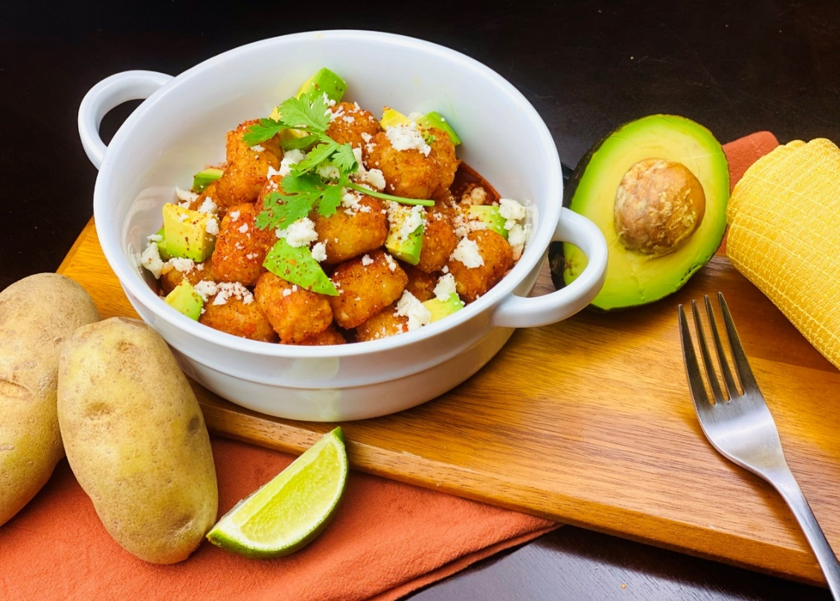

**Description:** Chili lime seasoned potato hash browns, on a bed of smoky enchilada sauce, garnished with avocado, cotija cheese, and cilantro.

**Servings:** 8

**Preparation Time:** 20 minutes

**Cooking Time:** 45 minutes

**Total Time:** 65 minutes

**Potato Type:** Frozen tater barrels

**Course:** Entrée, Shareable Appetizer

**Ingredients**

*Enchilada Sauce:*

* 2 tablespoons (30ml) Olive Oil
* 2 tablespoons (30g) All Purpose Flour
* ¼ cup (20g) Chili Powder
* ½ teaspoon (2g) Garlic Powder
* ½ teaspoon (2g) Ground Cumin
* ¼ teaspoon (1g) Dried Oregano
* 2 cups (480ml) Chicken Stock
* 2 teaspoons Sea Salt

*Chili Lime Hash Brown Bites:*

* 2.2 lbs. (1kg) Frozen Tater Barrels
* As Needed Vegetable Oil for Frying
* 2 teaspoons (8g) Chili Lime Seasoning

*To Plate:*

* 1 cup (240ml) Cotija Cheese, crumbled
* 1-½ cups (225g) Avocado, diced
* ¼ cup (4g) Cilantro, picked

**Preparation**

1. Heat the oil in a medium saucepan over medium-high heat. Add the flour and cook for 1-2 minutes while stirring constantly. Add in the spices and oregano and cook for an additional minute.
2. Add in the stock and allow the sauce to come to a simmer for 15 minutes. Adjust the seasoning and keep warm.
3. To fry the hash brown bites, fry them at 375 °F (190 °C) until they are crisp and golden brown. Drain the potatoes and place into a bowl, season them with the chili lime seasoning.
4. To plate up, spoon some of the enchilada sauce into the bottom of a serving dish. Arrange the potatoes on the sauce and garnish with the diced avocado, cilantro and cotija cheese. Enjoy!

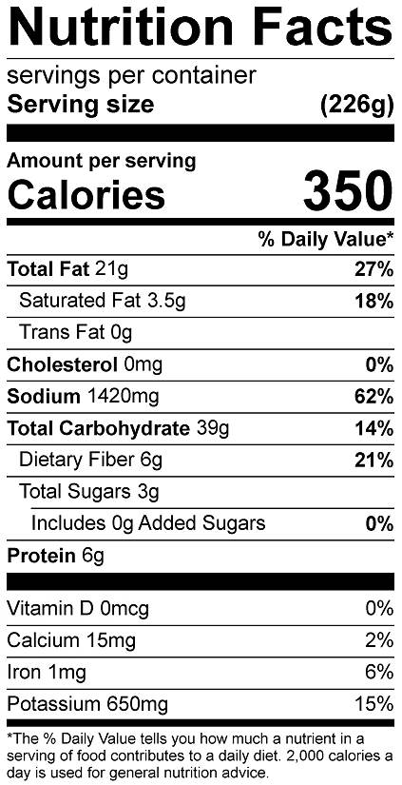

Vitamin C: 3.07mg