Teriyaki Chicken Loaded Fries
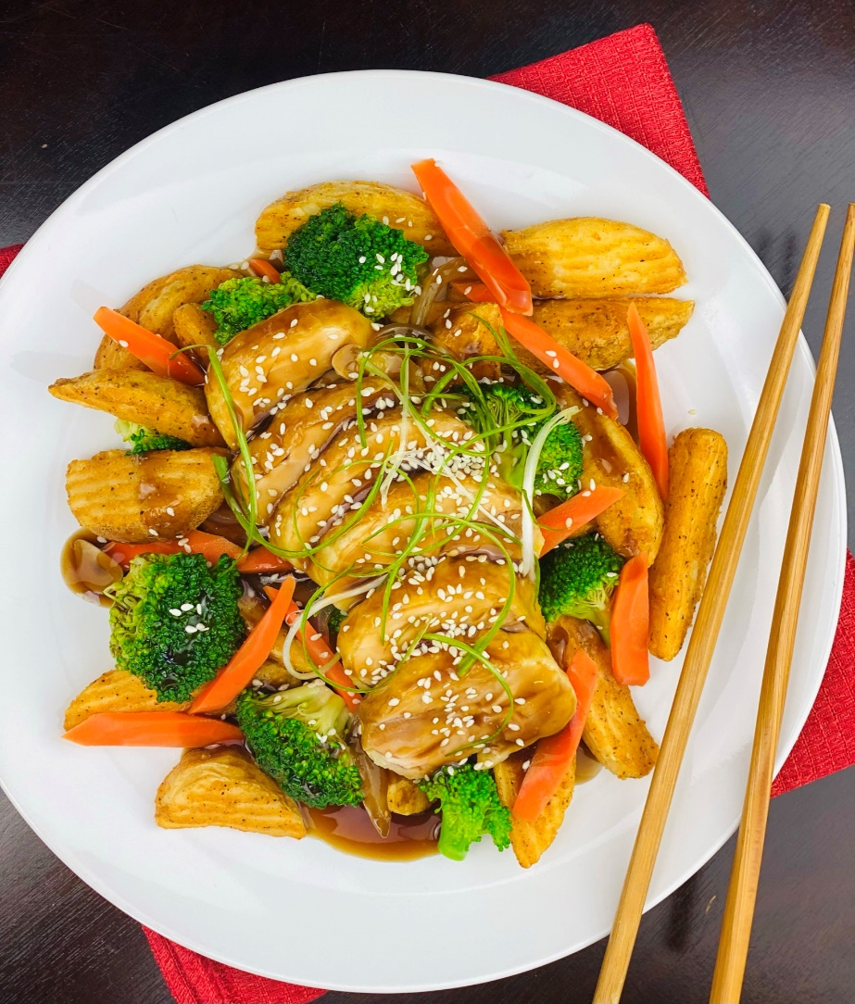
Description: Juicy pieces of roasted chicken thighs glazed with a sweet teriyaki sauce on top a bed of crispy potato wedges, carrots, and broccoli.
Servings: 12
Preparation Time: 30 minutes
Cooking Time: 30 minutes
Total Time: 60 minutes
Potato Type: Frozen potato wedges
Course: Entrée, Shareable Appetizer

Ingredients
For the Chicken Thighs:
- 3 lbs. (1.36 kg) Bone In Chicken Thighs (Boneless, Skinless can be subbed)
- 1 tablespoon Kosher Salt
- 2 teaspoon Ground White Pepper
For the Stir-Fried Vegetables:
- 1 tablespoon Peanut Oil (Vegetable or Canola Oil can be subbed)
- 1 lb. (454g) Broccoli Florets
- 1 lb. (454g) Carrots, cut on the bias into half moons
For the Potato Wedges
- As Needed Vegetable Oil for Frying
- 2.2 lbs. (1 kg) Frozen Potato Wedges
- 1 tablespoon Sea Salt
To Plate:
- 1 cup (240 ml) Teriyaki Sauce
- 1 tablespoon (2g) White Sesame Seeds
- ¼ cup (4g) Green Onions, sliced

Preparation
- Preheat the oven to 425 °F (218 °C), de-bone the chicken thighs, leaving the skin intact. Season the inside of the chicken thighs where the bone was with salt and white pepper. Roll the chicken thighs into little cylinders and place skin side up on a sheet pan lined with a silpat or aluminum foil. Roast the chicken for 25 minutes or until the skin is crispy and the chicken reaches an internal temperature of 165 °F. Remove from the oven and allow the chicken to rest for 5-7 minutes before slicing.
- In a large pot bring some water to a boil, enough water to blanch the broccoli and carrots. When the water reached a full boil add the carrots, and cook for 5 minutes. Add the broccoli and cook for an additional 1-2 minutes. Remove the vegetables from the boiling water and immediately place into an ice water bath, this will stop the cooking process. Drain the vegetables very well and set aside until you are ready to stir fry them.
- To stir fry the vegetables, heat the sesame oil in a large saute pan or a wok over high heat. Add the blanched vegetables and stir constantly for about 2-3 minutes.
- Heat the teriyaki sauce and keep warm.
- To fry the potato wedges, fry the wedges in the vegetable oil preheated to 375 °F (190 °C) for 4-6 minutes or until they are golden brown and crispy. Drain the wedges and place them into a large bowl. Season them with the salt and toss to combine. Arrange the wedges on a platter.
- Top the wedges with the stir-fried vegetables, and the sliced pieces of chicken. Ladle the teriyaki sauce over the chicken and vegetables and garnish with the sesame seeds and green onions. Serve immediately. Enjoy!
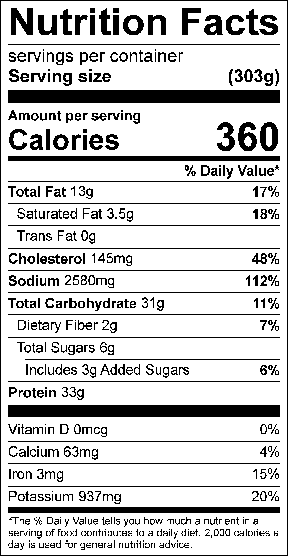
Vitamin C: 47.17mg

