Chicken Korma Hash Brown Bites
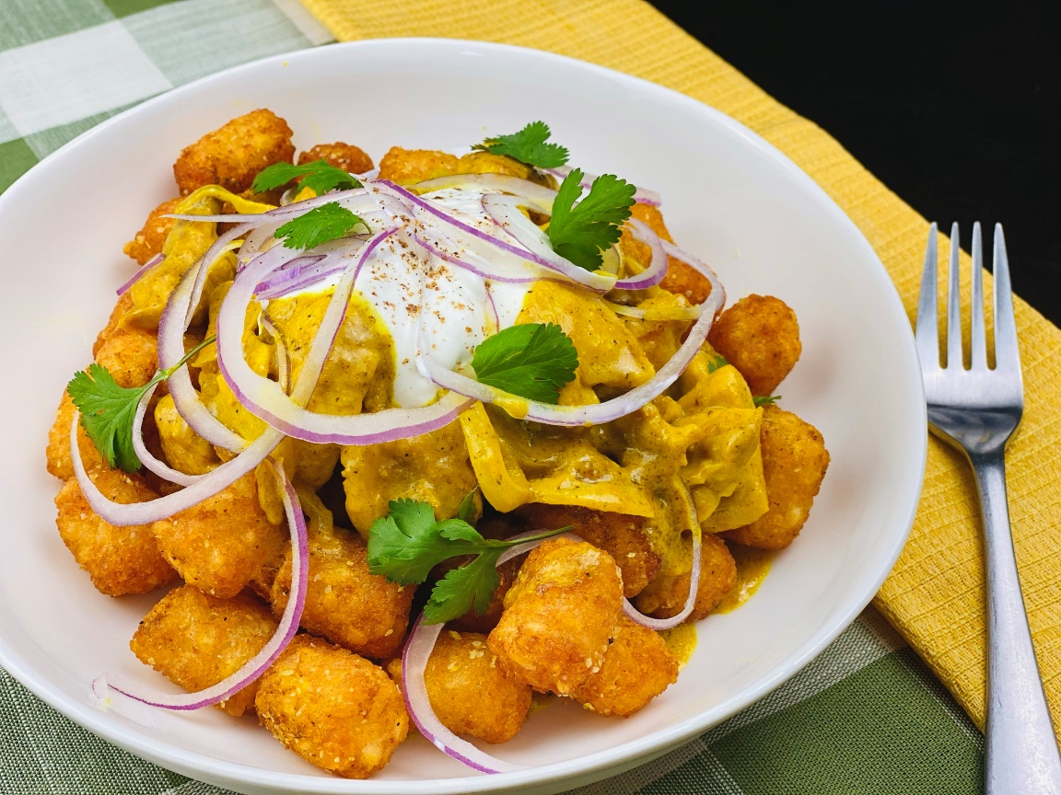
Description: Crispy curry seasoned hash brown bites topped with fragrant chicken korma, cool yogurt and thinly sliced onions.
Servings: 8
Preparation Time: 20 minutes
Cooking Time: 45 minutes
Total Time: 65 minutes
Potato Type: Frozen tater barrels
Course: Entrée, Appetizer

Ingredients
Chicken Korma Marinade:
- 2 lbs. (960g) Boneless chicken thighs, chopped into bite sized pieces
- ½ cup (120g) Cashews, lightly chopped
- 3 tablespoons (45g) Tomato Paste (optional)
- 4 each (20g) Cloves Garlic, chopped
- 1 tablespoon (15g) Fresh Ginger, grated
- 1 tablespoon (4g) Garam Masala
- 1 teaspoon (2g) Crushed Red Pepper Flakes
- 1 teaspoon (2g) Paprika
- 1 teaspoon (2g) Turmeric
- 1 teaspoon (2g) Ground Coriander
- ½ teaspoon (1g) Ground Cardamom
- ½ teaspoon (1g) Ground Cumin
- ½ teaspoon (1g) Ground Cinnamon
- 2 teaspoons (8g) Sea Salt
- 1 teaspoon (4g) Freshly Ground Black Pepper
- 1 cup (240ml) Plain Yogurt
To finish the korma:
- 1 tablespoon olive oil
- 1 medium onion, chopped
- ½ cup chicken stock
- 1 cup heavy cream (Coconut Milk can be subbed)
Curry Hash Brown Bites:
- 2.2 lbs. (1kg) Frozen Tater Barrels
- As Needed Vegetable Oil for Frying
- 2 teaspoons (8g) Curry Powder
- 2 teaspoons (8g) Sea Salt
To Plate:
- 1 cup (240ml) Plain Yogurt
- ½ cup (75g) Red Onion, thinly sliced
- ¼ cup (4g) Cilantro, picked

Preparation
- To make the korma marinade, add the cashew nuts to a food processor and pulse to break them up. Add the tomato paste, garlic, ginger, and seasonings. Add salt and pepper to taste and pulse to form a thick paste. If it is too thick, add a couple tablespoons of water to thin it just slightly. Add the yogurt and blend to combine. Remove from the food processor and mix with the chicken. Allow the chicken to marinate over night and up to 3 days.
- To prepare the korma, heat the oil in a large pan. Add the peppers and onion and cook them down for 5 minutes to soften. Add the chicken with all the marinade (Korma sauce) along with the chicken stock. Stir and cook for 15 minutes, stirring here and there. Stir in the heavy cream or coconut milk and simmer for 10 more minutes. Hold the chicken korma warm until ready to plate.
- To cook the hash brown bites, heat a fryer to 375 °F (190 °C). Fry the tater barrels for 4-6 minutes or until they are golden and crispy. Removed from the oil and allow to drain, transfer the barrels to a bowl and season them with the curry powder and sea salt.
- To plate arrange the potatoes in the bottom of a serving bowl. Top with the chicken korma and a spoonful of yogurt. Garnish the dish with the thinly sliced onions and cilantro. Enjoy!
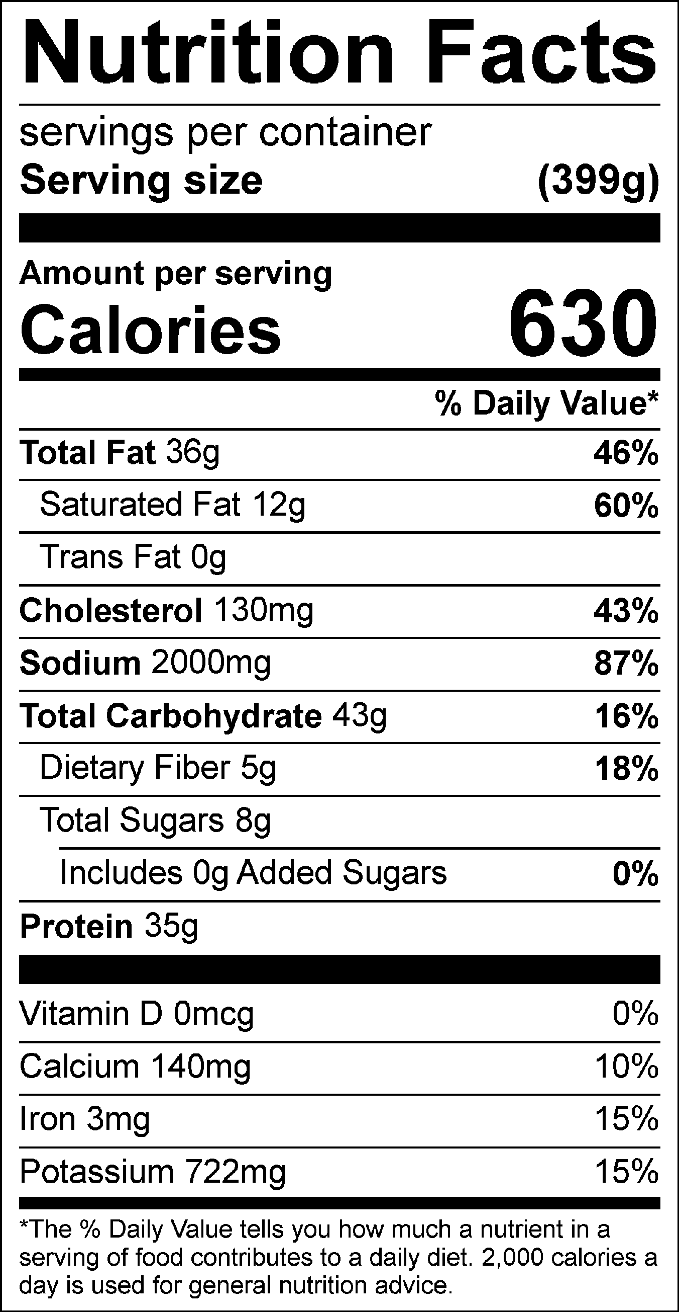
Vitamin C: 3.73mg

