Chicago Giardiniera Loaded Fries
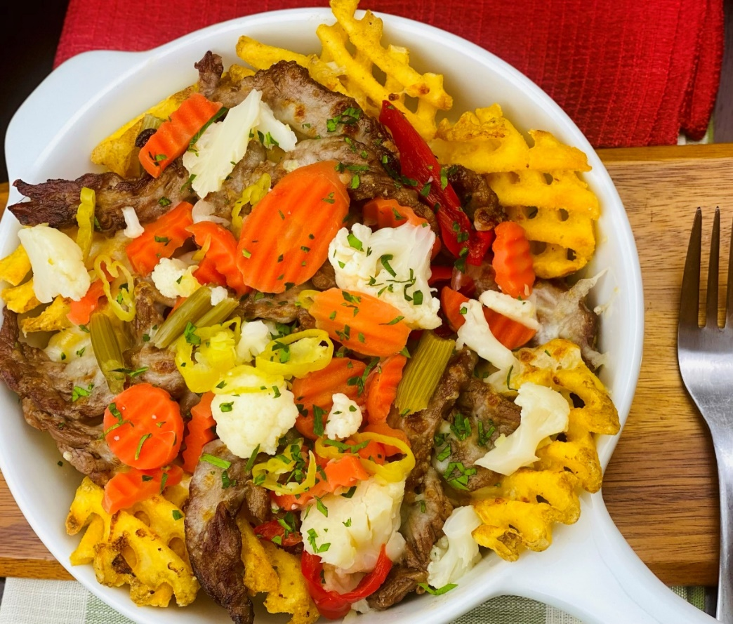
Description: Tender, shredded beef in au jus on top of crispy waffle fries with melted provolone cheese and pickled spicy vegetables.
Servings: 12
Preparation Time: 30 minutes
Cooking Time: 240 minutes
Total Time: 270 minutes
Potato Type: Frozen Waffle Fries
Course: Entrée, Shareable Appetizer

Ingredients
For the Shredded Beef:
- 3.5 lbs. (1.59kg) Beef Chuck Roast or Top Sirloin
- 3 tablespoons (20g) Kosher Salt (Sea Salt can also be subbed)
- 2 tablespoons (7g) Freshly Ground Black Pepper
- 2 tablespoons (30ml) Olive Oil
- ¾ cup (120g) Yellow Onion, sliced
- 1 tablespoon (3g) Italian Seasoning
- 2 teaspoons (1g) Crushed Red Pepper Flakes
- 6 each (30g) Garlic Cloves, chopped
- ½ cup (120ml) Dry Red Wine (Cabernet Sauvignon, Pinot Noir, Merlot, etc.)
- 3 cups (720ml) Beef Stock
- 2 each (2g) Fresh Thyme Sprigs
For the Waffle Fries:
- 2.2 lbs. (1kg) Frozen Waffle Fries
- As Needed Vegetable Oil for Frying
- 2 teaspoons (8g) Sea Salt
- 2 teaspoons (8g) Freshly Ground Black Pepper
To Plate:
- 8 ounces (226g) Sliced Provolone
- 4 ounces (113g) Giardiniera Vegetables (Prepared)

Preparation
- To prepare the beef, preheat the oven to 300 °F (149 °C).
- Liberally sprinkle the chuck roast or top sirloin with salt and pepper.
- Heat the vegetable oil in an enamel Dutch oven or large heavy bottomed pot/roasting pan.
- Brown the roast on all sides until all the sides are caramelized.
- Remove the roast and in the rendered fat sauté the onions, stirring occasionally until the onions are brown, this should take 8-10 minutes.
- Add the Italian seasoning and the crushed red pepper flakes, sauté this mixture for 2-3 more minutes. Add the garlic, and cook for 30 seconds.
- Deglaze with the red wine and allow the wine to reduce by half. Add the beef stock and thyme, then bring the liquid to a simmer. Adjust the seasoning if desired.
- Place the roast back in the pot and place in the oven. Cook the roast for 3-1/2 to 4 hours or until very tender. Allow the meat to rest for 20-30 minutes before shredding with two forks. Toss the meat in the reserved liquid in the pan and hold warm until ready to use.
- To fry the fries, preheat a fryer filled with vegetable oil to 375 °F (190 °C) drop the fires into the oil and allow them to cook for 4-6 minutes or until they are golden and crispy. Drain the fries and transfer to a large bowl.
- Season the fries with salt and pepper and toss to coat. Arrange the fries on a serving platter.
- Top the fries with the shredded beef, ensuring you get some of the broth with the beef. Top the beef with provolone and place under the broiler for 1-2 minutes or until the cheese is melted and bubbling. Remove from the oven and top with the Giardiniera vegetables. Serve immediately. Enjoy!
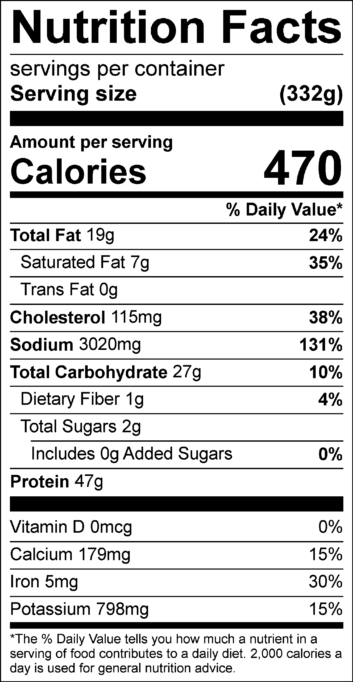
Vitamin C: 6.53mg

