Caramel Chocolate Turtle Sundae Loaded Fries
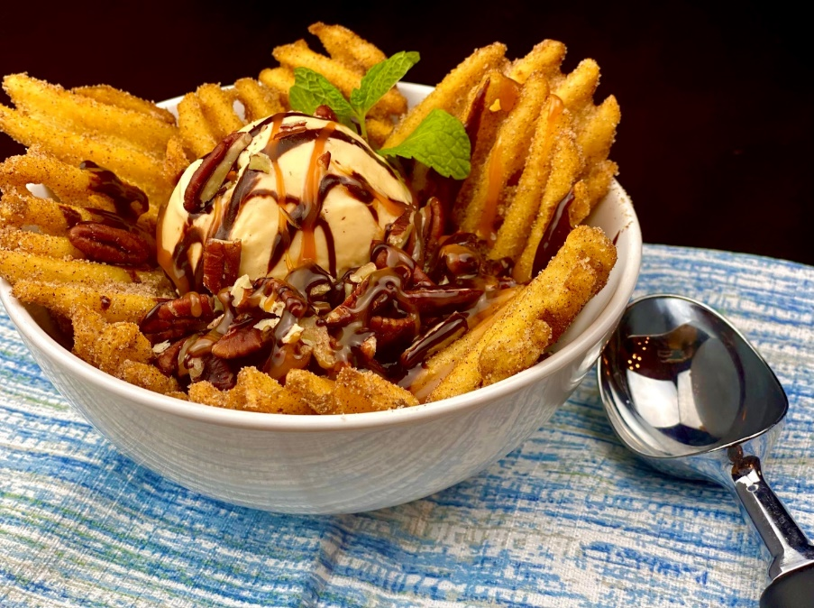
Description: Cinnamon and sugar-dusted waffle fries topped with vanilla ice cream, toasted pecans, sea salt caramel, and hot fudge.
Servings: 8
Preparation Time: 10 minutes
Cooking Time: 7 minutes
Total Time: 17 minutes
Potato Type: Frozen Waffle Fries
Course: Dessert

Ingredients
Waffle Fries:
- 2.2 lbs. (1kg) Waffle Fries
- As Needed Vegetable Oil for Frying
- 2 teaspoons (8g) Cinnamon
- ½ cup (120g) Granulated Sugar
To Plate:
- 4 cups (960ml) Vanilla Bean Ice Cream
- ½ cup (120ml) Hot Fudge (Warm Chocolate Sauce can be subbed)
- ½ cup Caramel Sauce
- 1 cup Chopped Toasted Pecans
- 8 each Mint Sprigs (optional)

Preparation
- Combine the sugar and the cinnamon in a small bowl.
- To fry the waffle fries, heat the oil to 375 F (190 C). lower the waffle fries into the hot oil and fry for 4-6 minutes or until golden and crispy. Drain the oil off the fries, and place it into a bowl. Season the potatoes with the cinnamon sugar, until they are well coated.
- To plate, arrange the cinnamon-sugar fries in the bowl of a bowl. Place a ½ cup scoop of ice cream on top of the fries, followed by the fudge, caramel sauce, and pecans.
- If desired garnish with a sprig of mint. Enjoy!
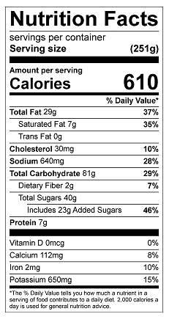
Vitamin C: 4 mg

