Cacio e Pepe Loaded Hash Brown Bites
Description: Crispy potato drums in a creamy pecorino cheese sauce with freshly cracked black pepper.
Servings: 8
Preparation Time: 20 minutes
Cooking Time: 10 minutes
Total Time: 30 minutes
Potato Type: Frozen Potato Drums
Course: Entrée, Shareable Appetizer

Ingredients
For the pecorino cheese sauce:
- 2 tablespoons (30ml) Extra Virgin Olive Oil
- 3 tablespoons (45g) All Purpose Flour
- 2 cups (480ml) Half and Half
- 1 cup (50g) Grated Pecorino Romano Cheese
- 1 tablespoon (12g) Freshly Ground Black Pepper (Coarse Grind)
For the potato drums:
- 2.2 pounds (1kg) Tater Barrels
- As Needed Vegetable Oil for Frying
- 2 teaspoons (8g) Sea Salt
To Plate:
- ½ cup (25g) Grated Pecorino Romano Cheese
- 1 tablespoon (12g) Freshly Cracked Black Pepper

Preparation
- To make the pecorino sauce, heat the olive oil in a medium saucepan over medium heat. Whisk in the flour and cook for 2-3 minutes. Carefully whisk in the half and half then bring to a boil while constantly stirring. Reduce the heat to a simmer and cook for an additional 2-3 minutes. Remove from the heat then stir in the grated pecorino cheese and black pepper. Keep warm until ready to use.
- To fry the tater barrels, heat the oil to 375 °F (190 °C). lower the tater barrels into the hot oil and fry for 4-6 minutes or until golden and crispy. Drain the oil off the tater barrels, and place into a bowl. Season the potatoes with the sea salt.
- To plate, spoons some of the sauce in the bottom of a serving dish. Nestle the potatoes on the sauce and spoon a little more sauce on top. Sprinkle the potatoes with some of the grated cheese and fresh cracked black pepper. Serve immediately. Enjoy!
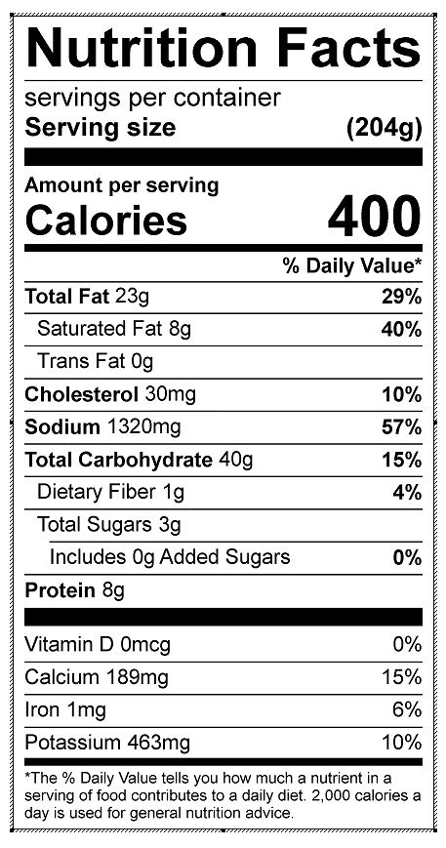
Vitamin C: 5.53 mg

