**Brazilian Steakhouse Fries**

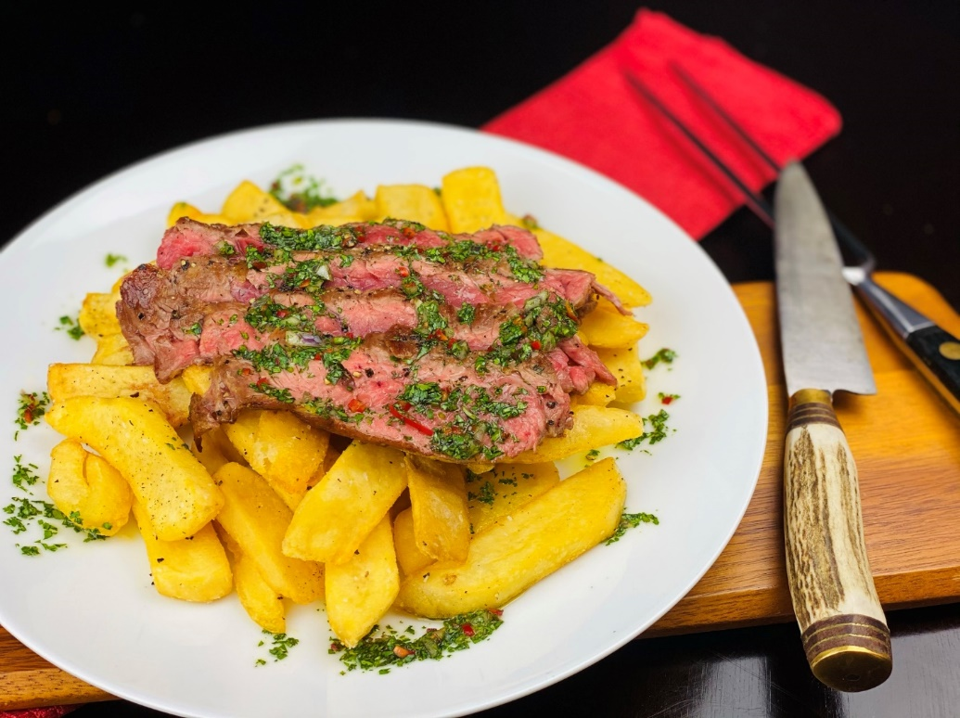

**Description:** A great way to enjoy “Meat and Potatoes”. Crispy steak cut fries, simply seasoned with salt and pepper. The fries are then topped with grilled skirt steak and drizzled with an Argentinian chimichurri.

**Servings:** 12

**Preparation Time:** 15 minutes

**Cooking Time:** 20 minutes

**Total Time:** 35 minutes

**Potato Type:** Frozen Steak Cut Fries

**Course:** Entrée, Appetizer

**Ingredients**

*Grilled Skirt Steak:*

* 2 lbs. (960g) Beef Skirt Steak
* 1 tablespoon (12g) Sea Salt
* 2 teaspoons (8g) Freshly Cracked Black Pepper

*Chimichurri:*

* 1 each (25g) Shallot, finely chopped
* 1 each (35g) Fresno Chili, finely chopped
* 4 each (20g) Garlic Cloves
* ½ cup (120ml) Red Wine Vinegar
* 1 teaspoon (4g) Sea Salt
* ½ cup (3g) Cilantro, freshly chopped
* ¼ cup (2g) Parsley, freshly chopped
* 2 tablespoons (1g) Oregano, freshly chopped
* ¾ cup (180ml) Extra Virgin Olive Oil

*Salt and Pepper Steak Cut Fries:*

* 2.2 lbs. (1kg) Frozen Steak Cut Fries
* As Needed Vegetable Oil for Frying
* 2 teaspoons (8g) Sea Salt
* 1-1/2 teaspoons (6g) Freshly Cracked Black Pepper

*To Plate:*

* 1 cup (240ml) Cotija Cheese, crumbled
* 1-½ cups (225g) Avocado, diced
* ¼ cup (4g) Cilantro, picked

**Preparation**

1. Preheat a grill or a char broiler to high heat, additionally preheat the fryer to 375 °F (190 °C).
2. Prep the steak by removing any excess fat from the steak and trim any thin edges that could burn on the grill. Season the steak with the salt and pepper and allow it to sit for 30 minutes.
3. Meanwhile make the chimichurri by combining the shallot, chili, garlic, vinegar, and salt in a medium bowl. Allow the mixture to sit for 10 minutes, then stir in the cilantro, parsley, and oregano. Whisk in the oil.
4. Use half of the sauce to pour over the meat and allow it to marinate for an additional 20 minutes.
5. Grill the meat on the grill to medium rare (or your desired temp), about 3 minutes on each side should yield a rosy pink center, depending on the thickness of your steak. Remove the steak from the grill and allow it to rest for 10-15 minutes.
6. To fry the fries drop them in the preheated fryer and cook for 4-6 minutes or until the fries are golden and crispy. Drain the fries well and transfer them into a large bowl. Season the fries with salt and pepper, then arrange them on the base of a platter.
7. Thinly slice the meat against the grain and place the slices on the crispy fries. Spoon the reserved chimichurri on the steak and serve immediately. Enjoy!

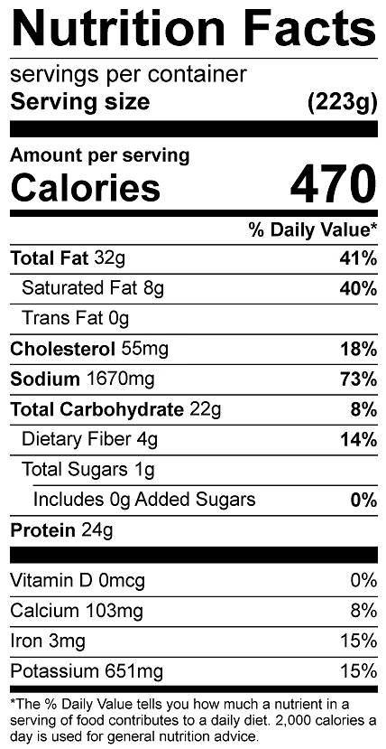

Vitamin C: 8.57mg