**Beef and Broccoli Loaded Fries**

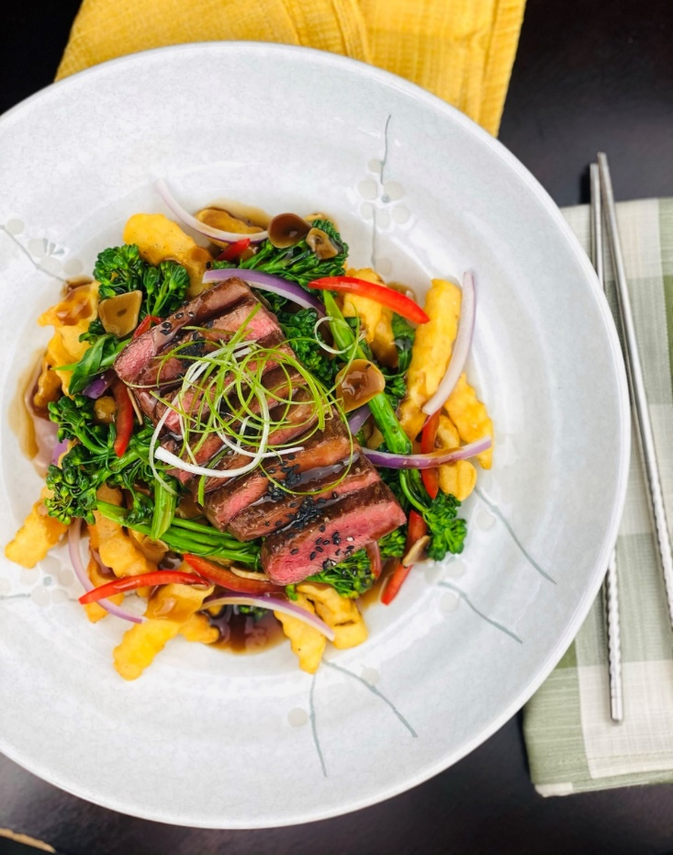

**Description:** Crispy crinkle cut fries topped with soy glazed flatiron steak, flavorful broccoli, red bell pepper, onions, and scallions.

**Servings:** 10

**Preparation Time:** 20 minutes

**Cooking Time:** 30 minutes

**Total Time:** 50 minutes

**Potato Type:** Frozen Crinkle Cut Fries

**Course:** Entrée, Shareable Appetizer

**Ingredients**

*Soy Glaze:*

* ½ cup (120ml) Light Soy Sauce
* 1 cup (240ml) Beef Stock
* 3 tablespoons (45ml) Oyster Sauce
* 4 each (25g) Garlic, sliced thin
* ½ tablespoon (2g) Crushed Red Chili Flakes
* 2 tablespoons (5g) Corn Starch
* ¼ cup (60ml) Cold Water
* 1 teaspoon (5ml) Toasted Sesame Oil

*Grilled Flat Iron Steak:*

* 1.5 pounds (680g) Flat Iron Steak, cut into ¼ pound (4 ounce) portions
* 1 tablespoon (4g) Kosher Salt
* ½ tablespoon (2g) Freshly Ground Black Pepper
* 1 tablespoon (15ml) Peanut Oil

*Stir Fried Vegetables:*

* 2 teaspoons (10ml) Toasted Sesame Oil
* 2 cups (300g) Baby Broccoli Florets (Regular Broccoli can be subbed)
* 1 cup (150g) Red Bell Peppers, cut into julienne strips
* 1 cup (150g) Red Onion, cut into julienne strips

*To Plate:*

* 2.2 lbs. (1 kg) Frozen Crinkle Cut Fries
* As Needed Vegetable Oil for frying
* 2 teaspoons (5g) Sea Salt
* 1-1/2 cups (150g) Green Onions, sliced thin
* 1 tablespoon (15g) Black Sesame Seeds

Preparation:

* 1. To make the sauce, combine the soy sauce, stock, oyster sauce, garlic, and chili flakes in a medium saucepan. Heat the sauce over medium heat until it reaches a simmer. In a small bowl combine the cornstarch and the cold water, whisk until smooth. Gradually whisk the cornstarch mixture into the warm sauce mixture. Bring the mixture to a boil while whisking until thick. Whisk in the sesame oil and remove from the heat. Keep the sauce warm until ready to use.
  2. To prepare the beef season the meat with the salt and pepper, then lightly drizzle the peanut oil on the beef. Grill the meat on a char broiler or on a grill pan until the desired doneness is reached. For medium rare grill until the internal temp reaches 120 °F (49 °C). Allow to rest for 5-7 minutes while you prepare the vegetables.
  3. To prepare the vegetables heat the sesame oil in a large sauté pan or a wok over high heat. Stir fry the red bell peppers along with the red onions, and the broccoli for 3-5 minutes or until the vegetables are tender but still brightly colored. Keep warm.
  4. To fry the fries, cook the fries in oil preheated 375 °F (190 °C) for 4-6 minutes or until golden and crisp. Drain the fries and season with salt.
  5. Place the fries down on a platter or individual plates and top them with the stir-fried vegetables. Follow the vegetables with the grilled beef that has been thinly sliced. Top the beef and the vegetables with the soy glaze, and finally garnish the entire dish with the sliced green onions and black sesame seeds.

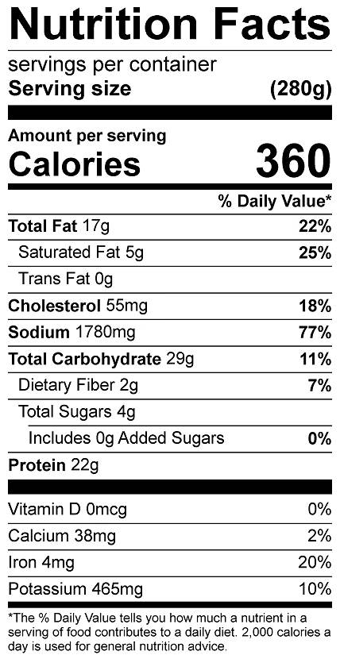

Vitamin C: 36 mg

Vitamin C: 61 mg