**Banh Mi Style Loaded Fries**

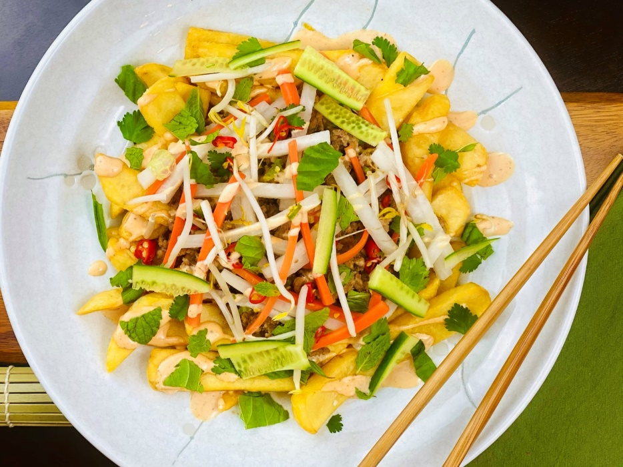

**Description:** Crispy steak cut fries topped with pickled vegetables, fresh herbs, sriracha mayo, and spicy ground pork.

**Servings:** 12

**Preparation Time:** 15 minutes

**Cooking Time:** 30 minutes

**Total Time:** 45 minutes

**Potato Type:** Frozen steak cut fries

**Course:** Entrée, Appetizer

**Ingredients**

*For the Pickled Vegetables*

* 2 cups (480ml) Rice Wine Vinegar
* ¼ cup (75g) Sea Salt
* ½ cup (100g) Granulated Sugar
* 3 cups (450g) Daikon Radish, julienne sliced
* 3 cups (450g) Carrots, julienne sliced
* 6 cups (840g) Ice, crushed

*For the Vietnamese Pork Larb (Spicy Ground Pork)*

* 2 lbs. (907g) Ground Pork
* 2 tablespoon (30g) Lard
* 3 tablespoons (45ml) Rice Wine (Xiaoxing, or sake)
* 3 tablespoons (45ml) Vietnamese Fish Sauce
* 3 tablespoons (45ml) Soy Sauce
* 2 each Thai Bird Chilies (1 green and 1 red)
* ½ teaspoon (2g) Ground White Pepper
* 3 tablespoons (45ml) Freshly Squeezed Lime Juice
* 1/3 cup (5g) Cilantro, chopped
* 1/3 cup (5g) Mint, chopped
* ½ cup (75g) Red Onion, thinly sliced

*For the Sriracha Mayo*

* 1 cup (240ml) Japanese Mayonnaise (ie. Kewpie, Kenko, etc.)
* ½ cup (120ml) Sriracha (Vietnamese Hot Sauce)

*For the Fries*

* 2.2 lbs. (1kg) Frozen Wedge Cut Fries
* As Needed Peanut Oil (any neutral oil can be subbed)
* 1 tablespoon (4g) Kosher Salt

Garnish

* 2 cups (300g) English Cucumbers, seeded and cut into 1/8” slices
* ¼ cup (37.5g) Sliced Jalapenos
* ¼ cup (4g) Cilantro Leaves, picked

Preparation:

* 1. In large saucepan combine the vinegar, salt and sugar. Place over medium high heat and bring the liquid to a boil until the sugar and salt has dissolved. Place the carrots and daikon into two smaller saucepans. Pour half of the mixture over the carrots and half of the mixture over the daikon. Place the carrots and daikon back on the stove and allow them to cook for 2-3 minutes. Remove from the heat and add the ice to both pots. Allow the mixture to cool completely. Drain the pickling liquid off the vegetables, reserving the liquid for storing any leftover pickles you may have. Keep cold until ready to use.
  2. Heat the oil in a pan over medium heat. Sauté the pork and cook until it is almost cooked all the way through. Stir the pork as it is cooking, so the pieces break up as much as possible. Add the rice wine, fish sauce, soy sauce, chilies, white pepper and stir until sauce reduces slightly. Remove from the heat, and stir in the cilantro, mint, and lime juice.
  3. Preheat a fryer with peanut oil to 375 °F (180 °C). When the oil is hot add the fries, this may have to be done in batches depending on the size of your fryer. (Conversely this can also be done in an air fryer or a convection oven without having to use the oil). Fry the fries for 7-8 minutes or until they are golden brown and crispy. Drain them well, place into a bowl and season with kosher salt to taste.
  4. To make the Sriracha mayo, combine the mayonnaise with the sriracha and stir well. Transfer the sauce to a plastic squeeze bottle.
  5. To plate up the dish, arrange the hot wedge cut fries on a serving platter or individual dishes. Spoon the hot ground pork mixture over the fries, drizzle the top with the sriracha mayo, and garnish the top with the sliced cucumbers, the jalapenos, the pickled carrot and daikon, as well as the micro cilantro. Serve Immediately.

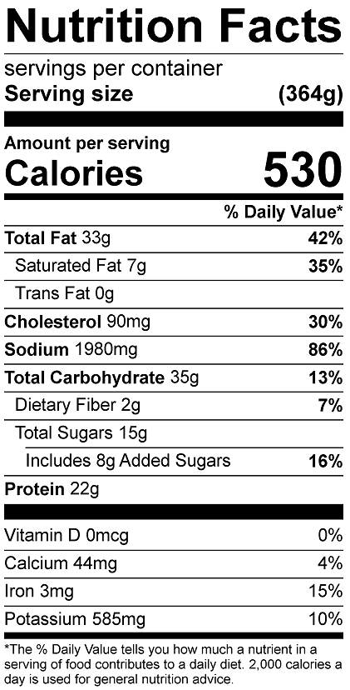

Vitamin C: 23 mg