**Al Pastor Loaded Fries**

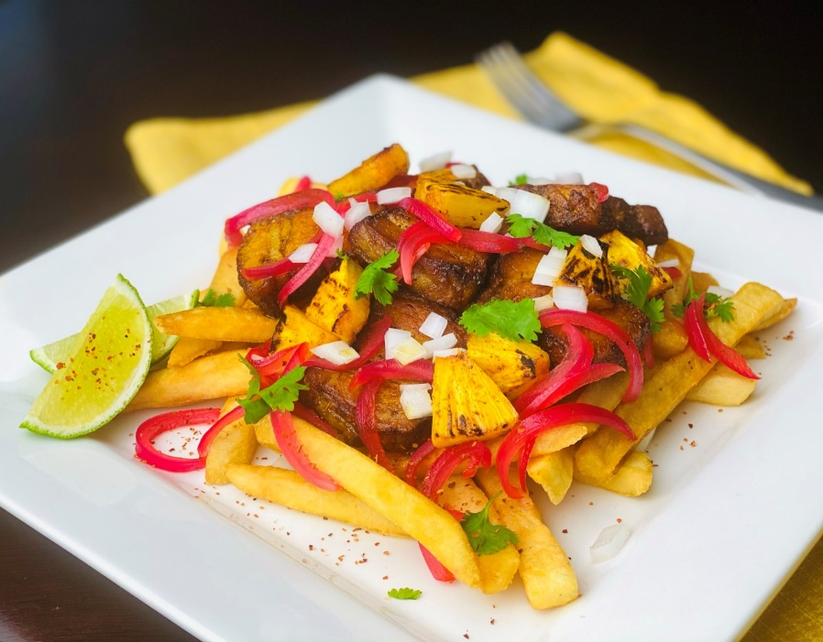

**Description:** Crispy straight cut fries topped with slow roasted, marinated pork belly, charred pineapple, pickled red onions and cilantro.

**Servings:** 12

**Preparation Time:** 20 minutes

**Cooking Time:** 240 minutes

**Total Time:** 260 minutes

**Potato Type:** Frozen Straight Cut Fries

**Course :** Entrée, Appetizer

**Ingredients**

* 24 ounces (680g) Pork Belly, skin removed

Al Pastor Marinade

* 3 tablespoons (45g) Achiote Paste
* 2 tablespoons (15g) Guajillo Chili Powder
* 1 tablespoon (7g) Chopped Garlic
* 1 tablespoon (2g) Dried Oregano
* 1 tablespoon (4g) Ground Cumin
* 1 tablespoon (4g) Sea Salt
* 1 tablespoon (4g) Freshly Ground Black Pepper
* ¾ cup (180ml) Apple Cider Vinegar
* 1 cup (240ml) Pineapple Juice

Pickled Red Onions

* ¼ cup (60g) Granulated Sugar
* ¼ cup (16g) Sea Salt
* ¼ cup (60ml) Beet Juice (Optional)
* ¾ cup (180ml) Rice Wine Vinegar (Apple Cider Vinegar can be subbed)
* 1 tablespoons (4g) Black Peppercorns
* 1-1/2 cups (300g) Red Onions, Sliced

Charred Pineapple

* 3 cups (450g) Fresh pineapple, diced
* 2 tablespoons (30ml) Coconut Oil, melted

Fries

* 4.5lbs (2 kg) Straight Cut Frozen Fries
* 1 tablespoon (4g) Sea Salt
* ½ tablespoon (2g) Freshly Ground Black Pepper
* 1 cup (6g) Cilantro, picked
* 1 cup (150g) White Onion, diced

**Preparation**

1. In a blender, combine the achiote paste, chili powder, garlic, oregano, cumin, salt, pepper, vinegar, and pineapple juice. Blend the contents until smooth. Pour over the pork belly and allow to marinate in the refrigerator for at least 12 hours, and up to 48 hours.
2. Preheat the oven to 425 °F (218 °C)
3. Remove the pork from the marinade and place it onto a baking sheet fitted with a wire rack which has been lightly sprays with nonstick spray. Place the pork into the oven and cook at 425 °F (218 °C) for 25-30 minutes before reducing the heat to 300 °F. Cook the pork belly at 300 °F (149 °C) for 3 to 3-1/2 hours or until the pork belly is tender and reaches an internal temperature of 195 °F (90 °C). Remove the pork from the oven and allow it to cool overnight in the fridge. The pork can now be sliced into bite sized pieces.
4. To make the pickled red onions, combine the sugar, salt, beet juice, vinegar, and peppercorns in a medium non-reactive saucepan. Place the pan over medium high heat until the vinegar reaches a boil and the sugar/salt have dissolved. Add the onions and allow them to simmer for 2-3 minutes. Remove from the heat and immediately add 4 cups of crushed ice. Once the mixture cools, allow the onions to sit for at least 30 minutes before using.
5. To char the pineapple, in a large non-stick pan, heat the coconut oil over medium-high heat. Once the pan is smoking, add the pineapple and allow it to sit for 1-2 minutes undisturbed. Then give the pan a toss or turn the pieces of pineapple over. The pieces should have a distinct char on them and should have had minimal moisture loss from cooking. Remove from the heat and set aside until ready to use.
6. To make the fries, preheat a fryer to 375 °F.
7. Crisp the pork belly chunks in a nonstick pan over medium high heat until crispy on the outside. Meanwhile fry the fries in the fryer for 4-6 minutes or until golden.
8. Remove the fries from the fryer and season with salt and pepper.
9. To plate up, arrange the fries on a serving platter and top them with the crispy pork belly, the charred pineapple, the drained pickled red onions, cilantro and diced white onion. Serve immediately and enjoy.

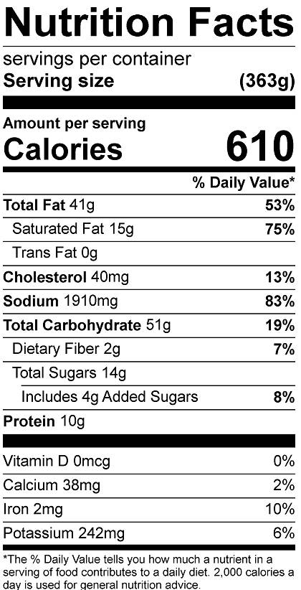

Vitamin C: 24 mg

**Notes**

* The nutritionals are based on this recipe being an entree. If sharing as an appetizer, the nutritionals can be divided by the number of people you're sharing it with.