**Potato and Turkey Pot Pie**

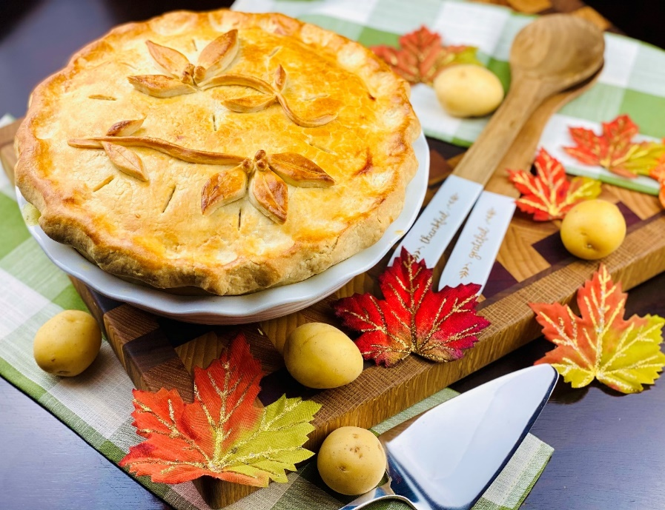

**Description:** Tender and juicy turkey folded into a savory gravy with aromatic vegetables and skin on potatoes before being surrounded in flaky pastry and baked in the oven until golden. A great way to use holiday leftovers.

**Servings:** 12

**Preparation Time:** 20 minutes

**Cooking Time:** 45 minutes

**Total Time:** 65 minutes

**Potato Type:** Yellow Potatoes, Red Potatoes, White Potatoes

**Course :** Side, Holiday

**Ingredients**

* 6 ounces (170g) Unsalted Butter
* ¾ cup (90g) All Purpose Flour
* 5 cups (1.2 L) Chicken Stock
* ½ cup (120 ml) Heavy Cream
* 1 teaspoon (4g) Sea Salt
* 2 teaspoons (8g) Freshly Ground Black Pepper
* ½ teaspoon (2g) Dried Thyme
* 1 teaspoon (4g) Poultry Seasoning
* 1-1/2 lbs. (350g) Roasted Turkey Meat (Rotisserie Chicken can be subbed)
* 1-1/2 cups (400g) Yellow, Red, or White Potatoes, cooked, diced 1-inch pieces, and skin on
* 1 cup (175g) Frozen Pearl Onions
* ¾ cup (140 g) Frozen Peas and Carrots

Pie Crust (To save time a frozen store-bought pie crusts can be subbed)

* 16 ounces (500g) All Purpose Flour
* 8 ounces (260g) Unsalted Butter, frozen
* 1 teaspoon (4g) Sea Salt
* ½ cup (120 ml) Cold Water

Egg Wash

* 1 each (55g) Large Egg
* 1 tablespoon (15 ml) Heavy Cream

**Preparation**

1. Preheat the oven to 400 F (205 C).
2. In a large pot, melt the butter over medium high heat. Add the flour and cook for 2-3 minutes to make a roux.
3. While whisking add in the chicken stock. Allow the mixture to thicken slightly and add the heavy cream. Reduce the heat to medium low and season with salt, pepper, thyme, and the poultry seasoning. Once this mixture is thick remove from the heat and stir in the roasted turkey meat, the cooked potatoes, pearl onions, and the peas & carrots.
4. If using a store-bought pie crust skip the next step and continue to step 6.
5. To make the pie crust, begin by placing the all-purpose flour into a large mixing bowl or food processor. Add the butter along with the salt, and gently mix the butter into the flour with the tips of your fingers. If using a food processor, pulse the butter into the flour and salt a few times. Add the cold water and mix until a dough is formed, do not over work the dough, only mix it until it comes together. Once the dough has come together, place the dough in a sheet of plastic wrap and allow it to rest in the fridge for at least 25 minutes. Remove the dough from the fridge and divide into two equal pieces. Save one for another pie, this crust freezes great. With the other crust divide it in half. On a lightly floured work surface roll both pieces of dough into a circle that is 1/8 inch thick.
6. Fold the circles of dough in half and then in half again to form a wedge. Place the tip of the wedge into the center of a pie pan and unfold the circle of dough. Press the dough into the pie pan and using the tip of a fork pierce the pie crust.
7. Place your now slightly cooled filling into the pie pan and place your other circle of pie dough on top. Using your fingers crimp the edges of the dough and if desired use scraps of pie dough to make a decorative top. Make sure to cut small slits in the crust to allow steam to escape.
8. Mix the egg and the heavy cream to make an egg wash.
9. Brush the top of the pie crust with the egg wash and place the pie pan on a baking sheet. Place the pie in oven and bake for 45 minutes or until the crust is golden. Remove from the oven and allow the pie to rest for 10-15 minutes before serving. Enjoy.

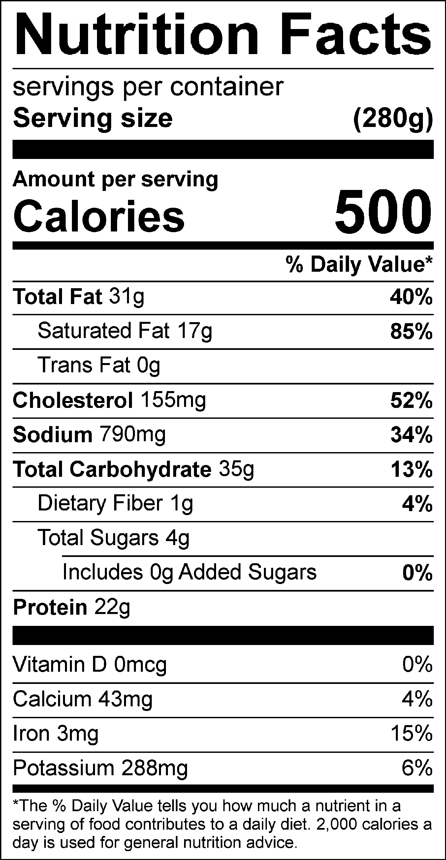

Vitamin C: 6 mg