**Terrifying Tater Treats**

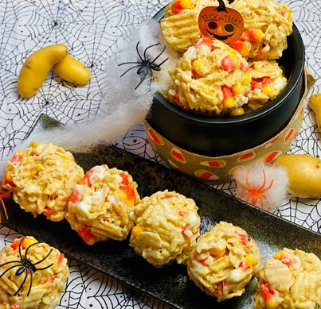

**Description:** Gooey marshmallow treats with sea salt chips, candy corn, white chocolate, and mini marshmallows.

**Servings:** 18

**Preparation Time:** 5 minutes

**Cooking Time:** 10 minutes

**Total Time:** 15 minutes

**Potato Type:** Potato Chips

**Course:** Dessert, Snack

**Ingredients**

* 4 ounces Butter, unsalted
* 2 lbs. (2 bags) Marshmallows
* 1-1/2 each (13 ounce bag) Sea Salt Crinkle Cut Kettle Chips
* 10 ounces Candy Corn
* 8 ounces White Chocolate Chips
* 8 ounces Mini Marshmallows
* As Needed Non-Stick Cooking Spray

**Preparation**

1. In a large pot over medium-low heat melt the butter, add the marshmallows, cook while continuously stirring until the marshmallows melt. Remove from the heat and allow to cool slightly (about 2-3 minutes).
2. Add the chips all at once. Using a rubber spatula, gentle fold the chips into the melted marshmallows, stir until the chips are well coated and combined well with the marshmallows.
3. Transfer the mixture to a large bowl. Add the candy corn, white chocolate chips, and mini marshmallows.
4. Lightly mist your hands with nonstick spray and gently toss the candy, chocolate, and marshmallows together with the chips and melted marshmallows.
5. Working quickly form the mixture into evenly shaped balls about the size of a small apple.
6. Place the treats on a baking sheet, lightly sprayed with nonstick spray.
7. Allow the treats to rest at room temperature for an hour before enjoying.

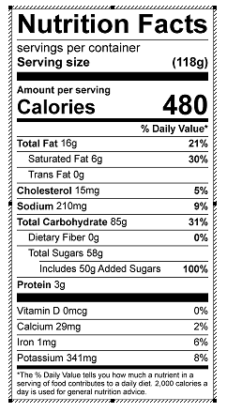

Vitamin C: 6.64 mg