**Tater Tombstones with Chili and Cheese**



**Servings:** 8

**Enticing Description:** Crispy potato half shells are filled with chili and cheese then topped with sour cream, black beans and green onions to resemble ghoulish ghosts, perfect for a great Halloween treat.

**Preparation Time:** 15 minutes

**Cooking Time:** 15 minutes

**Total Time:** 30 minutes

**Potato Type:** Russet

**Ingredients:**

1 lb. Russet Potatoes, cut in half lengthwise

4 tablespoons Olive Oil

As Needed Salt and Pepper

1 cup Prepared Chili

½ cup Shredded Cheddar Cheese

¼ cup Green Onions, sliced

¼ cup Sour Cream

¼ cup Black Beans, drained and rinsed

**Directions:**

1. Preheat the oven to 450 °F
2. Wash, scrub and cut the potatoes in half, lengthwise.
3. Place the potatoes in a pot and cover them with water. Place the pot over high heat and bring the potatoes to a boil. Reduce the heat to medium and cook the potatoes for 10-12 minutes until they are fork tender but not falling apart.
4. Drain the potatoes very well and using a spoon, scoop out some of the potato to create little potato boats (discard the filling, or save for soups, mashed, etc.)
5. Arrange the potato boats on a baking sheet lined with foil. Brush the inside of the potato boats with olive oil and season them with salt and pepper.
6. Place in the oven and allow the potatoes to roast for 10-15 minutes or until they are golden brown. Remove from the oven and keep them warm until ready to use.
7. Spoon about two tablespoons of chili into the potato shells and top each one with a tablespoon of shredded cheddar.
8. Place the stuffed shells under the broiler for 1-2 minutes or until the cheese is melted.
9. Remove the tater shells from the oven and garnish with black beans, green onions, and sour cream to make spooky ghosts.

Enjoy!

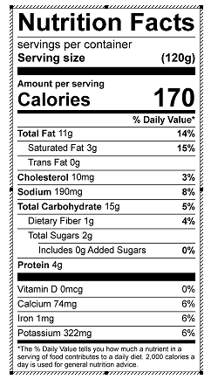

Vitamin C: 4.36 mg