Spooky Spud Skulls
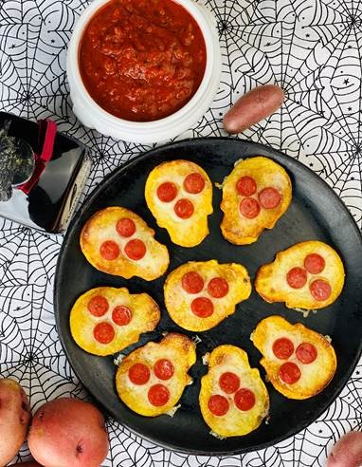
Description: Crispy Potato Shaped Skulls topped with mozzarella cheese, and mini pepperoni, served with a side of tomato-basil marinara.
Servings: 6
Preparation Time: 10 minutes
Cooking Time: 15 minutes
Total Time: 25 minutes
Potato Type: Russets, Yellows, Reds, or Whites
Course: Lunch, Dinner, Starter

Ingredients
- 4 each (2 lbs.) Fresh Russet, White, Red, or Yellow Potatoes (Must be large enough for skull shaped cookie cutter)
- ¼ cup Olive Oil
- 6 ounces Part Skim Shredded Mozzarella Cheese
- 36 each (4 ounces) Mini Pepperoni
- 6 ounces Prepared Marinara Sauce

Special Equipment Needed:
- Skull Shaped Cookie Cutter

Preparation
- Wash and dry the potatoes. Slice the potatoes ½ inch thick. The way you slice your potatoes depends on your cookie cutter. The goal is to be able to punch out the potato using the cookie cutter. Once the potatoes are sliced ½ inch thick use the skull shaped cookie cutter to make the skull shapes, for a standard recipe you should have 12 skulls. The scraps of the potatoes can be saved for mashed potatoes, potato soup, etc.
- Place the skull shaped potatoes in a bowl of ice water to soak for 15-20 minutes, this will remove some excess starch from the potatoes. Drain the potatoes well on some paper towel.
- Preheat a large sauté pan over medium high heat. Add the olive oil to the pan and then place your potato skulls into the hot oil. Cook the potatoes for 3-4 minutes on each side or until they are golden. Remove the potato skulls from the pan and place them onto a aluminum foil lined baking sheet.
- Top each spud skull with ½ ounce (1 tablespoon) of cheese. Place the baking sheet under the broiler for 1-2 minutes until the cheese is melted and bubbling. Remove the tray from the oven.
- Arrange the mini pepperoni on the skulls, three pepperoni per skull (2 for the eyes, 1 for the nose)
- To serve simply heat the marinara sauce and serve it alongside the spooky skulls for dipping.
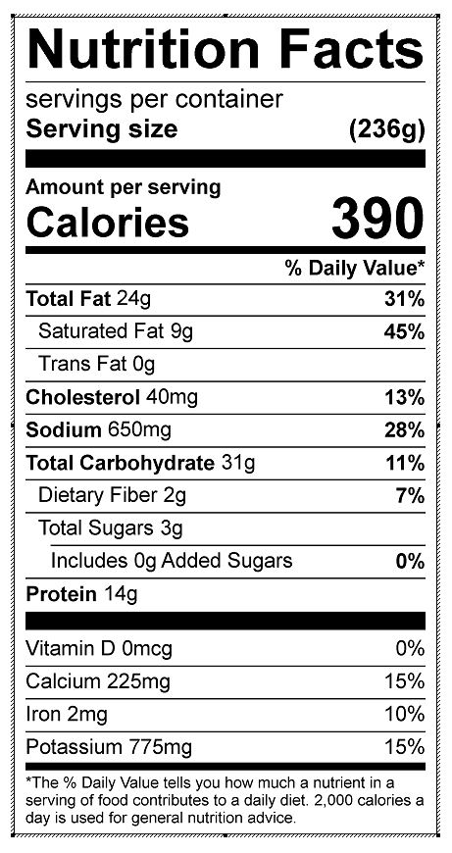
Vitamin C: 9.19 mg

