Roasted Pumpkin and Potato Soup with Gnocchi, Sage, and Pancetta
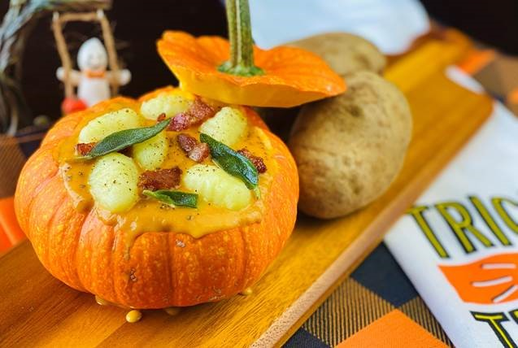
Description: Pumpkin and potatoes are whisked together in a velvet smooth soup perfect for fall time. Tender gnocchi and crispy Italian style bacon garnish the soup and make for the ultimate autumn treat.
Servings: 8
Preparation Time: 10 minutes
Cooking Time: 20 minutes
Total Time: 30 minutes
Potato Type: Dehydrated Potato Flakes
Course: Lunch, Dinner, Starter

Ingredients
Soup
- 3 cups Canned Pumpkin Puree
- 3 cups Prepared Mashed Potatoes (From Dehy Flakes)
- 4 cups Vegetable Stock
- 2 cups Half & Half
- 2 tablespoons Sea Salt
- 2 teaspoons Freshly Ground Black Pepper
- 1 teaspoon Orange Zest (Optional)
- ¼ cup Freshly Squeezed Orange Juice
- ½ teaspoon Freshly Grated Nutmeg

Garnish
- 1 package (16 ounces) Potato Gnocchi, cooked, & drained
- 6 ounces Pancetta (Bacon or Prosciutto can be subbed), diced, and crisped up in a pan.
- As needed Sage Leaves (fried in olive oil for 20-30 seconds)
Preparation
- In a large pot over medium heat, combine the ingredients for the soup. Whisk them together until the soup is creamy and slightly thickened. Bring the soup to a boil then reduce to a simmer and allow the soup to cook for about 20 minutes. It should reduce by about 25% in volume and coat the back of a soup nicely.
- Adjust the seasoning if desired.
- Remove from the heat and keep warm until ready to serve.
- To prepare the gnocchi, bring a pot of water to a boil then reduce to a simmer. Add in the prepared potato gnocchi, cook for 5-6 minutes or until the gnocchi float. Carefully remove the gnocchi and place on a plate with a drizzle of olive oil, this will prevent the gnocchi from sticking to each other as well as prevent them from drying out.
- To serve top portion 8 ounces of soup into a bowl (a hollowed pumpkin can also be used as a serving bowl). Arrange roughly six gnocchi in each bowl of soup then top with some crispy pancetta and sage.
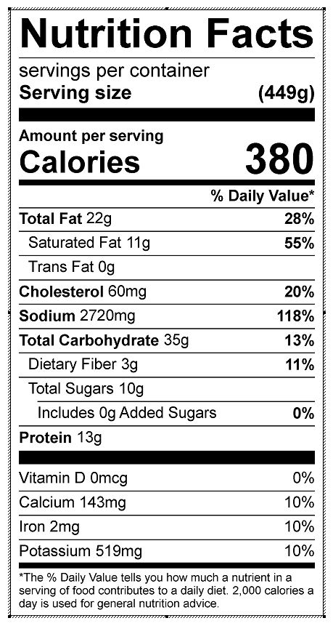
Vitamin C: 4.32 mg

