**Potato Breakfast Boo-Ritos**

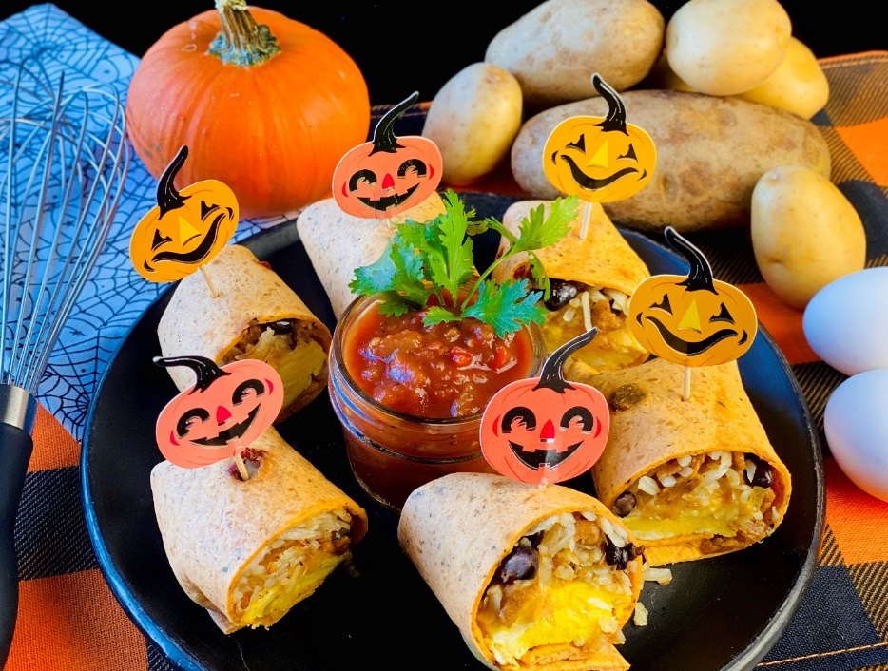

**Enticing Description:** Crispy hash browns, black beans, seasoned breakfast sausage and fluffy scrambled eggs are topped with cheddar cheese and wrapped in a festive flour tortilla.

**Servings:** 6

**Preparation Time:** 5 minutes

**Cooking Time:** 20 minutes

**Total Time:** 25 minutes

**Potato Type:** Dehydrated Shredded Potatoes

**Ingredients:**

2 cups Dehydrated Shredded Potatoes

4 cups Hot Water

2 tablespoons Vegetable Oil

1 teaspoon Kosher Salt

4 ounces Breakfast Sausage

4 ounces Black Beans, drained and rinsed

5 each Eggs, large, beaten

½ cup Shredded Pepper Jack Cheese

3 each Tomato Basil Tortillas/Wraps

6 ounces Prepared Salsa

**Directions:**

1. Place the dehy shreds in a large bowl and cover them with the hot water for 15-20 minutes. This can be done the day before. This can also be done with frozen potato shreds or refrigerated potato shreds, simply omit the water if using these as an option.
2. Heat a pan over medium high heat.
3. Add the sausage and cook until brown. Remove the sausage from the pan and reserve the rendered fat. Add the fat back to the pan and place it over the heat.
4. Drain the potatoes very well and then pat dry with paper towel.
5. Add the drained rehydrated potatoes to the pan and saute until golden brown and crispy. Stir the potatoes occasionally but be sure to allow them to sit in the pan every now and then so they can get golden brown. Remove the potatoes from the pan and set aside.
6. Combine the sausage, potatoes, and beans together and keep warm.
7. In a non-stick pan over medium heat, cook the beaten eggs until they are just set. Stir them constantly and remove them from the heat when they are finished. Sprinkle the cheese on top and allow the cheese to melt.
8. Arrange 3 tortillas out on a work surface and build the burritos as follows ½ cup of the potato-sausage mixture, followed by some of the cheesy eggs (place them cheese side down on the potatoes. Then roll the burritos by folding in the ends and then roll them up. Secure the burritos using festive toothpicks. Serve on a platter with the prepared salsa. Enjoy!

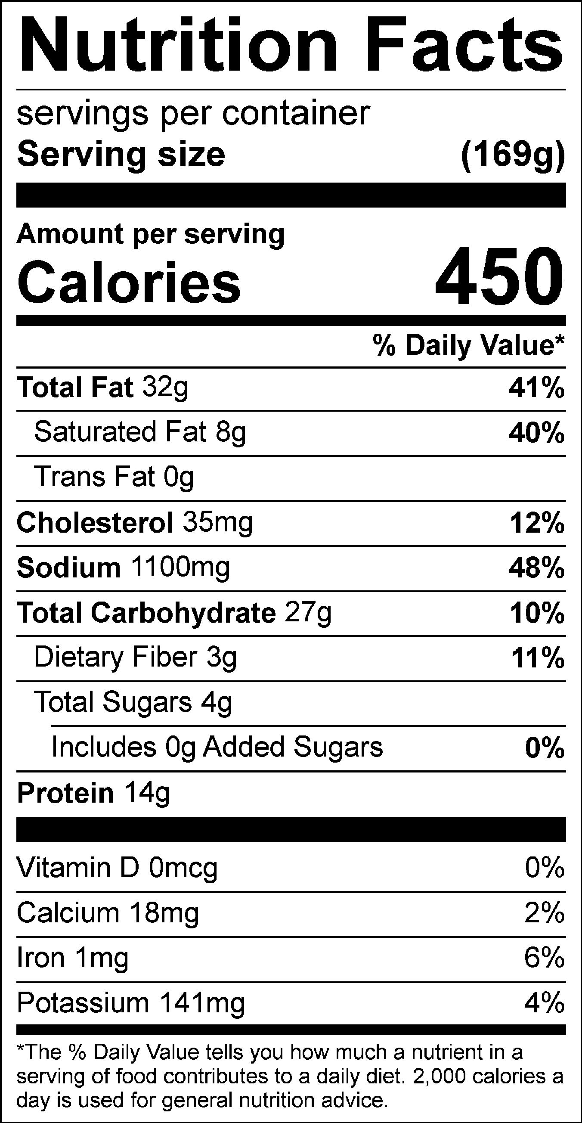

Vitamin C: .54mg