**Frankenstein’s Triple Layer Enchilada Quesadilla**

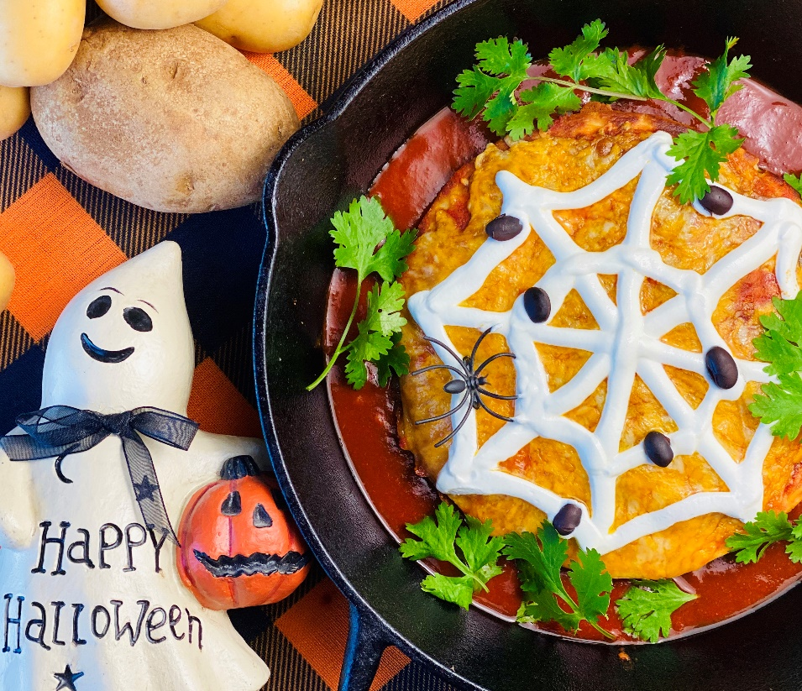

**Enticing Description:** Three layers of spooky southwest fun. Crispy tater drums, two types of gooey melted cheese, refried beans, and zesty taco meat are sandwiched in between crispy flour tortillas before being smothered in enchilada sauce and topped with sour cream.

**Servings:** 8

**Preparation Time:** 15 minutes

**Cooking Time:** 35 minutes

**Total Time:** 50 minutes

**Potato Type:** Frozen Tater Drums

**Ingredients:**

½ lb. 80/20 Ground Beef

1 packet Taco Seasoning

2 cups Frozen Tater Drums

2 tablespoons Butter, unsalted

12 each 6-inch Flour Tortillas

4 ounces Shredded Pepper Jack

8 ounces Prepared Refried Beans, warmed

12 fluid ounces Prepared Red Chili Enchilada Sauce

4 ounces Shredded Cheddar Cheese

½ cup Sour Cream

As Needed Black Beans

As Needed Cilantro

**Directions:**

1. Cook the ground beef in a skillet over medium-high heat. Once the beef is brown add the taco seasoning and a touch of water. Stir until combined, remove from the heat and keep warm.
2. Bake the tater drums in the oven for 20-25 minutes or until they are golden brown and crispy. Remove from the oven and set aside.
3. In a large saute pan, heat a little butter over medium high heat. Brown two tortillas on both sides and set them aside.
4. Melt a little more butter in the pan and lay down the third tortilla. Add the shredded pepper jack and cook until the tortilla is golden brown and the cheese is melted. Remove from the heat.
5. Top the cheese with some of the crispy tater drums, and place one of the toasted tortillas on top. Carefully spread the beans on the exposed side of the tortilla and top with some of the taco seasoned meat.
6. Place the third toasted tortilla on top of the taco meat.
7. Spoon some enchilada sauce on top and then finish the quesadillas with the shredded cheddar. Place the smothered quesadillas in the oven at 375 °F until the cheese is melted and bubbling.
8. Remove the quesadillas from the oven and garnish the top of the quesadillas with sour cream, cilantro, and black beans if desired. Enjoy!

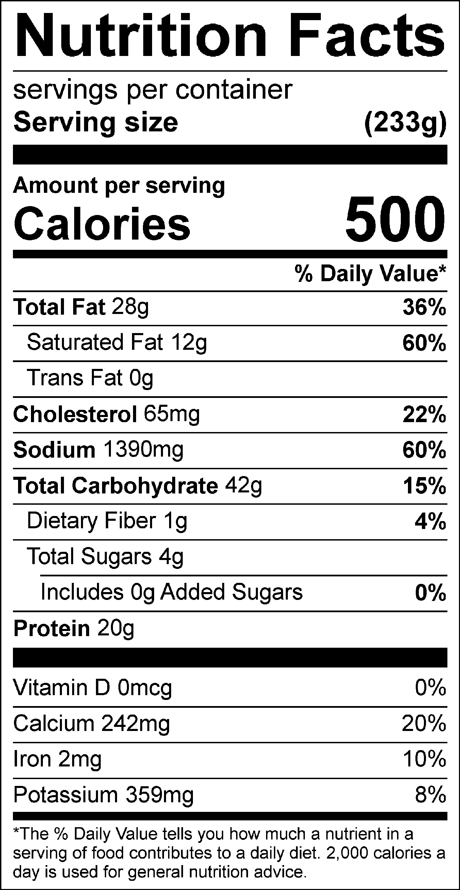

Vitamin C: 6.79mg