Fingerling Potato Mummies with Green Goo Dipping Sauce
Description: Tender fingerling potatoes, wrapped in bacon and croissant dough and baked until golden. Served with Avocado Ranch.
Servings: 8
Preparation Time: 15 minutes
Cooking Time: 15 minutes
Total Time: 30 minutes
Potato Type: Fingerling Potatoes
Course: Appetizer, Snack, Lunch, Dinner

Ingredients
- 1 lb. Fingerling Potatoes, washed
- ½ lb. Hickory Smoked Bacon *thin
- 8 ounces (1 can) Croissant Dough
- 6 ounces (1 each) Avocado
- 8 fluid ounces (1 cup) Ranch Dressing
- As Needed Sriracha (Thai/Vietnamese Hot Sauce) *optional*

Preparation
- Preheat the oven to 350 °F.
- In a large pot over medium-high heat, cover the fingerling potatoes with water and cook them until they are fork tender. Remove from the water and allow them to cook before proceeding.
- Cut the bacon into pieces long enough to wrap the fingerling potatoes one time. Wrap the bottom half of the potatoes with the bacon, followed by a thin strip of croissant dough to resemble a mummy.
- Arrange the wrapped potatoes on a nonstick baking sheet or a baking sheet lined with parchment paper. Make sure the crease side of the dough wrapping is facing towards the pan.
- Place the potatoes in the oven and bake for 13-15 minutes or until the croissant dough is golden brown. The bacon fat should be rendered, and the bacon should be cooked but not quite crispy. Remove the potatoes from the oven and allow them to cool for 3-5 minutes.
- To make the avocado ranch simply blend/puree the flesh of the avocado with the ranch dressing.
- Serve right away and enjoy!

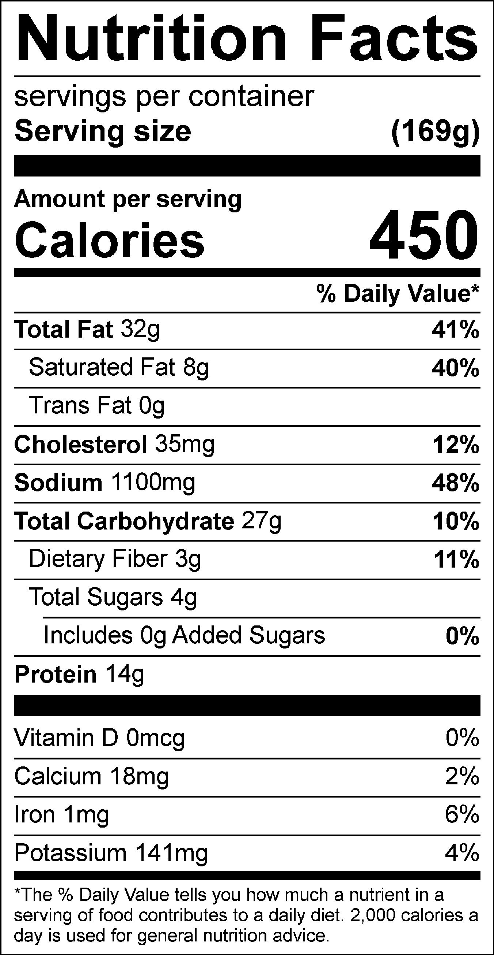
Vitamin C: 13.72mg

