Potato Pizzas: Tuscan Potato Pizza
Description: Roasted yellow potatoes, marinated roasted tomatoes, rosemary, and pecorino romano.
Servings: 8
Preparation Time: 20 minutes
Cooking Time: 20 minutes
Total Time: 40 minutes
Potato Type: Yellow Potatoes
Course: Main Entrée

Ingredients
- 16-ounce Prepared Pizza Dough
- 10 fluid ounces Marinara Sauce
- 8 ounces Part Skim Mozzarella
- 10 ounces Yellow Potatoes, sliced and roasted
- 8 ounces Marinated Tomatoes
- 1/3 cup Pecorino Romano Cheese, shaved
- 1 tablespoon Rosemary Leaves

Preparation
- Preheat the oven to 425 °F.
- Pull and stretch the dough so that a 16-inch round disc is formed. The dough should then be placed on a pizza peel sprinkled lightly with corn meal or flour to prevent sticking.
- Evenly spread a 10-ounce ladle of the prepared marinara sauce on the dough, this should be done by starting in the center of the disc and using the back of the ladle to evenly spread it outward. Make sure to leave about 1-inch un-sauced for the crust edge.
- Sprinkle the mozzarella cheese evenly on top of the sauce. Followed by 10 ounces of the cooked yellow potato slices.
- Place the pizza in the oven on a pizza stone or on the back side of a sheet pan.
- Cook the pizza for 18-20 minutes, rotating it once halfway though to ensure even cooking.
- Remove the pizza from the oven and top it with the marinated tomatoes, pecorino Romano cheese, and rosemary. Cut the pizza into 8 slices. Enjoy!
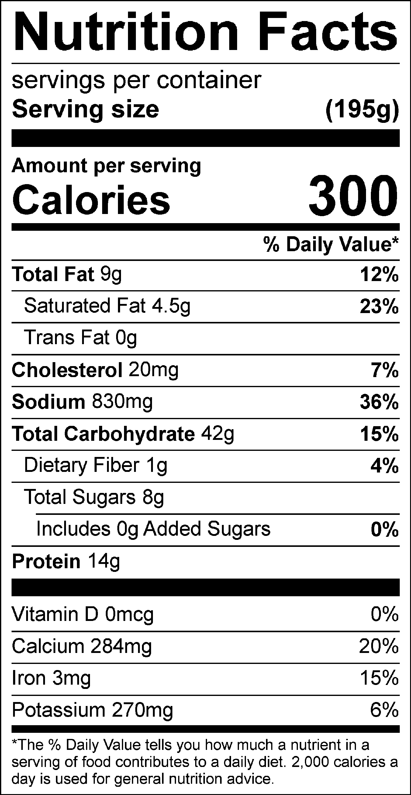
Vitamin C: 9.29mg

