Foil Wrapped Potato Meals: The All American
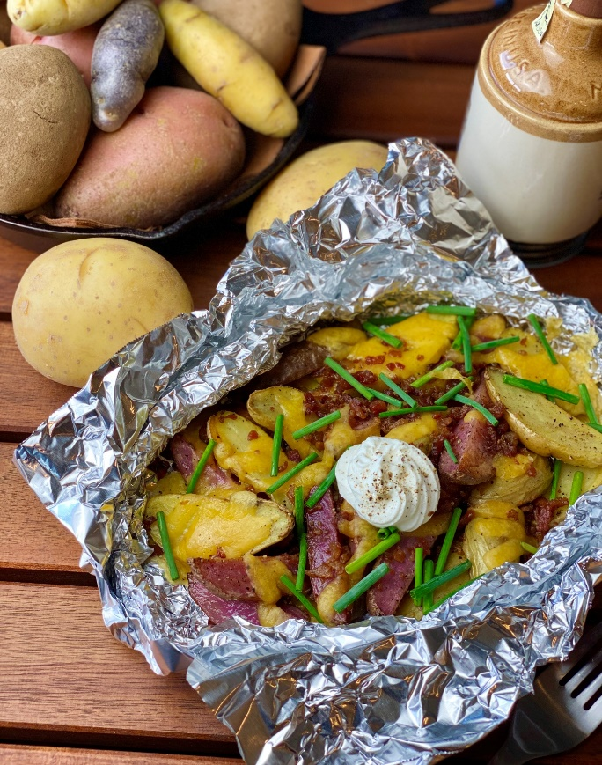
Description: Roasted fingerling potatoes topped with melted cheddar, bacon, green onions, and sour cream.
Servings: 4
Preparation Time: 10 minutes
Cooking Time: 25 minutes
Total Time: 35 minutes
Potato Type: Fingerling Potatoes
Course: Main Entrée, American, Foil Meals

Ingredients
- 2 lbs. Fingerling Potatoes, washed and cut lengthwise
- 2 tablespoons Vegetable Oil
- 1-1/2 teaspoons Kosher Salt
- 1 teaspoon Freshly Ground Black Pepper
- ¼ cup Bacon Bits, fully cooked
- ¾ cup Sharp Cheddar Cheese, shredded
- ¼ cup Chives or Green Onions
- ½ cup Sour Cream

Preparation
- Preheat the oven to 400 °F, this can also be done on the grill, simply preheat to 400 °F. If cooking outdoors without a thermometer and over an open flame (cook time may vary slightly).
- Place the potatoes onto a large square of aluminum foil. Drizzle the potatoes with the vegetable oil and season with the salt and pepper.
- Wrap the foil around the food by creating an envelope style fold over the top and rolling the edges up, this will make it easier to check the contents of the package as well as for easy serving.
- Place the foil pouch into the oven or over the campfire on a grate. Allow the packages to cook for about 20 minutes or until the potatoes are tender. Its important to rotate the foil package around the heat from time to time to prevent scorching.
- To finish the dish, top the potatoes with the shredded cheddar cheese and bacon bits, place back in the oven or on the fire to allow the cheese to melt. Remove from the heat and top with chives/green onions and sour cream. Enjoy!
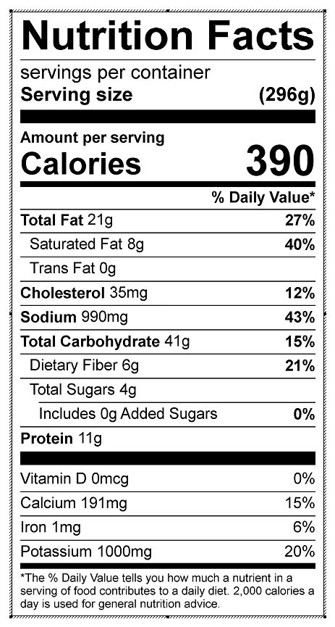
Vitamin C: 47.49 mg

