Foil Wrapped Potato Meals: That’s Amore! Potatoes
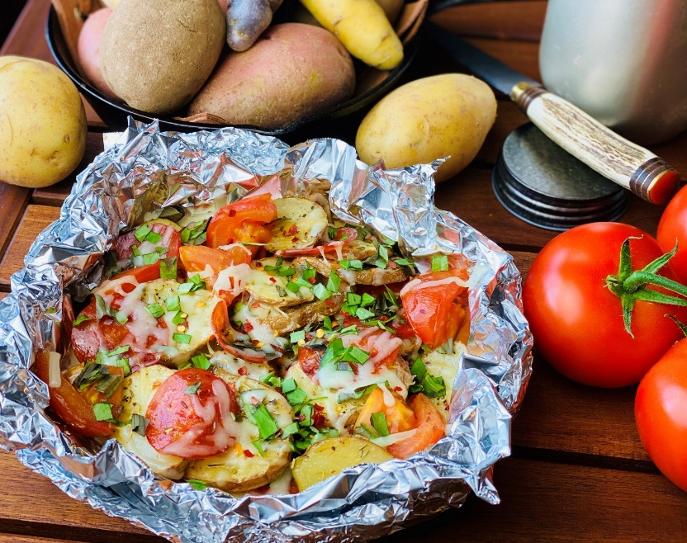
Description: Red potatoes seasoned with Italian seasoning and studded with pepperoni, mozzarella, basil, tomatoes, and chilies.
Servings: 4
Preparation Time: 10 minutes
Cooking Time: 25 minutes
Total Time: 35 minutes
Potato Type: Red Potatoes
Course: Main Entrée

Ingredients
- 2 lbs. (roughly 7 medium) Red Potatoes, washed and cut into ¼ inch rounds
- 1 cup Diced Fresh Tomatoes
- 2 tablespoons Olive Oil
- 1 1/2 tablespoons Italian Seasoning
- 1 teaspoon Crushed Red Chili Flakes
- 1 teaspoon Kosher Salt
- 1 teaspoon Freshly Ground Black Pepper
- 4 ounces Pepperoni Slices
- ¾ cup Part Skim Shredded Mozzarella
- ¼ cup Fresh Basil (1/2 Tablespoon of Dried Basil can be subbed if desired)

Preparation
- Preheat the oven to 400 °F, this can also be done on the grill, simply preheat to 400 °F. If cooking outdoors without a thermometer and over an open flame (cook time may vary slightly).
- Place the potatoes onto a large square of aluminum foil. Drizzle the potatoes and tomatoes with the olive oil and season with the Italian seasoning, crushed red chili flakes, salt, and pepper.
- Wrap the foil around the food by creating an envelope style fold over the top and rolling the edges up, this will make it easier to check the contents of the package as well as for easy serving.
- Place the foil pouch into the oven or over the campfire on a grate. Allow the packages to cook for about 25 minutes or until the potatoes are tender. Its important to rotate the foil package around the heat from time to time to prevent scorching.
- To finish the dish, top the potatoes and Tomatoes with the shredded mozzarella cheese and place back in the oven or on the fire to allow the cheese to melt. Lay the pepperoni on top and sprinkle with basil before enjoying.
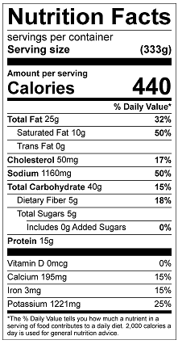
Vitamin C: 26.28mg

