**Teriyaki Glazed Sesame Potatoes**

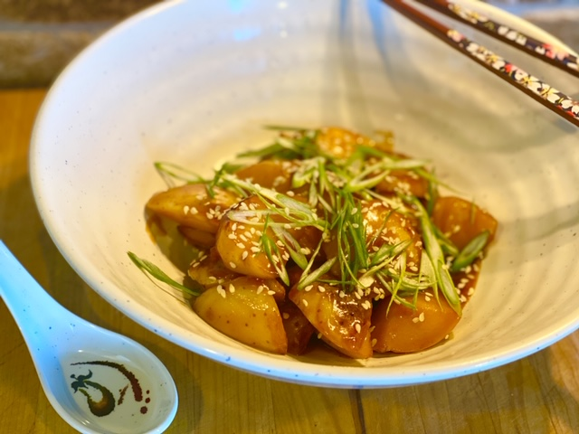

**Description:** Sweet and sticky teriyaki glaze on sautéed potatoes.

**Servings:** 4

**Preparation Time:** 5 minutes

**Cooking Time:** 20 minutes

**Total Time:** 25 minutes

**Potato Type:** White

**Course: Lunch Entrée, Dinner Entree, Sharable Appetizer**

**Ingredients**

* 1-pound White Potatoes, cut into bite sized pieces
* ½ tablespoon Sesame Oil
* ½ cup Prepared Teriyaki Sauce
* 2 tablespoons Sesame Seeds
* ¼ cup Green Onions (Scallions), thinly sliced

**Preparation**

1. Rinse and scrub the potatoes and then cut them into bite sized pieces.
2. Place the potatoes in a pot and cover them with water. Bring the potatoes to a boil over high heat. Reduce the heat to medium and cook the potatoes for 8-10 minutes or until they can be pierced with the tip of a knife, they should be fully cooked but not falling apart.
3. Drain the potatoes very well and add them to a large sauté pan or a non-stick wok. Add the sesame oil and cook the potatoes 3-5 minutes over medium heat.
4. Add the prepared teriyaki sauce and stir the potatoes until they are well glazed.
5. Transfer the potatoes to a serving bowl and top them with the sesame seeds and the green onions. Serve immediately.

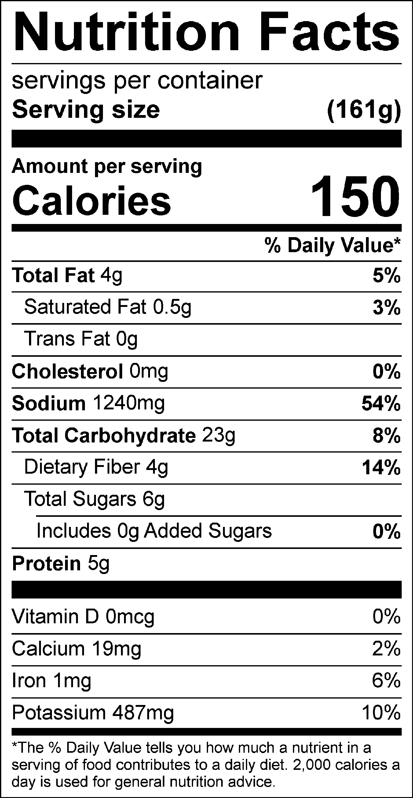

Vitamin C: 11.12 mg