**Take and Shake Tuscan Potato Salad**

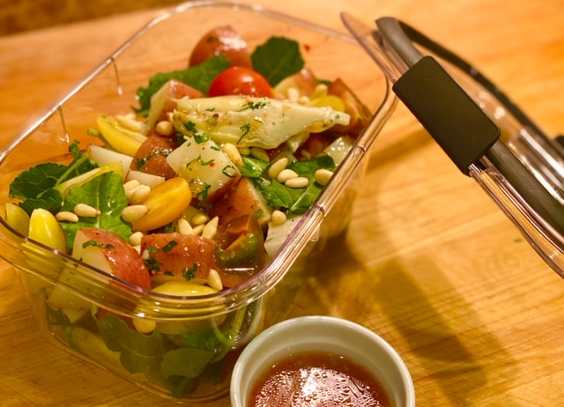

Description: Vibrant salad made for meals on the go. Mediterranean vegetables are tossed with pine nuts and potatoes for a satisfying dish.

Servings: 4

Preparation Time: 15 minutes

Cooking Time: 15 minutes

Total Time: 30 minutes

Course: Appetizer, Salad, Lunch Entrée, Dinner Entree

Ingredients:

1-pound Red Potatoes, cut into 1-inch dice

2 tablespoons Extra Virgin Olive Oil

As Needed Salt and Pepper

6 cups Baby Kale (Baby Spinach can be subbed)

1 cup Prepared Marinated Artichoke Hearts

1 cup Cherry Tomatoes, cut in half lengthwise

¼ cup Pine Nuts

¾ cup Italian Dressing

Preparation:

1. Preheat the oven to 450 °F.
2. Wash, scrub and cut the potatoes into 1-inch pieces,
3. Place the potatoes in a medium sized pot and cover them with water. Place the pot over high heat and bring the potatoes to a boil. Reduce the heat to medium and allow the potatoes to cook for 10-12 minutes or until they are just tender.
4. Drain the potatoes and transfer them to a baking sheet to cool slightly. Once the potatoes are cool (about 10-12 minutes) drizzle them with olive oil. And season them with salt and pepper.
5. Arrange the potatoes in “to-go” containers, divided evenly with baby kale, cherry tomatoes, pine nuts, and artichoke hearts. Just before serving drizzle the salad with the Italian dressing, place the lid on the container and shake until the salad is dressed.
6. Serve immediately.

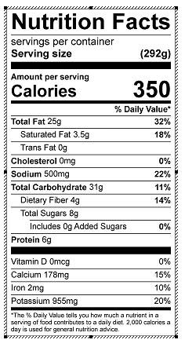

Vitamin C: 28 mg