Potato Pizzas: Sunrise Hash Brown Pizza
Description: Everything bagel crust, sausage gravy, crispy bacon, hash browns, and an egg.
Servings: 8
Preparation Time: 20 minutes
Cooking Time: 20 minutes
Total Time: 40 minutes
Potato Type: Frozen Hash Brown Patties
Course: Main Entrée, Pizza, Breakfast, American

Ingredients
- 16-ounce Prepared Pizza Dough
- 10 fluid ounces Sausage Gravy, prepared
- 8 ounces Mozzarella Cheese, shredded
- 4 ounces Applewood Smoked Bacon, cooked, chopped
- 3 each Hash Brown Patty, cut in half
- 1 each Large Egg
- 2 tablespoons Unsalted Butter, melted
- 1 tablespoon Everything Bagel Seasoning
- 1 tablespoon Parsley, chopped fine

Preparation
- Preheat the oven to 425 °F.
- Pull and stretch the dough so that a 16-inch round disc is formed. The dough should then be placed on a pizza peel sprinkled lightly with corn meal or flour to prevent sticking.
- Evenly spread a 10-ounce ladle of prepared sausage gravy on the dough, this should be done by starting in the center of the disc and using the back of the ladle to evenly spread it outward. Make sure to leave about 1-inch un-sauced for the crust edge.
- Sprinkle the cheese evenly on top of the sauce. Followed by 4 ounces of the cooked and chopped applewood smoked bacon.
- Arrange the hash brown patties in a circle around the pizza. There should be a circle in the center of the pizza left open, this is where the egg will go.
- Place the pizza in the oven on a pizza stone or on the back side of a sheet pan.
- Cook the pizza for about 15 minutes, rotating it once halfway though to ensure even cooking. Remove the pizza from the oven and crack the egg in the center of the pizza. Return the pizza to the oven and continue to cook for 5-7 minutes, or until the egg is just set. The white should be opaque, and the yolk should have a slight jiggle to it.
- Remove the pizza from the oven and brush the crust with the melted butter. Sprinkle the crust with the everything bagel seasoning and the top of the pizza with the chopped parsley. Enjoy!

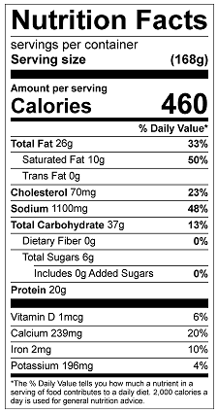
Vitamin C: 1.70mg

