Potato Pizzas: Sunday Night Pot Roast Pizza
Description: Velvety mashed potatoes, tender braised beef pot roast, aromatic vegetables, and rich brown gravy.
Servings: 8
Preparation Time: 20 minutes
Cooking Time: 20 minutes
Total Time: 40 minutes
Potato Type: Mashed Potatoes
Course: Main Entrée

Ingredients
- 16-ounce Prepared Pizza Dough
- 10 ounces Prepared Mashed Potatoes
- 16 ounces Braised Beef Pot Roast
- 1-1/2 cups Carrots, cooked
- 6 ounces Prepared Brown Gravy (Red Wine Demi Glace)
- 1/3 cup Celery, thinly shaved
- 1/3 cup Green Onions, sliced

Preparation
- Preheat the oven to 425 F.
- Pull and stretch the dough so that a 16-inch round disc is formed. The dough should then be placed on a pizza peel sprinkled lightly with corn meal or flour to prevent sticking.
- Evenly spread 10-ounces of the prepared mashed potatoes on the dough, this should be done by starting in the center of the disc and using the back of the ladle to evenly spread it outward. Make sure to leave about 1-inch for the crust edge.
- Place the pizza in the oven on a pizza stone or on the back side of a sheet pan.
- Cook the pizza for 18-20 minutes, rotating it once halfway though to ensure even cooking.
- Remove the pizza from the oven and top it with pot roast, carrots, gravy, celery and green onions. Cut the pizza into 8 slices. Enjoy!
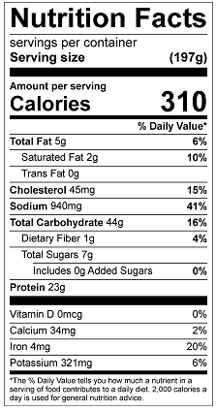
Vitamin C: 4.39 mg

