**Steak House Potatoes with Caramelized Onions**



**Description:** Roasted potatoes seasoned with Montreal steak seasoning, roasted crisp and served with caramelized onions.

**Servings:** 4

**Preparation Time:** 5 minutes

**Cooking Time:** 25 minutes

**Total Time:** 30 minutes

**Potato Type:** White

**Course:**

**Ingredients**

* 1-pound White Potatoes, cut into wedges
* 2 tablespoons Extra Virgin Olive Oil
* 2 tablespoons Montreal Steak Seasoning
* 1 tablespoon Unsalted Butter
* 2 cups Yellow Onions, thinly sliced
* 1 tablespoon Apple Cider Vinegar
* As Needed Salt and Pepper

**Preparation**

1. Preheat the oven to 450 °F.
2. Rinse and scrub the potatoes and cut them into wedges, about 8 wedges per potato.
3. Place the potatoes in a medium mixing bowl and toss them with the extra virgin olive oil and the Montreal steak seasoning. Arrange the potatoes on an aluminum foil lined baking sheet and cook for 18-20 minutes or until they are golden brown on the outside and tender on the inside.
4. While the potatoes are roasting in the oven, prepare the caramelized onions by heating the butter in a large nonstick skillet over medium-high heat.
5. Add the sliced onions, and allow them to cook, stirring them occasionally until they start to brown slowly. Continue to stir as the onions cook down. Once the onions take on a beautiful brown color remove them from the heat and add in the apple cider vinegar and adjust the seasoning with the salt and pepper.
6. To serve spoon the warm caramelized onions on the bottom of a serving tray. Arrange the potatoes on top of the onions and serve immediately.

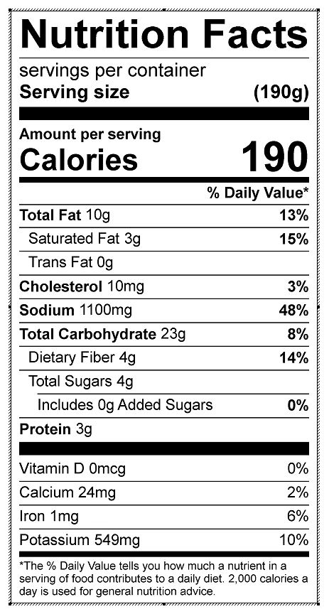

Vitamin C: 14.57 mg