Southwest Breakfast Hash – Multi Cooker Recipe
Description: Diced potatoes along with black beans, corn, chilies, tomatoes and onions, a great accompaniment to eggs of any style.
Servings: 6 (5-ounce portions)
Preparation Time: 10 minutes
Cooking Time: 15 minutes
Total Time: 25 minutes
Potato Type: White Potatoes
Course: Side Dish, Breakfast, Lunch, Brunch, Dinner

Ingredients
- 1 tablespoon Olive Oil
- 2 pounds White potatoes, diced 1” inch thick
- 1 cup Red Onions, diced ¼” inch
- 2 tablespoons Fresh Garlic, chopped
- ¾ cup Diced Tomatoes and Chilies, canned
- 1/2 cup Chicken Stock
- 2 teaspoons Ground Cumin
- ¾ cup Frozen Corn Kernels
- ¾ cup Black Beans, canned, drained and rinsed
- 2 teaspoons Fresh Lime Juice
- 1 tablespoon Kosher Salt
- 2 teaspoons Freshly Ground Black Pepper

Preparation
- Turn the multicooker to sauté mode, add the olive oil and sauté Potatoes for 5 to 7 minutes or until they are slightly golden on all sides. Remove the potatoes and set aside.
- Add the red onions, garlic, and canned tomatoes with green chilies to the multicooker on sauté mode. Cook the vegetables for 2-3 minutes until the onions are translucent.
- Add the potatoes, chicken stock, cumin, and corn. Turn off sauté mode.
- Place the lid on the multicooker and set the timer for 5 minutes at high pressure. Allow for a natural release of pressure for 2 minutes then manually release the pressure. Carefully removed the lid.
- Stir in the black beans and adjust the seasoning with the lime juice, salt, and pepper.
- Serve with eggs or in a breakfast burrito.

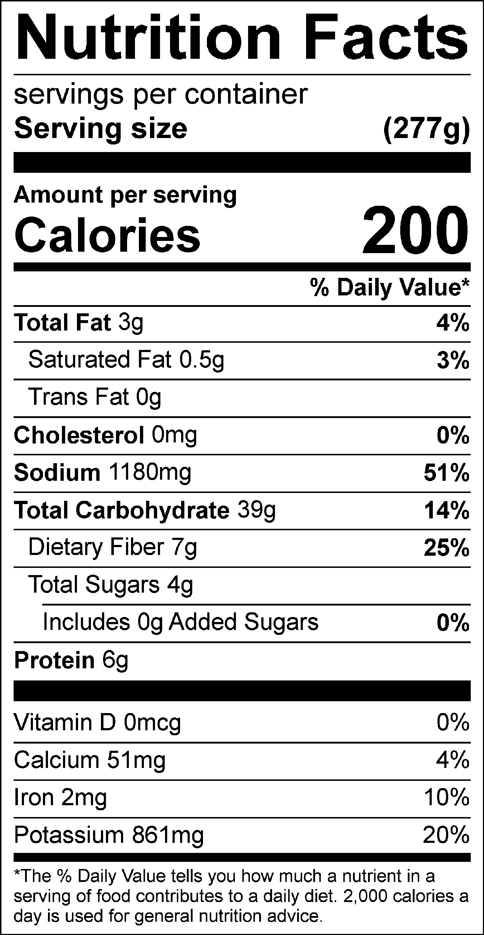
Vitamin C: 20.11mg

