Southern Style Potato Spiked Spoon Bread
Photo:

Description: Soft and luscious cornmeal and shredded potatoes baked into a soft pudding and served with sour cream.
Servings: 24
Preparation Time: 15 minutes
Cooking Time: 30 minutes
Total Time: 45 minutes
Potato Type: Dehydrated Potato Shreds
Course: Side Dish, BBQ, Southern

Ingredients
- 3 cups Finely Ground Yellow Cornmeal
- 1 tablespoon Kosher Salt
- 1 quart Boiling Water
- ¾ cup Unsalted Butter, melted
- 8 each Large Eggs
- 1 quart Whole Milk
- 3 tablespoons Baking Powder
- 3 cups Dehydrated Shredded Potatoes
- 5 cups Boiling Water
- 1-1/2 cups Sour Cream (Optional)

Preparation
- Preheat the oven to 350 °F.
- Spray a baking dish with non-stick spray or lightly rub the dish with butter.
- Combine the cornmeal with the salt.
- Slowly add the boiling water to the cornmeal while whisking to ensure there aren’t any lumps, then allow the mixture to cool for 7-10 minutes.
- Whisk the milk into the cornmeal mixture.
- In a small bowl, beat the eggs very well and add them to the cornmeal mixture along with the baking powder.
- In a larger bowl, add the shredded potatoes and cover them with the boiling water. Allow the potatoes to sit for 8-10 minutes to rehydrate.
- Drain the potatoes very well and gently fold them into the cornmeal mixture.
- Transfer the mix into the lightly greased baking dish from step 2.
- Bake the spoonbread at 350 °F for 35 minutes or until the mixture is set and lightly brown on top.
- Serve the spoonbread with sour cream. Enjoy!

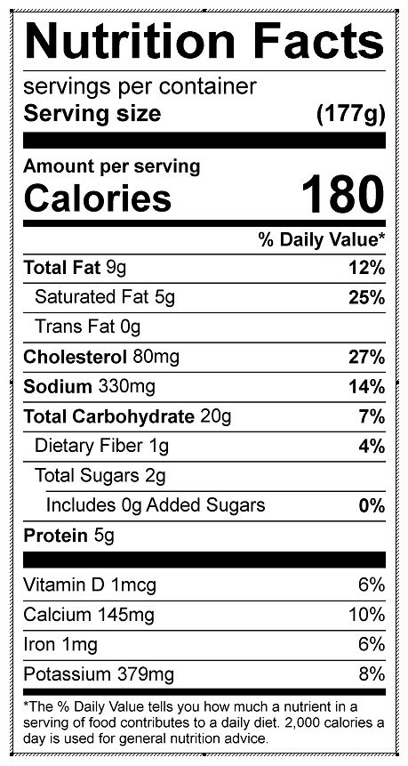
Vitamin C: 0 mg

