Potato Pizzas: Smothered Green Chili and Hash Brown Pizza
Description: Colorado Green Chili, Crispy Tater Barrels, Pulled Pork, Pepper Jack Cheese, Tomatoes, and Green Onions
Servings: 8
Preparation Time: 20 minutes
Cooking Time: 20 minutes
Total Time: 40 minutes
Potato Type: Frozen Tater Drums/Barrels
Course: Main Entrée, Pizza, American, Southwest

Ingredients
- 16-ounce Prepared Pizza Dough
- 10 fluid ounces Stewed Pork Green Chili
- 8 ounces Pepper Jack Cheese shredded
- 10 ounces Frozen Tater Drums/Barrels, cooked
- 8 ounces Pulled Pork, prepared
- 2/3 cup Roma Tomatoes, diced
- ¼ cup Green Onions, sliced

Preparation
- Preheat the oven to 425 F.
- Pull and stretch the dough so that a 16-inch round disc is formed. The dough should then be placed on a pizza peel sprinkled lightly with corn meal or flour to prevent sticking.
- Evenly spread a 10-ounce ladle of the prepared pork green chili sauce on the dough, this should be done by starting in the center of the disc and using the back of the ladle to evenly spread it outward. Make sure to leave about 1-inch un-sauced for the crust edge.
- Sprinkle the cheese evenly on top of the sauce. Followed by 10 ounces of the cooked tater barrels/drums.
- Top the pizza with 8 ounces of shredded pulled pork.
- Place the pizza in the oven on a pizza stone or on the back side of a sheet pan.
- Cook the pizza for 18-20 minutes, rotating it once halfway though to ensure even cooking.
- Remove the pizza from the oven and top it with the diced tomatoes and green onions. Cut the pizza into 8 slices.
- Enjoy!

Notes
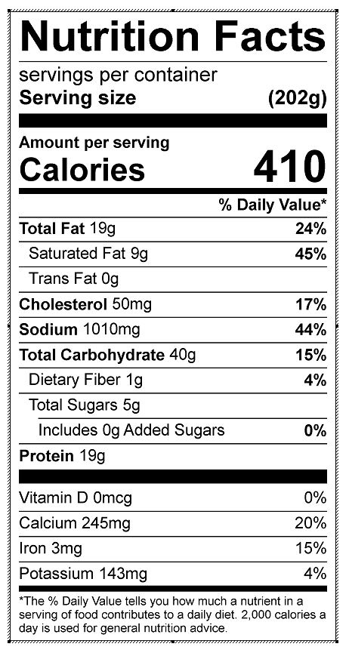
Vitamin C: 2.46 mg

