**Smashed Lemon-Pesto Potatoes**

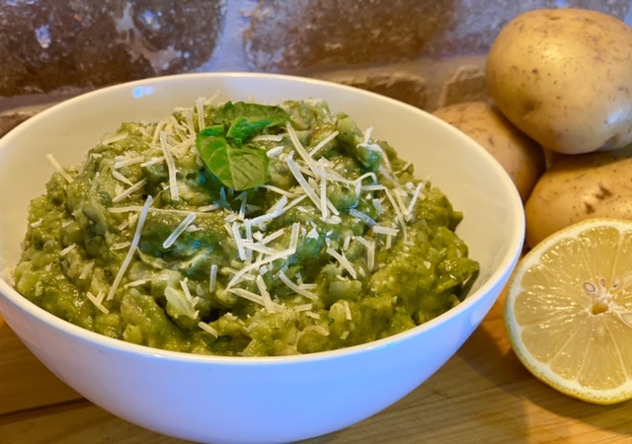

Description: Smashed potatoes are blended with fragrant basil pesto, lemon, and parmesan cheese, for a fun potato side dish.

Servings: 4

Preparation Time: 5 minutes

Cooking Time: 20 minutes

Total Time: 25 minutes

Course: Side Dish

Ingredients:

1-pound Yellow Potatoes, cut quarters

1 cup Prepared Pesto

2 tablespoons Lemon Juice

As Needed Salt and Pepper

2 tablespoons Grated Parmesan Cheese

Directions:

1. Rinse and scrub the potatoes and then cut them into quarters.
2. Place the potatoes in a pot and cover them with water. Bring the potatoes to a boil over high heat. Reduce the heat to medium and cook the potatoes for 15-20 minutes or until they are easily pierced with a fork.
3. Drain the potatoes and smash slightly, using a potato masher or a whisk.
4. Add the prepared pesto and the lemon juice. Stir gently to combine and adjust the seasoning with salt and pepper if desired.
5. Transfer the potatoes to a serving bowl and top with the grated parmesan, serve immediately.

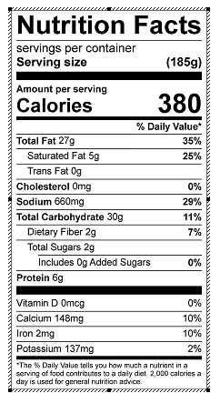

Vitamin C: 21 mg