**Simple Skillet Potatoes with Garlic and Herb Cheese**

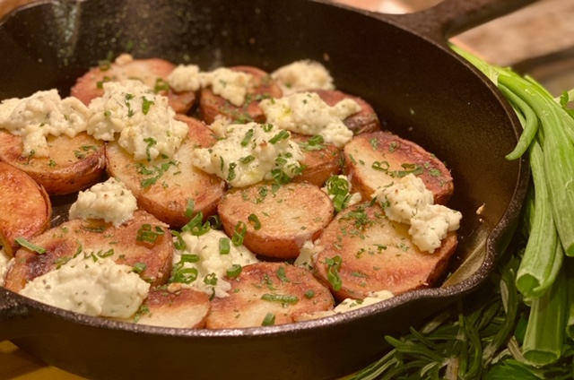

**Description:** Crispy pan-roasted potatoes topped with creamy garlic and herb cheese.

**Servings:** 4

**Preparation Time:** 5 minutes

**Cooking Time:** 25 minutes

**Total Time:** 30 minutes

**Potato Type:** Red

**Course: Side Dish**

**Ingredients**

* 1-pound Red Potatoes, cut into 1inch slices
* 2 tablespoons Vegetable Oil
* As Needed Salt and Pepper
* 2 tablespoons Unsalted Butter
* 5 ounces Soft Garlic and Herb Cheese
* 2 tablespoons Lemon Juice

**Preparation**

1. Preheat the oven to 450 F.
2. Wash, scrub and cut the potatoes into 1-inch thick slices.
3. Place the potatoes into a large pot and cover them with water just until the water is about 2 inches above the potatoes. Place the pot on the stove and bring it to a boil over high heat. Reduce the heat to medium. Allow the potatoes to cook for 12-14 minutes or until they are just fork tender.
4. Drain the potatoes. While the potatoes are draining. Place a cast iron skillet with the vegetable oil over medium heat and allow it to heat up for 3-4 minutes.
5. Carefully add the potatoes down in one even later. Cook the potatoes for 3-4 minutes on each side until they are golden brown. Remove them from the oil and season them with salt and pepper. Drain the oil from the pan and add the butter. Return the potatoes to the pan in one even layer in the melted butter.
6. Crumble the garlic and herb cheese over the potatoes and place the skillet into the preheated 450 F oven for 3-5 minutes until the cheese begins to melt. Remove the potatoes from the oven
7. Drizzle the potatoes with lemon juice. And serve them immediately.

**Notes**

* A portion of oil was backed out of the nutritionals to account for the oil that is drained out of the pan after cooking the potatoes.

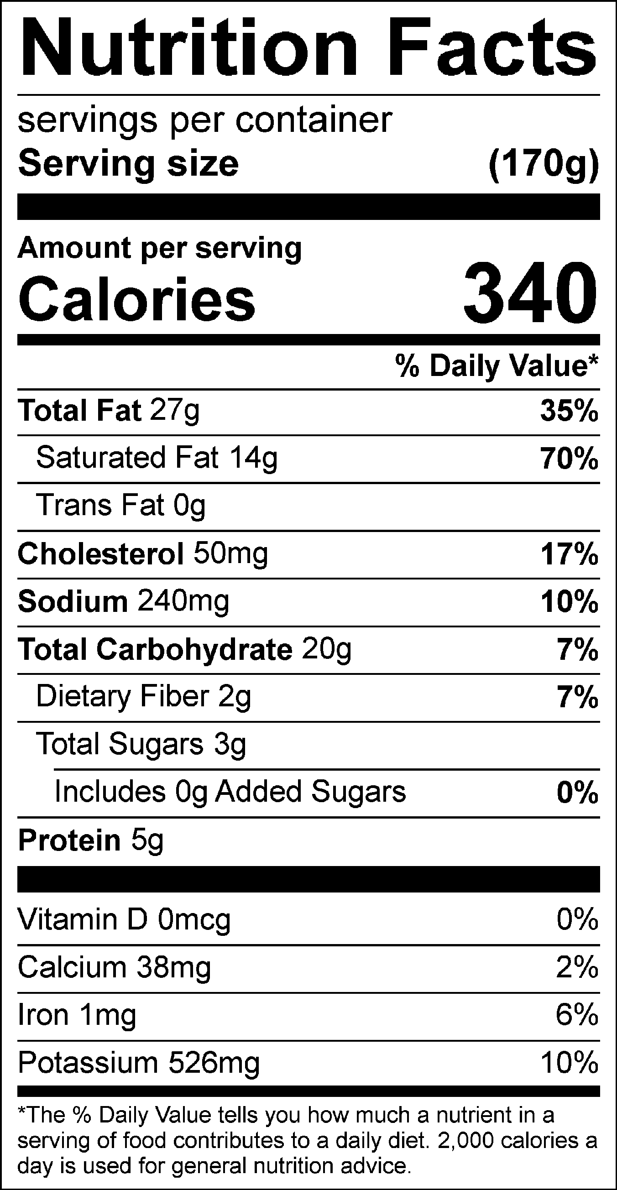

Vitamin C: 12.70 mg