**Shawarma Spiced Potatoes with Cucumber-Tomato Salad**



**Description:** Crispy slices of potatoes seasoned with middle eastern spices and topped with a fresh salad of tomatoes and cucumbers.

**Servings:** 4

**Preparation Time:** 15 minutes

**Cooking Time:** 15 minutes

**Total Time:** 30 minutes

**Potato Type:** White

**Course: Lunch Entrée, Dinner Entree, Sharable Appetizer**

**Ingredients**

* 1-pound White Potatoes, cut into ¼ inch slices
* 2 tablespoons Extra Virgin Olive Oil
* 1 tablespoon Prepared Shawarma Spice (Ras El Hanout or Zaatar Spice can be subbed)
* As Needed Salt and Pepper
* ½ cup English Cucumbers, sliced ¼-inch slices
* ½ cup Cherry Tomatoes, cut in half
* ¼ cup Red Onions, sliced thin
* 1 teaspoon Dill, chopped
* 1 tablespoon Extra Virgin Olive Oil
* ½ cup Greek Yogurt

**Preparation**

1. Preheat the oven to 450 °F.
2. Rinse and scrub the potatoes and slice them into ¼ inch slices. Place them in a bowl and toss with the olive oil, prepared spice blend, and salt and pepper to taste.
3. Arrange them on a foil lined baking sheet. In an even layer. Bake for 15-20 minutes or until they are golden brown. Remove from the oven and keep them warm until ready to serve.
4. To make the cucumber salad, combine the cucumbers, cherry tomatoes, red onions, dill, and extra virgin olive oil. Adjust the seasoning with salt and pepper, then stir to combine.
5. Arrange the potatoes on a serving platter. Top them with the cucumber salad and serve with Greek yogurt if desired.

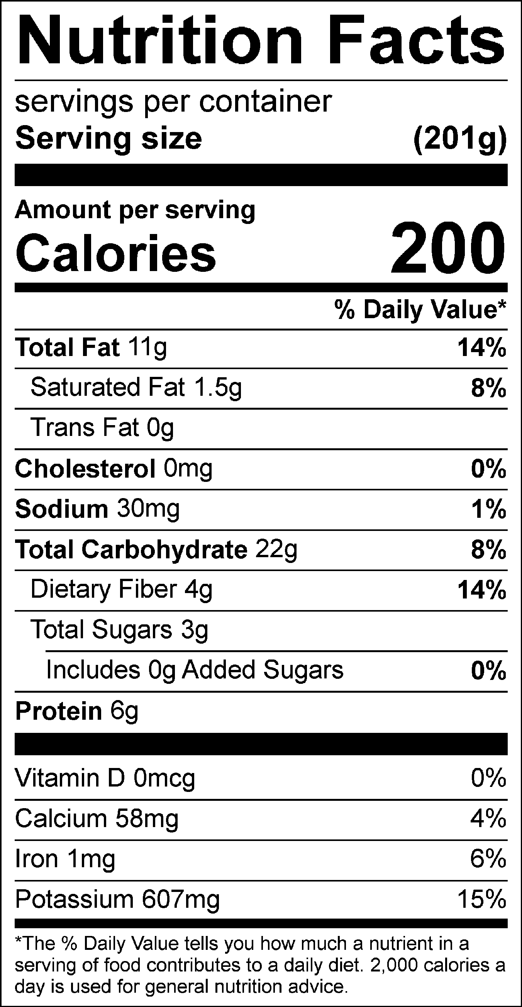

Vitamin C: 14.46 mg