**Salt and Pepper Air Fryer Chips**

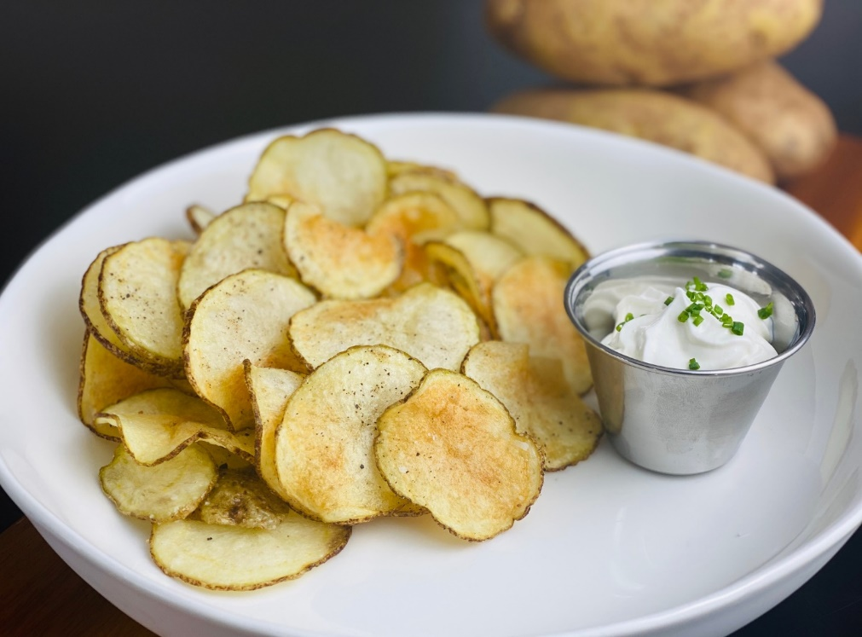

**Description:** A crispy snack or side dish, made with less oil than traditional frying.

**Servings:** 4

**Preparation Time:** 5

**Cooking Time:** 30 minutes

**Total Time:** 20 minutes

**Potato Type:** Russet

**Course:** Side Dish, Snack

**Ingredients**

* As Needed Cooking Oil Spray
* 1 each (6 ounce) Russet Potato, washed and dried
* 1 tablespoon Vegetable Oil
* ½ teaspoon Fine Sea Salt
* ¼ teaspoon Freshly Ground Black Pepper

**Preparation**

1. Preheat the air fryer to 375 °F
2. Thinly slice the potatoes either with a knife or a mandoline/food processor with a thin setting for slicing works well too. Place the potato slices into a bowl of cold water to rinse some of the starch off.
3. Lightly Spray the air fryer basket with the cooking oil spray.
4. Remove the potato slices from the water and drain well before laying them on some paper towel to dry.
5. Place the potato slices in an even layer (the bigger your air fryer, the more chips you can do). Lightly brush the potatoes with the vegetable oil and cook them in the air fryer for about 20 minutes.
6. Using a pair of tongs gently remove the chips from air fryer. Season them with the sea salt and black pepper. Repeat if more chips are desired.

**Notes**

* Serve chips with your favorite dips or sauce.

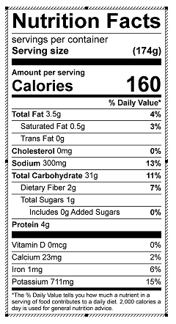

Vitamin C: 9.7 mg