Foil Wrapped Potato Meals: Rocky Mountain Spudtactular Breakfast
Description: Diced potatoes roasted in Colorado green chili, topped with ham, melted cheddar, and an egg.
Servings: 4
Preparation Time: 10 minutes
Cooking Time: 35 minutes
Total Time: 45 minutes
Potato Type: Yellow Potatoes
Course: Main Entrée, American, Foil Meals

Ingredients
- 1 1/2 lbs. Yellow Potatoes, washed and cut into 1/2-inch dice
- 1 1/2 tablespoons Vegetable Oil
- 1 teaspoon Cumin
- 1 teaspoon Kosher Salt
- 1 1/2 teaspoons Freshly Ground Black Pepper
- 2 cups Prepared Green Chili
- 6 ounces Diced Ham
- ½ cup Shredded Cheddar Cheese
- 4 each Large Eggs
- 2 tablespoons Parsley, chopped (optional)

Preparation
- Preheat the oven to 400 °F, this can also be done on the grill, simply preheat to 400 °F. If cooking outdoors without a thermometer and over an open flame (cook time may vary slightly).
- Place the potatoes onto a large square of aluminum foil. Drizzle the potatoes with the vegetable oil and season with the cumin, salt, and pepper.
- Carefully pour the green chili over the potatoes. Wrap the foil around the food by creating an envelope style fold over the top and rolling the edges up, this will make it easier to check the contents of the package as well as for easy serving.
- Place the foil pouch into the oven or over the campfire on a grate. Allow the packages to cook for about 25 minutes or until the potatoes are tender. Its important to rotate the foil package around the heat from time to time to prevent scorching.
- To finish the dish, add the ham and cheddar cheese followed by cracking an egg on top of the potatoes.
- Reseal the packages and allow the meal to cook for 6-7 minutes or until the egg is set and the cheese is melted. Sprinkle the dish with chopped parsley if desired. Enjoy!
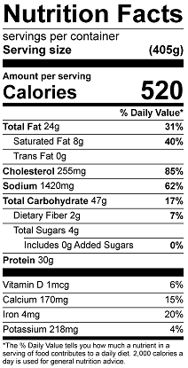
Vitamin C: 37.74mg

