Potato Pizzas: Roasted Garlic and Herb Potato Pizza
Description: Alfredo sauce, garlic and herb roasted red potatoes, and Parmesan cheese.
Servings: 8
Preparation Time: 20 minutes
Cooking Time: 20 minutes
Total Time: 40 minutes
Potato Type: Red Potatoes
Course: Main Entrée

Ingredients
- 10 ounces Red Potatoes, quartered
- 2 tablespoons Extra Virgin Olive Oil
- 2 tablespoons Garlic, chopped
- ½ tablespoon Italian Seasoning
- 1 teaspoon Kosher Salt
- ½ teaspoon Freshly Ground Black Pepper
- 16-ounce Prepared Pizza Dough
- 10 fluid ounces Alfredo Sauce
- 4 ounces Parmesan Cheese, shaved
- 1 tablespoon Rosemary Leaves, chopped

Preparation
- Preheat the oven to 425 °F.
- In a bowl toss together the potatoes, oil, garlic, Italian seasoning, salt and pepper.
- Roast the potatoes 20-25 minutes or until they are golden brown and tender. Allow the potatoes to cool before using.
- Pull and stretch the dough so that a 16-inch round disc is formed. The dough should then be placed on a pizza peel sprinkled lightly with corn meal or flour to prevent sticking.
- Evenly spread a 10-ounce ladle of the prepared Alfredo sauce on the dough, this should be done by starting in the center of the disc and using the back of the ladle to evenly spread it outward. Make sure to leave about 1-inch un-sauced for the crust edge.
- Arrange the roasted and cooled red potato wedges, followed by half of the parmesan cheese.
- Place the pizza in the oven on a pizza stone or on the back side of a sheet pan.
- Cook the pizza for 18-20 minutes, rotating it once halfway though to ensure even cooking.
- Remove the pizza from the oven and top it with the remaining parmesan cheese and the chopped rosemary. Cut the pizza into 8 slices and enjoy!
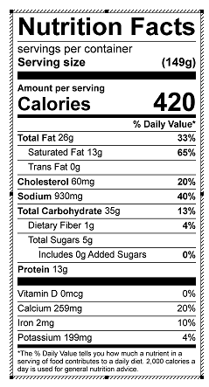
Vitamin C: 3mg

