Potato Pizzas: Red, White and Brie Potato Pizza
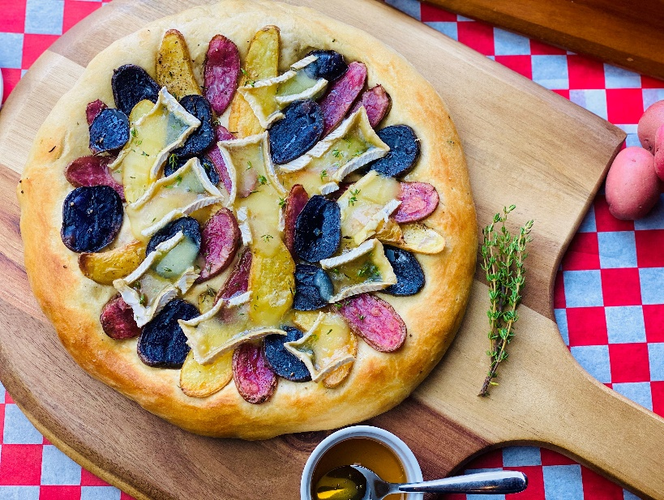
Description: Roasted sliced fingerling potatoes, triple cream Brie, honey, fresh thyme, and sea salt.
Servings: 8
Preparation Time: 20 minutes
Cooking Time: 20 minutes
Total Time: 40 minutes
Potato Type: Fingerling Potatoes
Course: Main Entrée

Ingredients
- 16-ounce Prepared Pizza Dough
- 8 ounces Sliced Fingerling Potatoes, roasted
- 6 ounces Brie, triple cream
- 3 tablespoons Honey
- 1 tablespoon Thyme, chopped
- 1 teaspoon Sea Salt

Preparation
- Preheat the oven to 425 °F.
- Pull and stretch the dough so that a 16-inch round disc is formed. The dough should then be placed on a pizza peel sprinkled lightly with corn meal or flour to prevent sticking.
- Evenly lay the roasted fingerling potatoes on the pizza dough, alternating colors so the pizza is decorative and colorful. Leave about an inch for the crust.
- Place the pizza in the oven on a pizza stone or on the back side of a sheet pan.
- Cook the pizza for 18-20 minutes, rotating it once halfway through to ensure even cooking.
- Remove the pizza from the oven and top it with the brie
- Return the pizza to the oven for 1-2 minutes. Remove the pizza from the oven, and drizzle it with the honey. Sprinkle the pizza with the chopped thyme, and sea salt. Cut the pizza into 8 slices. Enjoy!
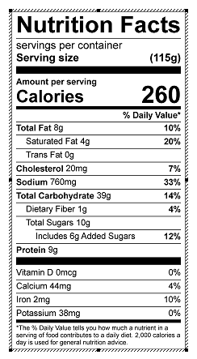
Vitamin C: 6mg

