**Potatoes Rancheros**

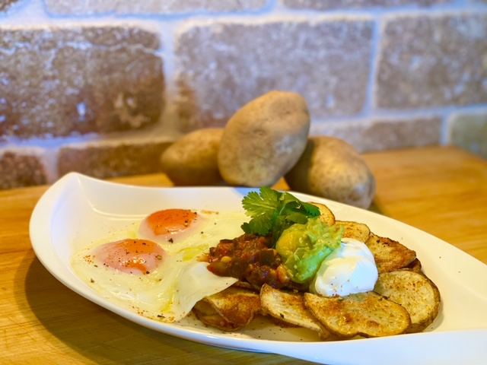

**Servings:** 4

**Preparation Time:** 10 minutes

**Cooking Time:** 20 minutes

**Total Time:** 30 minutes

**Potato Type:** Russet

**Ingredients:**

* 1-pound Russet Potatoes, Sliced into ¼ inch slices
* 2 tablespoons Olive Oil
* As Needed Salt and Pepper
* 3 tablespoons Olive Oil
* 8 each Large Eggs
* 1 cup Prepared Guacamole
* 1 cup Prepared Black Bean and Corn Salsa
* 1 cup Sour Cream

**Directions:**

1. Preheat the oven to 425 F
2. In a large bowl, toss the potatoes together with the olive oil, salt, and pepper.
3. Arrange the potato slices on a foil lined baking tray. Place the potatoes in the oven and allow them to roast for 10-12 minutes. Flip the potatoes and rotate the pan and continue to cook for an additional 10-12 minutes or until the potatoes are golden brown. Remove the potatoes from the oven and keep them warm.
4. In a non-stick pan, heat the olive oil over medium heat. Add the eggs and cook for 3-5 minutes or until the whites are set and the yolk is gently warm. Add 2-3 tablespoons of water to the pan and place a lid over the eggs, allow the eggs to steam for 30 seconds to a minute.
5. To plate the dish, arrange the potatoes on each plate to resemble a disk the size of a tortilla. Then carefully arrange the eggs overlapping the top of the potatoes. Top the dish with the guacamole, salsa, and sour cream. Serve immediately.

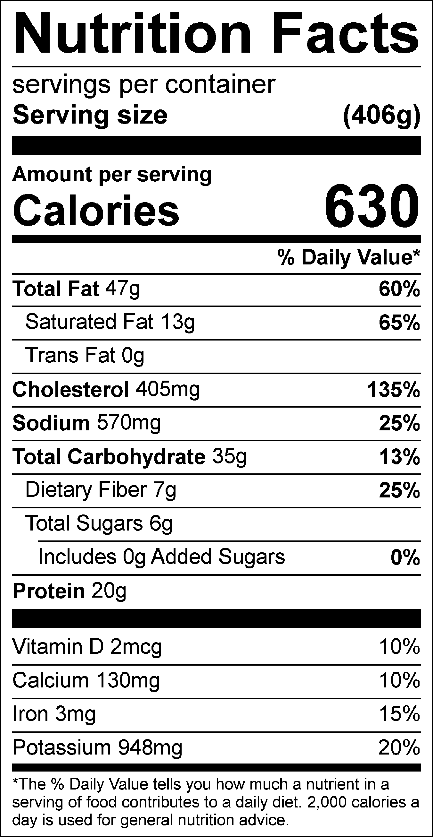

Vitamin C: 17.78 mg