Potato Crusted Burger with Alabama White BBQ Sauce

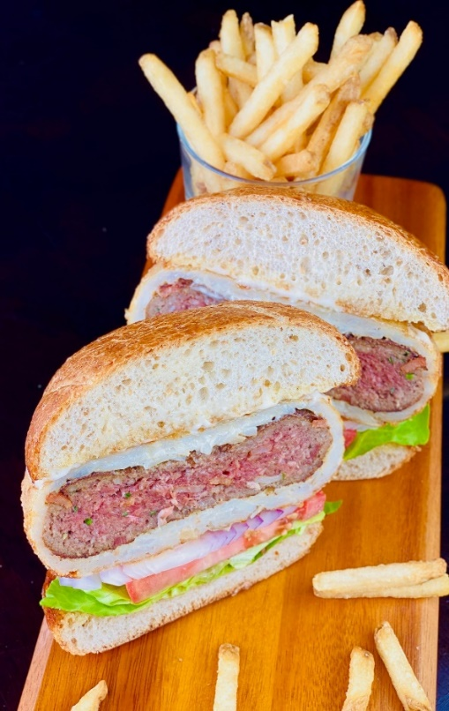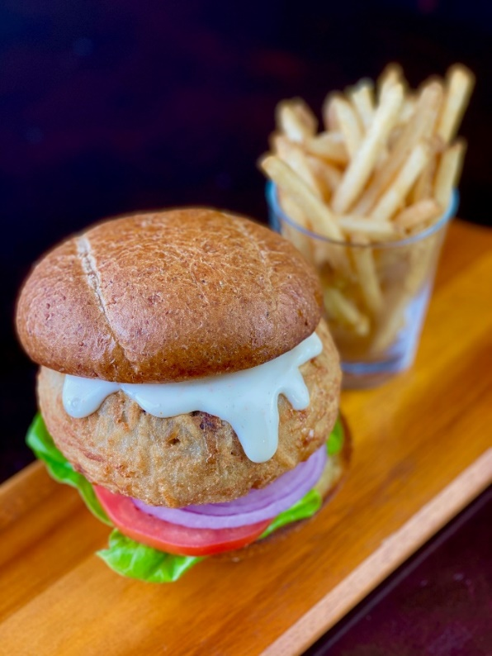

Description: An epic tender and juicy burger studded with bacon, seasoning, and herbs then encased in crispy hash browns and topped with a tangy Alabama white BBQ sauce.
Servings: 24
Preparation Time: 45 minutes
Cooking Time: 15 minutes
Total Time: 60 minutes
Potato Type: Dehydrated Potato Shreds
Course: Main Entrée

Ingredients
Hash Brown Burger
- 9 lbs. Ground Beef (90/10)
- 3 lbs. Hickory Smoked Bacon, diced fine
- 6 each Large Eggs
- 2 cups Panko Breadcrumbs
- ½ cup Chives, chopped
- ½ cup Parsley, chopped
- 2 tablespoons Kosher Salt
- 3 tablespoons Fresh Ground Black Pepper
- 12 cups Dehydrated Potato Shreds
- 1-gallon Boiling Water
- 1-1/2 cups All Purpose Flour
- 2 gallons Vegetable Oil for frying.

White BBQ Sauce
- 3 cups Mayonnaise
- ½ cup White Wine Vinegar
- 1 tablespoon Worcestershire Sauce
- 2 teaspoons Horseradish
- 1-1/2 teaspoon Garlic Powder
- 1 teaspoon Smoked Paprika
- ½ teaspoon Cayenne

For Assembly
- 24 each Potato Hamburger Buns
- 4 each Tomatoes, sliced ¼ inch thick
- 24 each Bibb Lettuce Leaves
- 2 each Red Onions, sliced 1/8 inch thick

Preparation
- In a large bowl combine the ground beef with the bacon, eggs, breadcrumbs, chives, parsley, salt, and pepper until well combined.
- In another large bowl, combine the potato shreds with the boiling water. And allow them to sit for 8-10 minutes to fully hydrate. Drain the potatoes very well and combine with them the flour.
- Shape and form the ground beef mixture into 8-ounce patties. Once all the patties are formed sear them on a flat top or griddle, conversely these can be seared in a large pan on the stovetop as well. Cook the burgers until they reach an internal temperature of 120 °F.
- Place the seared burgers in the fridge to cool completely, about 60 minutes (this can be done the day before as well).
- To wrap the burger patties, lay down sheets of plastic wrap on a flat surface. Carefully place a thin layer of the hash brown mixture on the plastic wrap.
- Place one of the seared burgers down and using the plastic wrap mold the hash browns around the burger. Once all the burgers are wrapped place them in the refrigerator for at least 2 hours to firm up before cooking.
- Meanwhile, make the BBQ sauce. Combine the Mayonnaise, Vinegar, Worcestershire, Horseradish, Garlic Powder, Smoked Paprika, and Cayenne in a medium bowl. Mix well and transfer to the fridge while the burgers cook.
- Heat the oil in a fryer or pot to 350 °F.
- Carefully submerge the burger in the oil and cook for 5-6 minutes or until the patties are golden brown and the internal temp of the burgers reach 140 F.
- Place the burgers on a paper towel to drain slightly and rest.
- Place the burgers on slightly toasted hamburger buns arranged with the lettuce, tomatoes, and onions.
- Top with the BBQ Sauce. Enjoy!
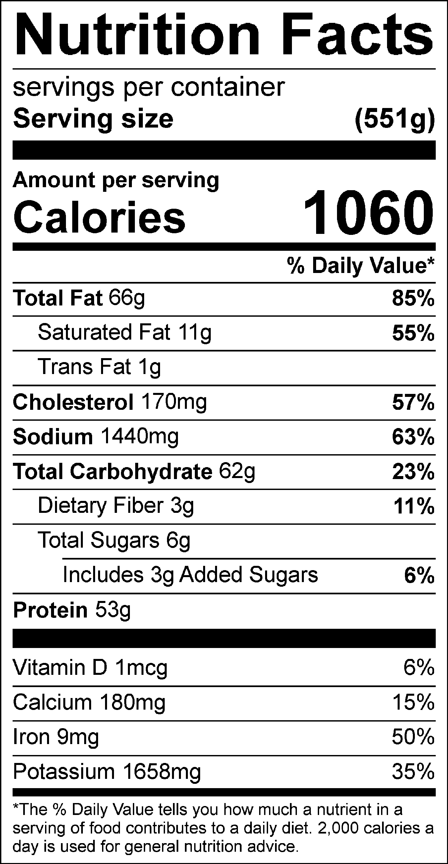
Vitamin C: 11.42 mg

