Foil Wrapped Potato Meals: Potato Beach Picnic in Tunisia
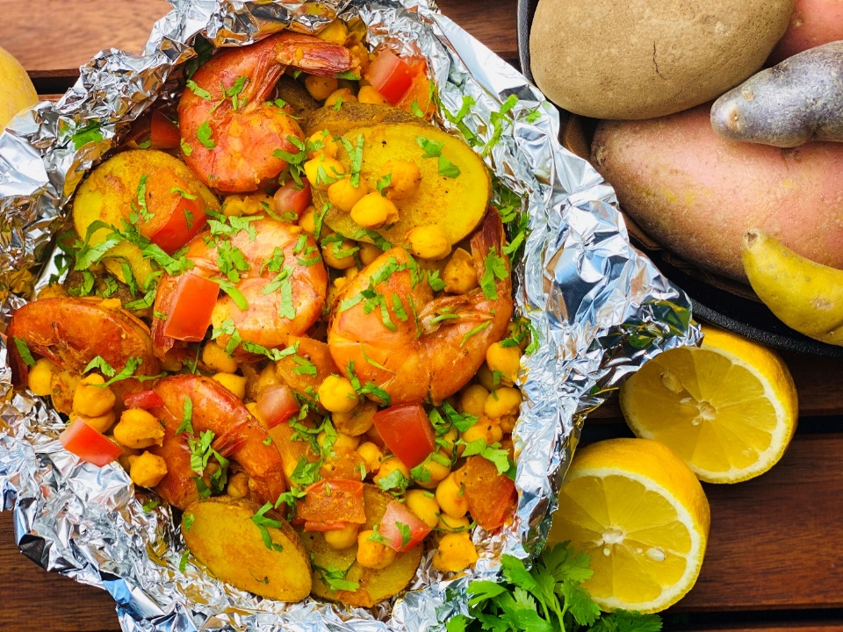
Description: Turmeric spiced potatoes and shrimp with chickpeas, tomatoes, garlic and coriander.
Servings: 4
Preparation Time: 10 minutes
Cooking Time: 35 minutes
Total Time: 45 minutes
Potato Type: Russet Potatoes
Course: Main Entrée, North African, Foil Meals

Ingredients
- 1-1/2 lbs. Russet Potatoes, washed and cut into 1/4-inch rounds
- 1-1/2 tablespoons Olive Oil
- 1 tablespoon Turmeric, ground
- ½ tablespoon Garlic Powder
- 1-1/2 teaspoons Kosher Salt
- 1-1/2 teaspoons Freshly Ground Black Pepper
- 1 lbs. Shell On Shrimp, Deveined (15/20 or U-15)
- ½ cup Chickpeas, canned, drained
- ¾ cup Diced Tomatoes, fresh (canned can be subbed)
- 2 tablespoons Cilantro (Coriander), chopped
- As Needed Fresh Lemon (optional)

Preparation
- Preheat the oven to 400 °F, this can also be done on the grill, simply preheat to 400 °F. If cooking outdoors without a thermometer and over an open flame (cook time may vary slightly).
- Place the potatoes onto a large square of aluminum foil.
- Drizzle the potatoes with the olive oil and season with the turmeric, garlic powder, salt, and pepper. Wrap the foil around the food by creating an envelope style fold over the top and rolling the edges up, this will make it easier to check the contents of the package as well as for easy serving.
- Place the foil pouch into the oven or over the campfire on a grate. Allow the packages to cook for about 25 minutes or until the potatoes are tender. Its important to rotate the foil package around the heat from time to time to prevent scorching.
- To finish the dish, add the shrimp, chickpeas and tomatoes, and seal the package back up, return to the oven or fire for 8-10 minutes, or until the shrimp are pink and fully cooked. Sprinkle the dish with chopped cilantro (coriander), and a squeeze of lemon if desired. Enjoy!
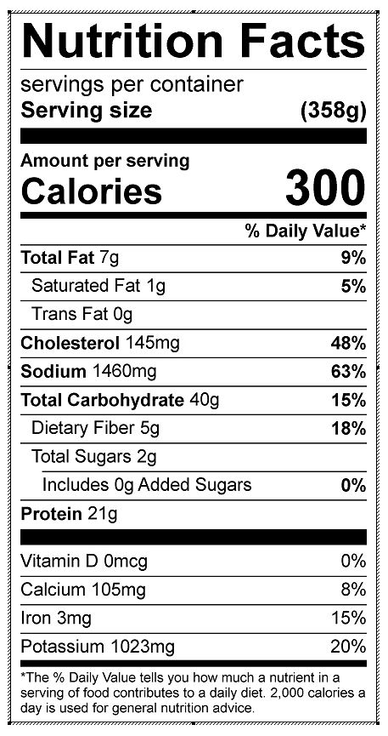
Vitamin C: 14.51 mg

