**Patatas Bravas**

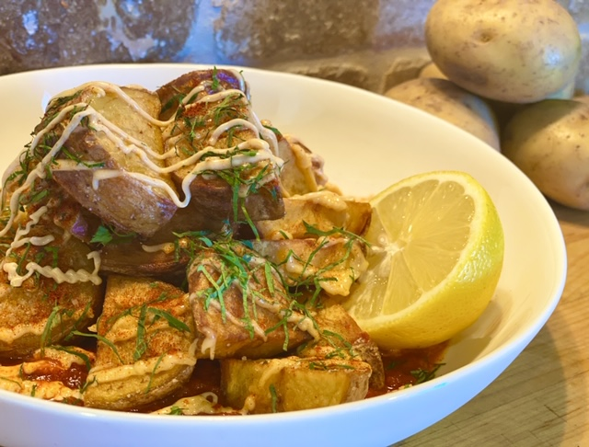

Description: Crispy Spanish style potatoes served with two sauces a smoky tomato sauce and a garlic mayonnaise.

Servings: 4

Preparation Time: 5 minutes

Cooking Time: 25 minutes

Total Time: 30 minutes

Course: Appetizer, Side Dish

Ingredients:

1-pound Yellow Potatoes, cut into ½ inch thick half moons

¼ cup Extra Virgin Olive Oil

As Needed Salt and Pepper

2 cups Prepared Marinara Sauce

2 tablespoons Smoked Paprika

½ cup Mayonnaise

1 teaspoon Garlic, chopped

2 teaspoons Lemon Juice

Directions:

1. Rinse and scrub the potatoes and then cut them in half lengthwise, place them flat side down on the cutting board and slice them into ½ inch thick slices.
2. Place the potatoes into a pot and cover them with water and place over high heat. Bring the potatoes to a boil and reduce the heat to medium, cook the potatoes for 8-10 minutes or until they are just fork tender. Drain the potatoes.
3. Heat the olive oil in a large sauté pan, add the cooked potatoes and fry them until they are golden on all sides. Season with salt and pepper to taste. Remove them from the olive and allow them to drain slightly on paper towels. Keep the potatoes warm while the sauce is being made.
4. To make the smoked tomato sauce, combine the marinara sauce with the smoked paprika.
5. To make the lemon aioli, combine the mayonnaise with the garlic and lemon juice.
6. To serve spoon the smoked tomato sauce down on a plate and top with the crispy potatoes. Serve with the lemon aioli or drizzle the lemon aioli over top of the potatoes.

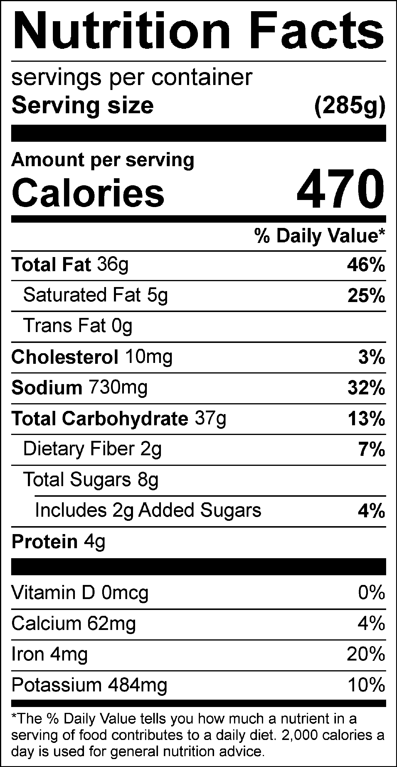

Vitamin C: 22 mg