**Mediterranean Potato Half Shells**

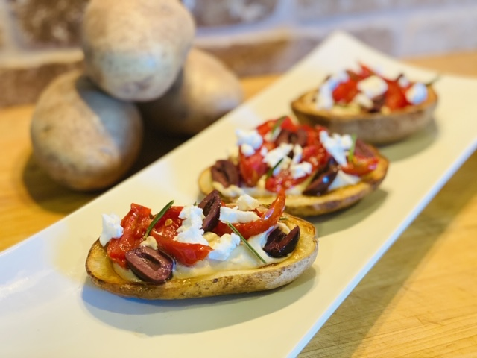

**Servings:** 8

**Preparation Time:** 15 minutes

**Cooking Time:** 15 minutes

**Total Time:** 30 minutes

**Potato Type:** Russet

**Ingredients:**

* 1-pound Russet Potatoes, cut in half lengthwise
* 4 tablespoons Olive Oil
* As Needed Salt and Pepper
* 1 cup Prepared Hummus
* ½ cup Sun-Dried Tomatoes
* ½ cup Kalamata Olives (any olive can be substituted)
* ½ cup Feta Cheese

**Directions:**

1. Preheat the oven to 450 F
2. Wash, scrub and cut the potatoes in half, lengthwise.
3. Place the potatoes in a pot and cover them with water. Place the pot over high heat and bring the potatoes to a boil. Reduce the heat to medium and cook the potatoes for 10-12 minutes until they are fork tender but not falling apart.
4. Drain the potatoes very well and using a spoon, scoop out some of the potato to create little potato boats (discard the filling, or save for soups, mashed, etc.)
5. Arrange the potato boats on a baking sheet lined with foil. Brush the inside of the potato boats with olive oil and season them with salt and pepper.
6. Place in the oven and allow the potatoes to roast for 10-15 minutes or until they are golden brown. Remove from the oven and keep them warm until ready to use.
7. To plate the potatoes place them on a serving platter skin side down. Spoon a little hummus into each potato boat, and top evenly with the tomatoes, olives and feta cheese. Serve immediately.

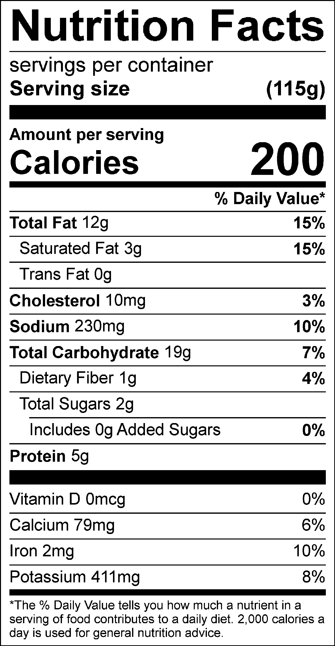

Vitamin C: 7.00mg